-

A TREATMENT IMPROVEMENT PROTOCOL
Trau a-In or ed Be aviora Hea t
- -
are 1• n erv1• ces



on

www.sam .gov• 1-877-SAMHSA-7 (1-877-726-4727)


A TREATMENT IMPROVEMENT PROTOCOL
Trauma-Info med Ca e in Beha ioral H alt S vices

Tl 7
U.S. DEPARTMENT OF HEALTH AND HUMAN SERVICES
Substance Abuse and Mental Health Services Administration Center for Substance Abuse Treatment
1 Choke Cherry Road Rockville, MD 20857

Acknowledgments
This publication was produced under contract numbers 270-99-7072, 270-04-7049, and 270- 09-0307 by the Knowledge Application Program (KAP), a Joint Venture ofThe CDM Group, Inc., and JBS International, Inc., for the Substance Abuse and Mental Health Services Administration (SAMHSA), U.S. Department of Health and Human Services (HHS). Andrea Kopstein, Ph.D., M.P.H., Karl D. White, Ed.D., and Christina Currier served as the Contracting Officer's Representatives.

Disclaimer
The views, opinions, and content expressed herein are the views of the consensus panel members and do not necessarily reflect the official position of SAMHSA or HHS. No official support of or endorsement by SAMHSA or HHS for these opinions or for the instruments or resources described are intended or should be inferred. The guidelines presented should not be considered substitutes for individualized client care and treatment decisions.

Public Domain Notice
All materials appearing in this volume except those taken directly from copyrighted sources are in the public domain and may be reproduced or copied without permission from SAMHSA or the authors. Citation of the source is appreciated. However, this publication may not be reproduced or distributed for a fee without the specific, written authorization of the Office of Communications, SAMHSA, HHS.

Electronic Access and Copies of Publication
This publication may be ordered or downloaded from SAMHSA's Publications Ordering Web page at http://store.samhsa.gov. Or, please call SAMHSA at 1-877-SAMHSA-7 (1-877-726- 4727) (English and Espanol).

Recommended Citation
Substance Abuse and Mental Health Services Administration. Trauma-Informed Care in Behavioral Health Services. Treatment Improvement Protocol (TIP) Series 57. HHS Publication No. (SMA) 13-4801. Rockville, MD: Substance Abuse and Mental Health Services Administration, 2014.

Originating Office
Qyality Improvement and Workforce Development Branch, Division of Services Improvement, Center for Substance Abuse Treatment, Substance Abuse and Mental Health Services Administration, 1 Choke Cherry Road, Rockville, MD 20857.

HHS Publication No. (SMA) 14-4816 First Printed 2014

II

Part 2: An Implementation Guide for Behavioral Health Program Administrators

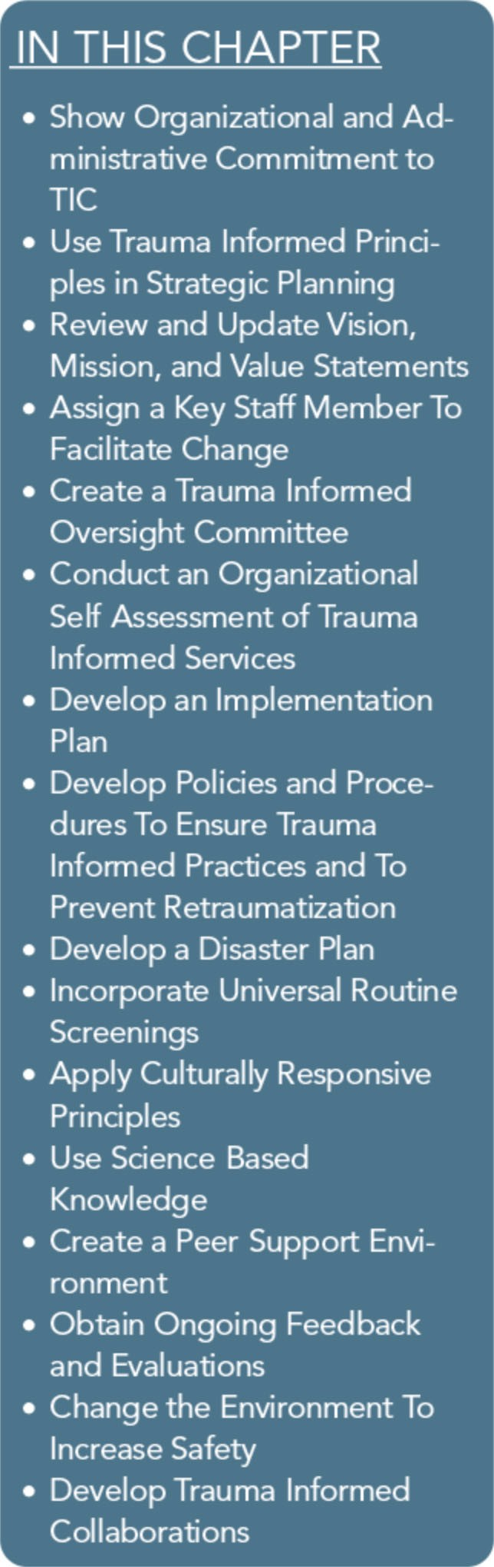
Trauma-Informed Organizations

Part 2 provides a broad overview of how to create and implement an institutional framework for trauma-informed services in pro­ gram delivery and staff development, policies and procedures, ad­ ministrative practices, and organizational infrastructure in behavioral health services. Chapter 1, "Trauma-Informed Organi­ zations," focuses on specific organizational strategies that will help develop a trauma-informed culture in behavioral health settings.
Numerous strategies are presented, including organizational com­ mitment to trauma-informed care (TIC), trauma-informed organi­ zational assessment, implementation of universal screening for trauma, and creation of a peer support environment.
Chapter 2, "Building a Trauma-Informed Workforce," focuses on organizational activities that foster the development of a trauma­ informed workforce, including recruiting, hiring, and retaining trauma-informed staff; providing training on evidence-based and emerging trauma-informed best practices; developing competen­ cies specific to TIC; addressing ethical considerations; providing trauma-informed supervision; and preventing and treating second­ ary trauma in behavioral health service providers.
The strategies described in the following sections can help supervi­ sors and other administrative staff members create a trauma­ informed behavioral health environment. As a starting point, the administration should identify key personnel and consumers to guide the organizational change process and the organizational as­ sessment. Administrators and supervisors need to plan for and demonstrate an ongoing commitment to these strategies, or staff may perceive development activities as comprising yet another idea or demand from the agency that is short-lived beyond the initial thrust of training.

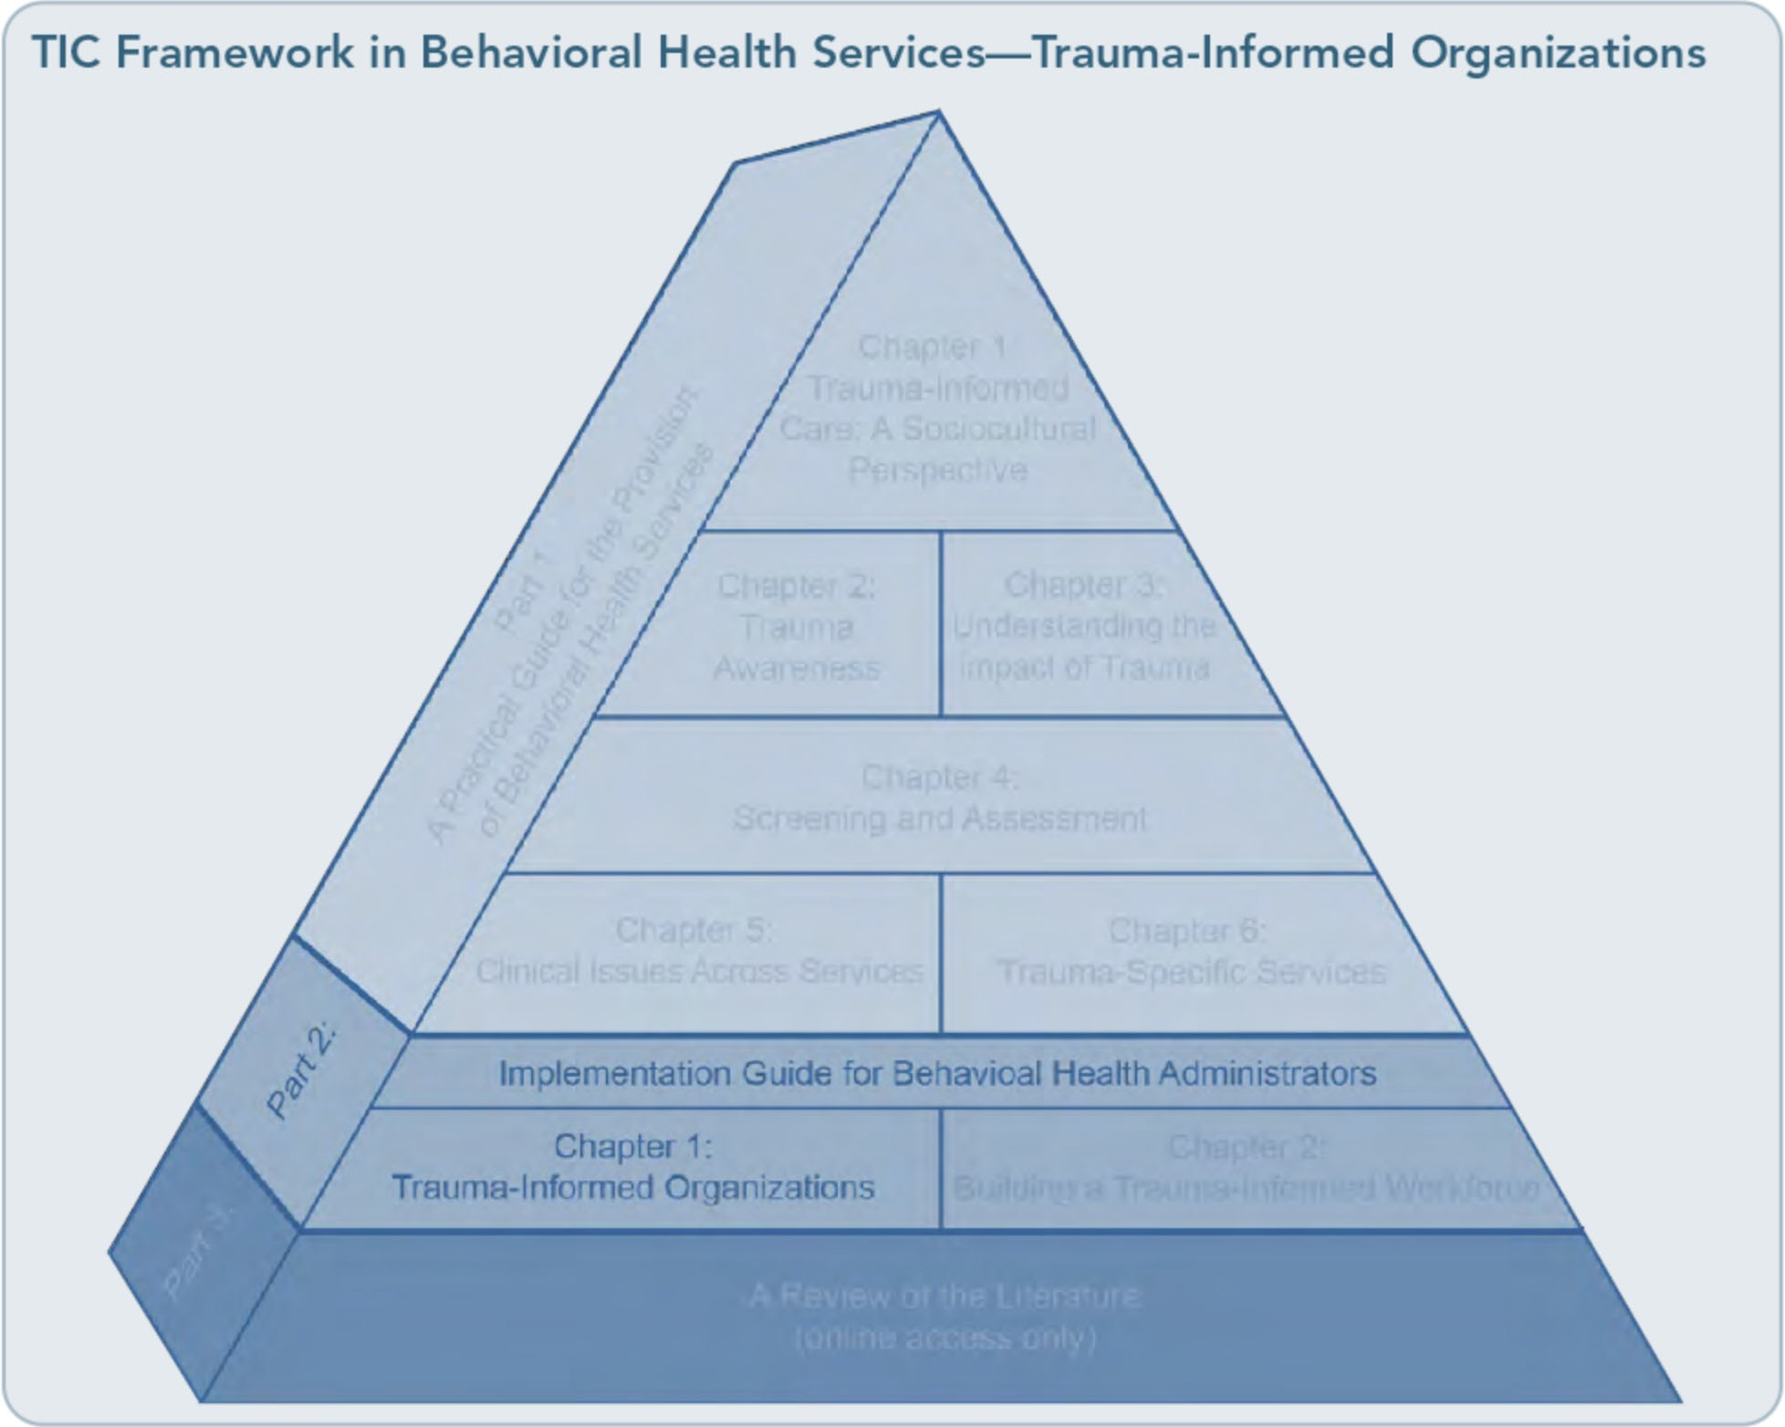

Creating a trauma-informed organization is a fluid, ongoing process; it has no completion date. Consumer demographics change across time, exposure to specific types of trauma may become more prevalent, and knowledge of best and evidence-based practices (EBPs) will continue to advance. A trauma-informed organization continues to demonstrate a commitment to compassionate and effective practices and organizational reassessments,
and it changes to meet the needs of consumers with histories of trauma. It is encouraging that recent Substance Abuse and Mental Health Services Administration (SAMHSA) data indicates that the majority of over 10,000 pro­ grams they surveyed state that they provide trauma-related care (Capezza & Najavits, 2012). However, there remains a major need to
make TIC consistently high-quality, routine, and pervasive across treatment systems.
The following stages form the basis of creat­ ing a trauma-informed organization:
- Commit to creating a trauma-informed agency.
- Create an initial infrastructure to initiate support, and guide changes.
'
- Involve key stakeholders, including con­ sumers who have histories of trauma.
- Assess whether and to what extent the organization's current policies, procedures, and operations either support TIC or in­ terfere with the development of a trauma­ informed approach.
- Develop an organizational plan to imple­ ment and support the delivery of TIC within the agency.

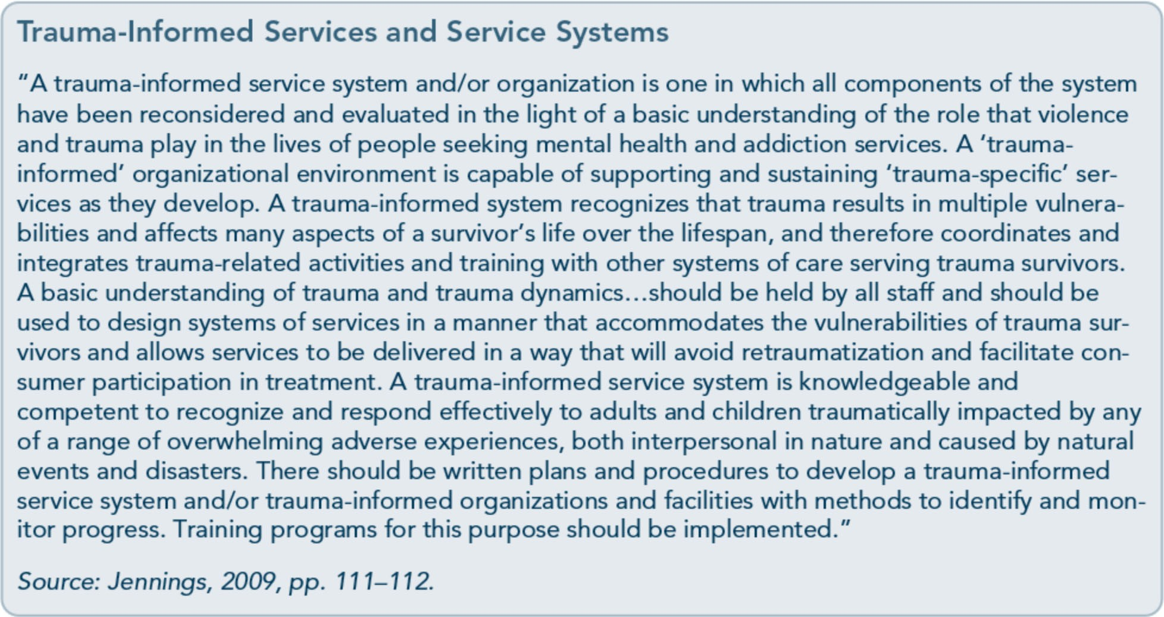

- Create collaborations between providers and consumers and among service provid­ ers and various community agencies.
- Put the organizational plan into action.
- Reassess the implementation of the plan and its ability to meet the needs of con­ sumers and to provide consistent TIC on an ongoing basis.
- Implement quality improvement measures as needs and problem areas are identified.
- Institute practices that support sustainabil­ ity, such as ongoing training, clinical su­ pervision, consumer participation and feedback, and resource allocation.

Strategy #1: Show Organizational and Administrative Commitment to TIC
Foremost, administrators need to understand the impact that trauma can have on people's lives. The consistent delivery of TIC is only as effective as the organization's commitment, which must extend to administrative practices with staff members, program policies and pro-
cedures, program design, staffing patterns, use of peer support, staff and peer training and supervision, organizational assessment and consumer feedback, and resources to uphold trauma-informed principles and practices.
Even short-term change is not sustainable without the agency's continual commitment.
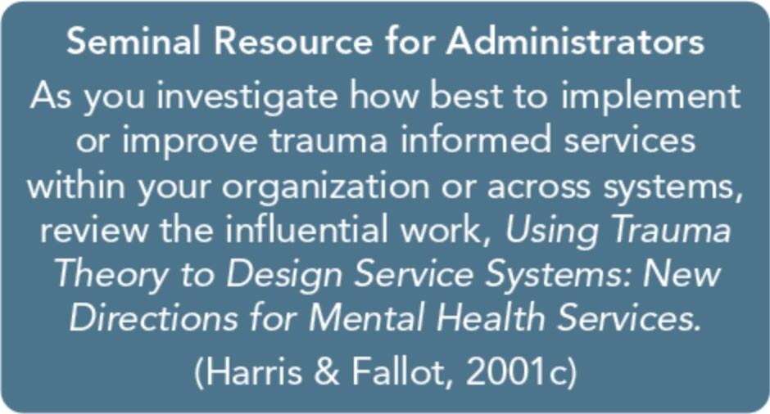
Typically, desirable organizational change doesn't occur by accident. It comes from steadfast leadership, a convincing message that change is necessary and beneficial for staff and consumers, and resources that support change. Many people naturally resist change; thus, an organization's commitment includes a will­ ingness to discuss with staff members the im­ pact and role of trauma in their service setting, patience in planning and implementation, and

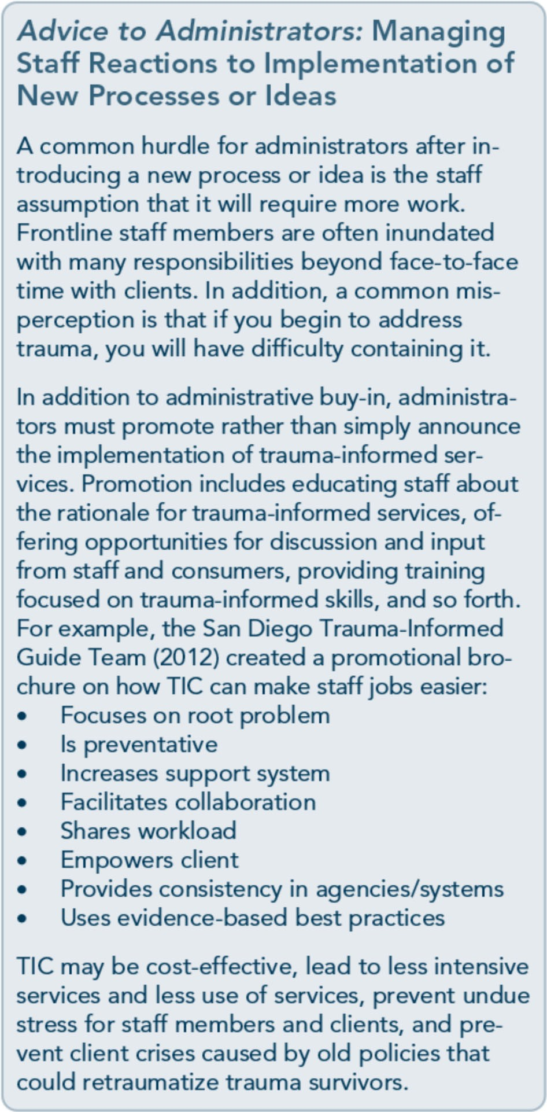
the ability to tolerate the uncertainty that nat­ urally accompanies transitions.

Strategy #2: Use Trauma­ Informed Principles in Strategic Planning
Strategic planning provides an opportunity to explore and develop short- and long-term goals. The planning process often begins with reevaluating the organizations'values, mission,

and vision, yet agencies cannot adequately develop a trauma-informed strategic plan without obtaining specific information about internal (staff, resources, processes) and exter­ nal environmental (referral constellation, changes in health care, funding sources, State and Federal standards, community needs, con­ sumer demographics, etc.) factors and influ­ ences. Data gathered through staff, consumer, organizational, and community assessments shapes the direction of the plan, including projected demands, challenges, obstacles, strengths, weaknesses, and resources. At the conclusion of this planning process, the organ­ ization will have specific goals, objectives, and tasks to meet the needs of their stakeholders and to address any anticipated challenges. Ide­ ally, strategic planning should define key steps in developing or refining trauma-informed services within the organization.

Strategy #3: Review and Update Vision, Mission, and Value Statements
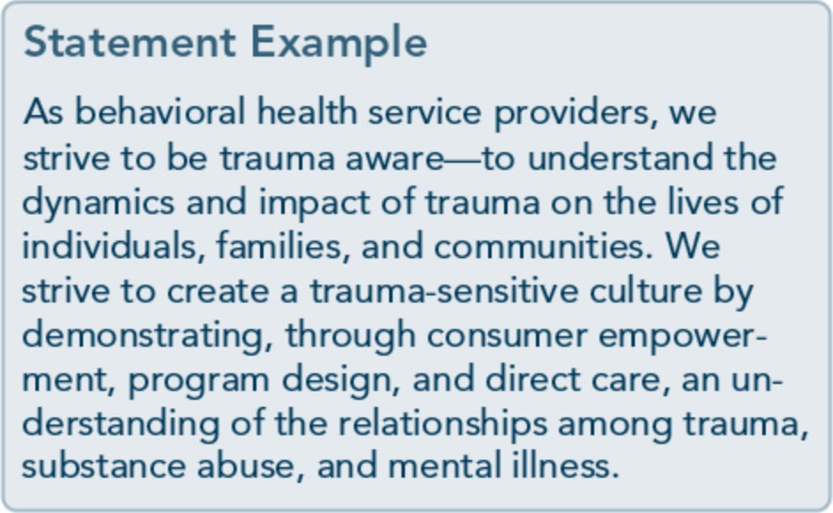
Vision, mission, and value statements provide a conceptual framework for TIC development and delivery. They should not be created in isolation; they should reflect voices from the community, populations, and other stakehold­ ers that the organization serves. These state­ ments develop through input, discussion, and assessment. They are not static; they evolve as needs, populations, or environments change.

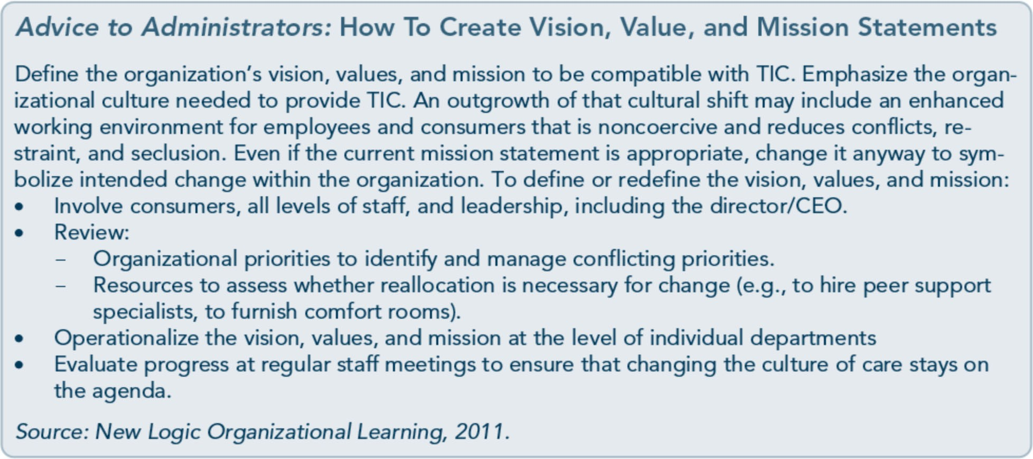

Strategy #4: Assign a Key Staff Member To Facilitate Change
Prior to the development of an oversight com­ mittee, a senior staff member with the authori­ ty to initiate and implement changes should be assigned to oversee the developmental process. By assigning a trauma-aware senior staff mem­ ber who is committed to trauma-informed services, it is more likely that the organiza­ tion's and committee's goals, objectives, and plans will remain in focus. This senior staff member is responsible for ongoing develop­ ment and facilitation of the oversight commit­ tee; management of the initial organizational assessment, reassessments, and other evaluative and feedback processes; and facilitation and oversight of the implementation plan and sub­ sequent changes, including policies and proce­ dures to ensure delivery of TIC.

Strategy #5: Create a Trauma-Informed Oversight Committee
The role of the oversight committee includes providing ongoing input and direction in the initial organizational assessment, strategic
plan, plan implementation, reevaluation and development of trauma-informed policies and procedures, and future reassessments.The committee monitors progress and uses real­ time data to forge a clear pathway to new pro­ cesses that support TIC.The committee should involve stakeholders from the commu­ nity, consumers, specialists, staff members, and administrators. Leadership involvement is necessary. Stakeholders may be alumni, family members, community-based organizations, and other institutions that interact with the agency or would benefit from trauma­ informed services.
Initially, the agency must educate the commit­ tee on the organization's mission, values, and vision as well as the task at hand-developing trauma-informed services. To ease potential conflicts or confusion about the organization's structure, the guidelines, expectations, and roles of the committee need to be communi­ cated directly to committee members as well as the organization as a whole, including board members, support and professional staff, su­ pervisors, and so forth. The committee also needs to know the extent of their power and the necessary lines of communication before, during, and after evaluating and implementing changes in the organization.

Including consumers and/or those who have lived through trauma is vital. They have unique knowledge, experiences, and perspec­ tives on the impact of treatment design, deliv­ ery, policies, and procedures. They offer firsthand information on practices that can potentially retraumatize clients in behavioral health settings and can suggest preventive, alternative practices and solutions. Consumer committee members keep staff and adminis­ trators aware of the goal of achieving TIC.

Strategy #6: Conduct an Organizational Self­ Assessment of Trauma­ Informed Services
An organizational self-assessment evaluates the presence and/or the effectiveness of cur­ rent trauma-informed practices across each service and level of the organization. This assessment allows an organization to see how it functions within the context of trauma­ informed principles and provides feedback to inform the development or revision of the implementation plan for TIC. In essence, this assessment process can serve as a blueprint for change and as a benchmark of compliance with and progress in implementing trauma­ informed practices across time. Overall, it is a process of identifying organizational strengths, weaknesses, opportunities, and threats related to the implementation and maintenance of TIC. Refer to Appendix F for sample organi­ zational assessment tools for the organization and the consumer.
The self-assessment should obtain feedback from key stakeholders, particularly consumers, family members, referral sources, community organizations, and all levels of the organiza­ tion's staff, including nonclinical and clinical staff, supervisors, and administrative person­ nel. Similar to the universal screening process,

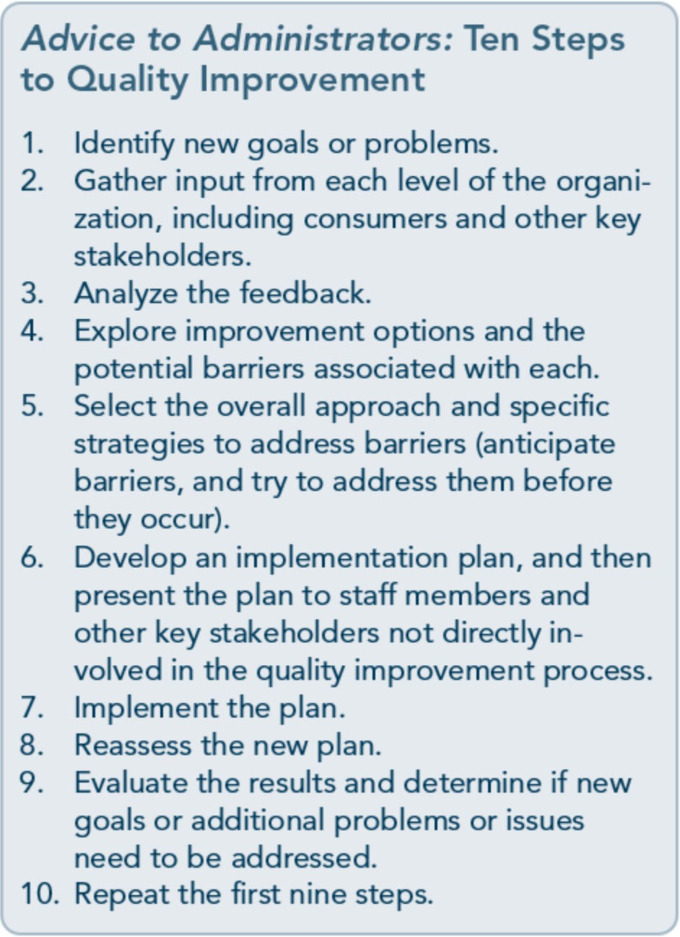
an organizational self-assessment is only as effective as the steps taken after data are gath­ ered and analyzed. From this assessment, an implementation plan should be established that highlights the goals, objectives, steps, timeframe, and personnel responsible in over­ seeing the specific objective. Assessment shouldn't be a once-and-done project. Timely and regularly scheduled organizational assess­ ments should follow to assist in quality im­ provement. For an explanation of more detailed steps to take in conducting an organi­ zational self-assessment, see Chapter 4 of the planned Treatment Improvement Protocol (TIP), Improving Cultural Competence (SAMHSA, planned c).

Strategy #7: Develop an Implementation Plan
Implementation plans should evolve from consumer participation, demographic profiles

Advice to Administrators: Implementation Plan Content
- Introduction and overview: This includes the organization's history, the demographics that char­ acterize its client base, the rationale for the implementation plan, and the incorporation of TIC. Focus on identification of strengths, weaknesses, opportunities, and threats. Provide an overview of goals and objectives.
- Specific goals and objectives: Goals and objectives should address:
Workforce development strategies for recruiting, hiring, retaining, training, supervising, and promoting wellness of clinical and nonclinical staff members to support TIC.
Consumer participation and peer support development and implementation strategies. Policies, procedures, and practices to support TIC and culturally responsive services, to pro­ mote safety, and to prevent retraumatization.
Specific evidence-based or best practice adoptions to support TIC.
Strategies to amend facility design or environment (plant) operations to reinforce safety. Fiscal planning to ensure sustainability of the steps initiated in the organization.
- Guidelines for implementation: Guidelines should highlight the specific steps, roles, responsibili-

l.....
ties, and timeframes for each activity to meet TIC objectives.

,/

of populations served, data from organization­ al self-assessment, and research on promising and evidence-based trauma-informed practic­ es. Using the framework proposed in this TIP,
the oversight committee is responsible for designing a plan that outlines the purpose, goals, objectives, timeframes, and personnel responsible for each objective (Exhibit 2.1-1).

Exhibit 2.1-1: TIC Planning Guidelines
The following publications provide samples of organizational guidelines for implementing TIC.
- Fallot, R. D. & Harris, M. (2009). Creating cultures of trauma-informed care (CCTIC): A self­ assessment and planning protocol. Washington, DC: Community Connections, 2009.
- Guarino, K., Soares, P., Konnath, K., Clervil, R., & Bassuk, E. (2009). Trauma-informed organiza­ tional toolkit. Rockville, MD: Center for Mental Health Services, Substance Abuse and Mental Health Services Administration; the Daniels Fund; the National Child Traumatic Stress Network; and the W. K. Kellogg Foundation.
- Huckshorn, K. (2009). Transforming cultures of care toward recovery oriented services: Guidelines toward creating a trauma informed system of care. In Trauma informed care (TIC) planning guide­ lines for use in developing an organizational action plan. Alexandria, VA: National Association of State Mental Health Program Directors.
- Jennings, A. (2009). Criteria for building a trauma-informed mental health service system. Re­ trieved on May 21, 2013, from http://www.theannainstitute.org/CBTIMHSS.pdf
- Ohio Legal Rights Service (2007). Trauma-informed treatment in behavioral health settings. Co­
lumbus, OH: Ohio Legal Rights Service.
- Prescott, L., Soares, P., Konnath, K., & Bassuk, E. (2008). A long journey home: A guide for creat­ ing trauma-informed services for mothers and children experiencing homelessness [draft]. Rock­ ville, MD: Center for Mental Health Services, Substance Abuse and Mental Health Services Administration; the Daniels Fund; the National Child Traumatic Stress Network; and the W.K. Kellogg Foundation.
The following resource is a systemwide set of guidelines for implementing TIC.
- U.S. Department of Health and Human Services, Health Resources and Services Administration (2006). Model trauma system: Planning and evaluation. Rockville, MD: Health Resources and Ser­ vices Administration.

Strategy #8: Develop Policies and Procedures To Ensure Trauma­ Informed Practices and To Prevent Retraumatization
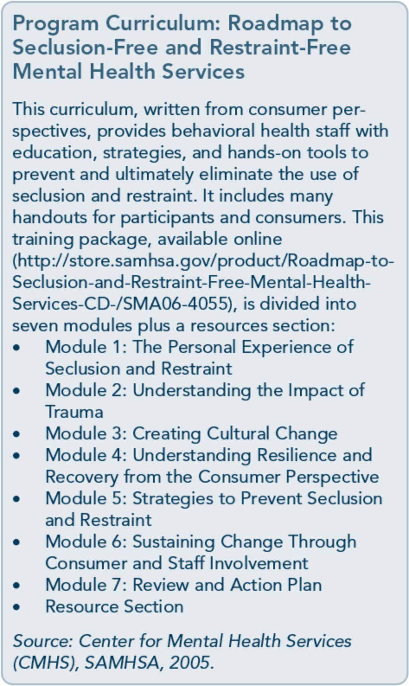
In the early stage of evaluating current services and planning for TIC, the committee needs to assess practices, procedures, and policies that may have been or could be retraumatizing to any individual, at any level of the organization, from consumers to administrators. Programs that are not trauma informed are as likely to be unaware of the impact of trauma on staff as they are to be unaware of its influence on con­ sumers. In the initial review, careful scrutiny

should be used to eliminate any practice that is potentially harmful, including seclusion and restraint practices, therapeutic activities that are shaming, treatment planning without col­ laboration, any medical inquiry without privacy, and so forth.
Policies and procedures are the building blocks of each agency. They guide the service process and, if followed, they provide an op­ portunity for the agency to deliver consistent responses and care. Policies and procedures must incorporate trauma-informed practices across all domains and standards, such as ad­ missions, plant/environmental standards, screening and assessment processes, referrals (to other services, including hospitalization, or for further evaluations), treatment planning, confidentiality, discharge, and more. They also need to be updated periodically to incor­ porate new science and to meet the changing needs of consumers. By regularly reviewing and adapting administrative and clinical poli­ cies and procedures in response to ever­ changing needs and evidence, the agency can provide staff members with good guidelines for providing trauma-informed services that are consistent yet flexible.

Strategy #9: Develop a Disaster Plan
Facilities are often required to develop disaster plans, but specific requirements vary from State to State. From the outset, developing a disaster plan in behavioral health services is essential. Many clients in behavioral health services have lived with trauma, so proactive steps that reduce the impact of a new trauma may prevent worsening of symptoms and de­ crease the risk for more pervasive effects. (See also Technical Assistance Publication 34, Dis­ aster Planning Handbookfor Behavioral Health Treatment Programs [SAMHSA, 2013].)

Most disaster events cannot be accurately an­ ticipated. Even so, behavioral health organiza­ tions can take steps to reduce the impact of a disaster event on program functioning and on the lives of clients. Each service or program should develop a disaster response committee that meets regularly to develop, maintain, and adapt policies and procedures to respond to disasters affecting the program. Committee planning efforts may include:
- Creating a disaster response team of pro­ gram staff members tasked with coordi­ nating program administration and services in a disaster event.
- Establishing a communication process for informing staff and clients of the status of program functioning and for coordinating staff assignments during and shortly after the disaster event.
- Outlining a process to inform clients and their families of available services, their lo­ cation, and contact information for access­ ing services to meet clients' critical needs.
- Developing plans for service provision during a disaster event and service imple­ mentation after the event.
- Creating special plans for high-risk or
special needs clients who need services during and shortly after the disaster. Ex­ amples of this are clients who are home­ less, in detoxification services or methadone programs, on prescribed psy­ chopharmaceuticals, or at risk for suicide.
- Making plans for maintaining the security of client records, program records, and fa­ cilities during and shortly after the event.
- Coordinating ahead with other community resources and services to ensure that clients at high risk or with special needs get the services they require as soon as possible.
- Prioritizing how services will start back up after a disaster event.
- Providing special services after the event to clients at high risk for trauma reactions and symptoms.

- Establishing a postdisaster debriefing pro­ cess to review disaster responses, services, and outcomes.
Some specific disaster events, such as hurri­ canes, may sometimes offer opportunities for planning and preparation in advance of the disaster event. This preparation time is usually just a few days, but it allows programs to make advance preparations and take advance action to establish lines of communication, stockpile resources, prepare for evacuation of clients, and protect client and program records.

Strategy #10: Incorporate Universal Routine Screenings
A key element of trauma-informed services is the institution of universal routine screening across all services, regardless of the individual's path in accessing services (e.g., primary care, hospitalization, outpatient). Considering the prevalence of trauma among individuals who seek services for mental and substance use disorders, the implementation of screening is paramount. Without screening, clients are not identified as trauma survivors. Subsequently, they miss recovery opportunities and treat­ ment services that would be more likely to meet their needs, while also running a higher risk of being retraumatized by unexamined organizational policies, procedures, and prac­ tices. For more information on the rationale, processes, and instruments of universal screen­ ing for trauma, refer to Part 1, Chapter 4.

Strategy #11: Apply Culturally Responsive Principles
Providers must be culturally competent when incorporating evidence-based and best prac­ tices as well as trauma-informed treatment

models within the organization. Clients' views of behavioral health differ according to race, ethnicity, and culture (refer to the planned Treatment Improvement Protocol [TIP], Im­ proving Cultural Competence [SAMHSA, planned c]). Likewise, cultures attach different meanings to trauma, and responses to trauma will vary considerable across cultures (see Part 3, the online literature review, for more in­ formation). For example, trauma survivors who come from a collective society or culture, in which the goals of the group take prece­ dence over the goals of the individual, may be more focused on the well-being of their family or the family's response to the trauma survi­ vors' experience. Often, this view runs in op­ position to the individualistic perspective of many behavioral health services. Subsequently, treatment providers who are not culturally competent may interpret collective values as a sign of resistance or avoidance in dealing with traumatic stress. CMHS (2003) outlines prin­ ciples of cultural competence in disaster work applicable across all forms of trauma:
l. Recognize the importance of culture and respect diversity. Those who value culture and diversity understand their own cul­ tures, attitudes, values, and beliefs, and they work to understand the cultures of others. This includes being able to com­ municate effectively with those from other cultures, respecting others' feelings about personal space, knowing about others' so­ cial organization, understanding how time is viewed, and being aware of others' be­ liefs about the effects of their behaviors.
  - Maintain a current profile of the cultural composition of the community. This in­ cludes describing the community's popula­ tion in terms of race and ethnicity, age, gender, religion, refugee and immigrant status, housing status, income levels, ru­ ral/urban balance, unemployment, lan­ guages spoken, literacy, schools, and businesses.

  - Recruit workers who are representative of the community or service area. If the work­ ers who are available do not match the community, they should have the personal attributes, knowledge, and skills to develop cultural competence.
  - Provide ongoing cultural competence train­ ing to staff Topics should include cultural values and traditions, family values, lin­ guistics and literacy, immigration experi­ ences and status, help-seeking behaviors, techniques and strategies for cross-cultural outreach, and the avoidance of stereotypes and labels (DeWolfe & Nordboe, 20006).
  - Ensure that services are accessible, appro­
priate, and equitable. In planning disaster work or TIC, community associations and organizations are invaluable. Gaining their acceptance requires time and energy.
  - Recognize the role of help-seeking behav­ iors, traditions, and natural support net­ works. Culture includes traditions that dictate whom, or which groups, to seek in times of need; how to handle suffering and loss; and how healing takes place. These customs and traditions are respected by a culturally responsive disaster relief program.
  - Involve community leaders and organiza­ tions representing diverse cultural groups as ''cultural brokers." Collaborating with community leaders is an effective means of learning about the community, establishing program credibility, and ensuring that ser­ vices are culturally responsive.
  - Ensure that services and information are culturally and linguistically responsive. Communication with individuals who do not speak English, who are illiterate in all languages or have limited literacy, and who are deaf or hard of hearing is essential to service provision. Local radio stations, tel­ evision outlets, and newspapers that are multicultural are an excellent venue for educational information after a disaster.

Using survivors' friends or relatives as in­ terpreters is not recommended, as survi­ vors may be uncomfortable discussing personal matters with family members or friends. Asking children to interpret can place too heavy a responsibility on them and reverses parents' and children's roles.
  - Assess and evaluate the program's level of
cultural responsiveness. Self-assessment and process evaluation can help keep a program on track. A variety of strategies can be used for collecting data and com­ municating findings to stakeholders.

Strategy #12: Use
Science-Based Knowledge
Along with culturally responsive services, trauma-informed organizations must use science-based knowledge to guide program development and the implementation of ser­ vices, policies, procedures, and practices. This includes the adoption of EBPs (see Part 1, Chapter 6, and Part 3, Section 1, to review definition, treatments, and resources for EBPs). TIC research is quite new; interpret these lim­ ited studies and information cautiously.
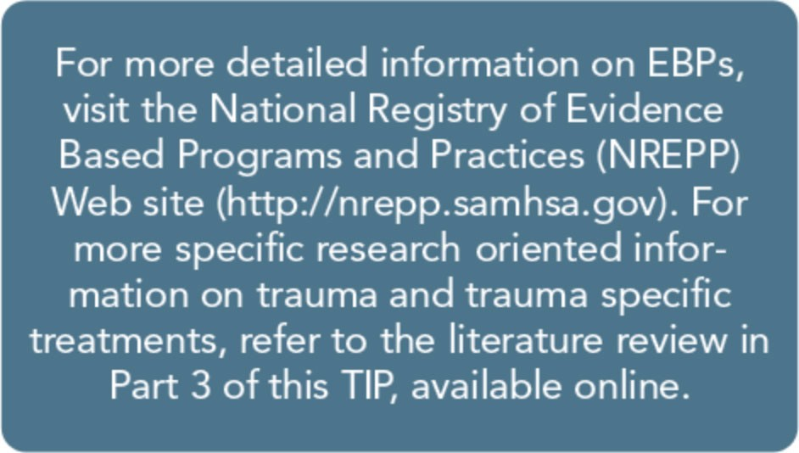
Chambless and Hollon's (1998) criteria, which are still the benchmark for EBPs, are valuable resources for administrators. Look closely at who was included-and excluded-from treatment studies. Often, the types of severe, chronic, and unstable cases seen in community settings are excluded from treatment studies. Evidence-based interventions should be a primary consideration in selecting appropriate
treatment models for people with mental ill­ ness, substance use disorders, and co-occurring psychological trauma. Nonetheless, other vari­ ables must also be contemplated before adopt­ ing EBPs in an organization, including the cultural appropriateness of the practice; the strength of its clinical focus on strengths­ based strategies; training and competence of clinical staff; the cost of training, materials, and implementation; and the ease of main­ taining EBP fidelity amidst staff turnover.

Strategy #13: Create a Peer-Support Environment
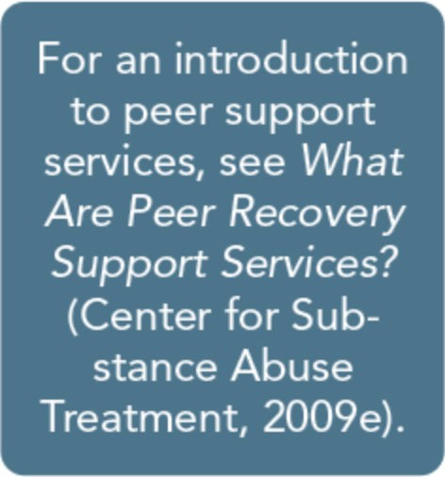
The main purpose of peer support services is to provide con­ sumer mentoring, support, and care coordination for cli­ ents with histories of mental illness or substance abuse. The
goals are to help others deal with personal and environmental barriers that impede recovery and achieve wellness. Peer support accom­ plishes this through many activities, including advocacy, support during crises and recovery activities, modeling, education, and assistance in accessing available resources. Peer support programs send a powerful message to staff members, consumers, and the community­ that recovery is possible through support, col­ laboration, and empowerment. These pro­ grams reinforce the trauma-informed premise that organizations need to reflect the popula­ tions that they serve and involve consumers in planning, implementing, monitoring, and de­ livering recovery services.
Notably, peer support services have the poten­ tial to be considerably flexible to meet client needs at each stage of recovery. Specifically, peer support services can be incorporated

across the continuum of care, starting with outreach services and extending into long­ term recovery services. Peer support specialists can enhance consumer motivation to change, to initiate services, and/or to engage in recov­ ery activities. They can play powerful liaison roles by supporting clients entering treatment and explaining what to expect from services. They can ease the transition into treatment, from one service to the next, from one mo­ dality to another (e.g., inpatient group to out­ patient group), and beyond formal treatment. Moreover, peer support services create an at­ mosphere focused on mutuality rather than pathology. They provide living models of re­ silience and promote hope-that recovery is possible and attainable.
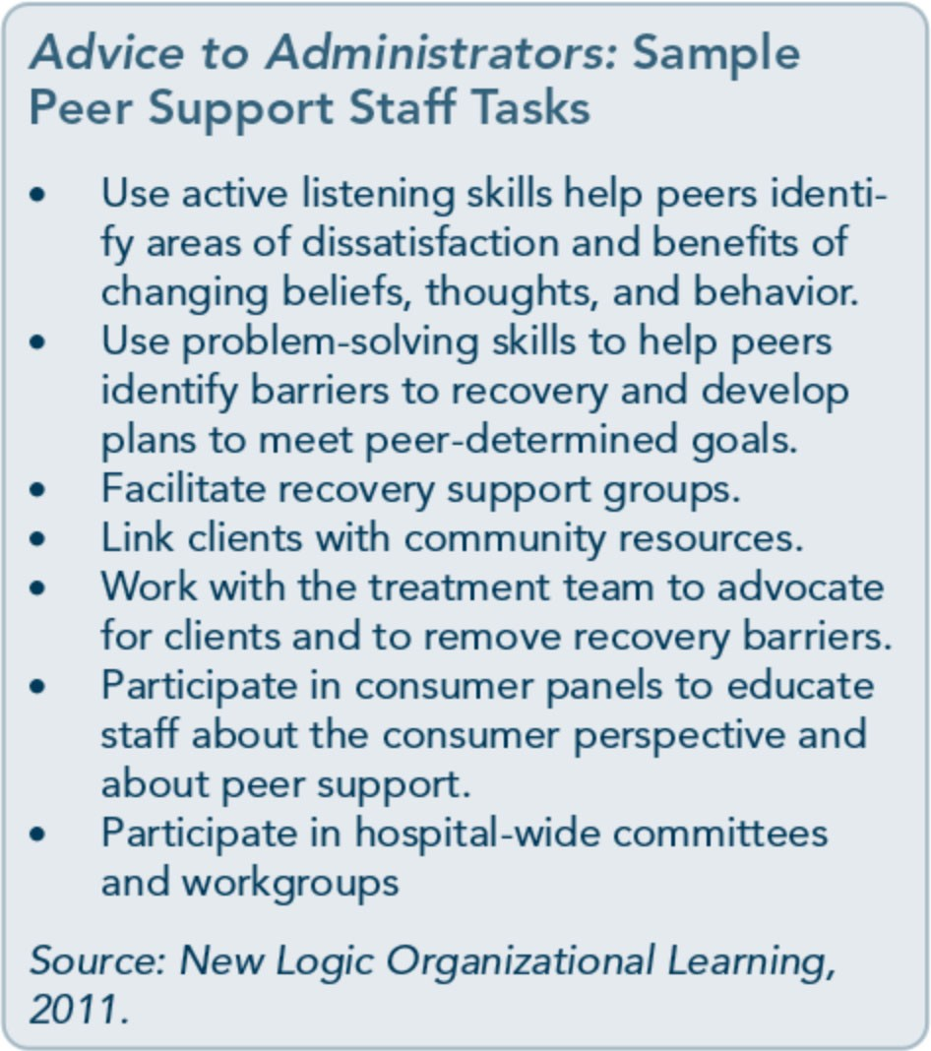
Administrators should familiarize themselves with how other organizations have imple­ mented peer support programs, current curric­ ula, certifications and training processes, competencies and ethics, and peer support service State standards or recommendations, if applicable. The Carter Center's Summit in 2009, The Pillars of Peer Support Services, supported in part by SAMHSA and CMHS,

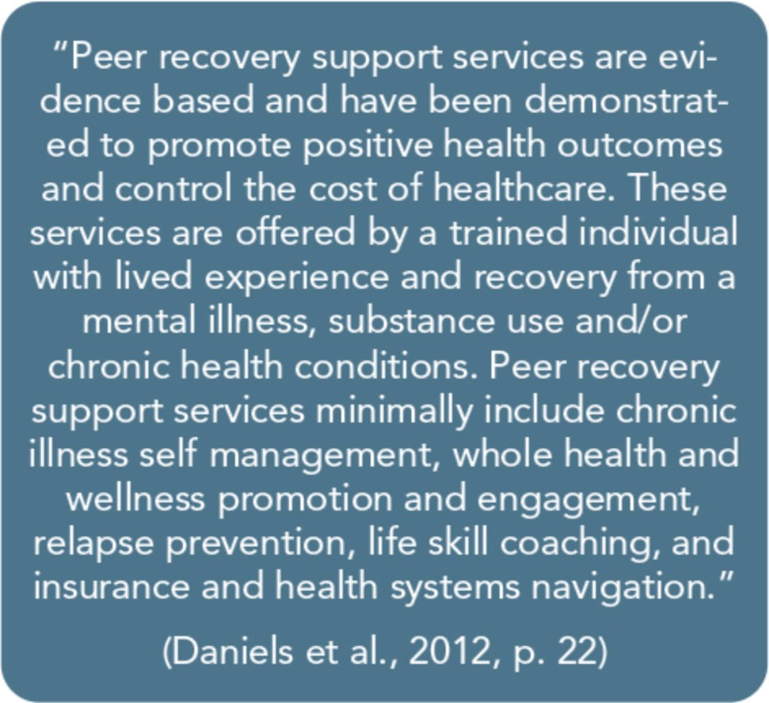
highlighted the numerous elements necessary to develop a strong, vital peer workforce (Daniels et al., 2010). These elements include:
- Clear job and service descriptions.
- Job-related competencies and competence- based testing processes.
- Peer support certifications.
- Ongoing continuing education.
- Media and technology access for peer spe- cialists.
- Sustainable funding.
- Research and evaluation components.
- Code of ethics and conduct.
- Competence-based training for supervisors.
- Multilevel support and program support teams.

Strategy #14: Obtain Ongoing Feedback and Evaluations
Obtain feedback on and evaluations of organi­ zational performance on a regular basis. Give consumers a clear avenue for offering feedback at any time, and make evaluations assessing the organization's progress toward providing trauma-informed services standard practice.
Without feedback and further evaluation, or­ ganizations cannot assess whether they are

meeting trauma-informed objectives. A rou­ tine monitoring process for TIC implementa­ tion gives the organization additional information necessary to combat new obsta­ cles and threats and to understand what works. Regular monitoring equips organizations with the ability to formulate different strategies to meet objectives as well as to respond to the changing needs of the population. Ongoing evaluation and consumer feedback are essen­ tial in improving the quality of services.

Strategy #15: Change the Environment To Increase Safety
Practices that generate emotional and physical safety are necessary. Another aspect of creating safety is reevaluating the physical facilities and environment to enhance safety and to circum­ vent preventable retraumatization. Think how traumatizing it would be if you were a female rape survivor and a night counselor was con­ ducting a room check at 2:00 a.m., or a male security guard was walking the women's resi­ dential wing. What would it be like if you were sitting with your back to the door in a small office during an intake interview, if your history included a physical assault and rob-

bery? For most, it would at least increase anxi­ ety; for others it would be retraumatizing.
Trauma-informed providers must carefully assess environmental safety. Although you are likely to identify some facility issues that could erode safety for trauma survivors, a safe envi­ ronment will only be established if regular feedback is obtained from consumers about their experiences with the program.

Strategy #16: Develop Trauma-Informed Collaborations
TIC is about collaboration with consumers, staff members, key stakeholders, and other agencies. Collaborative relationships provide opportunities for consumers to access the most appropriate services as needs arise. Rather than waiting for a crisis or a dire need for a service to investigate available resources, it is
far more efficient and compassionate to estab­ lish relationships within the agency and with other community resources before these needs arise. No agency can meet the needs of every client; referral agreements and/or collaborative arrangements that integrate the delivery of TIC, including support services (e.g., housing, legal, medical), are important.

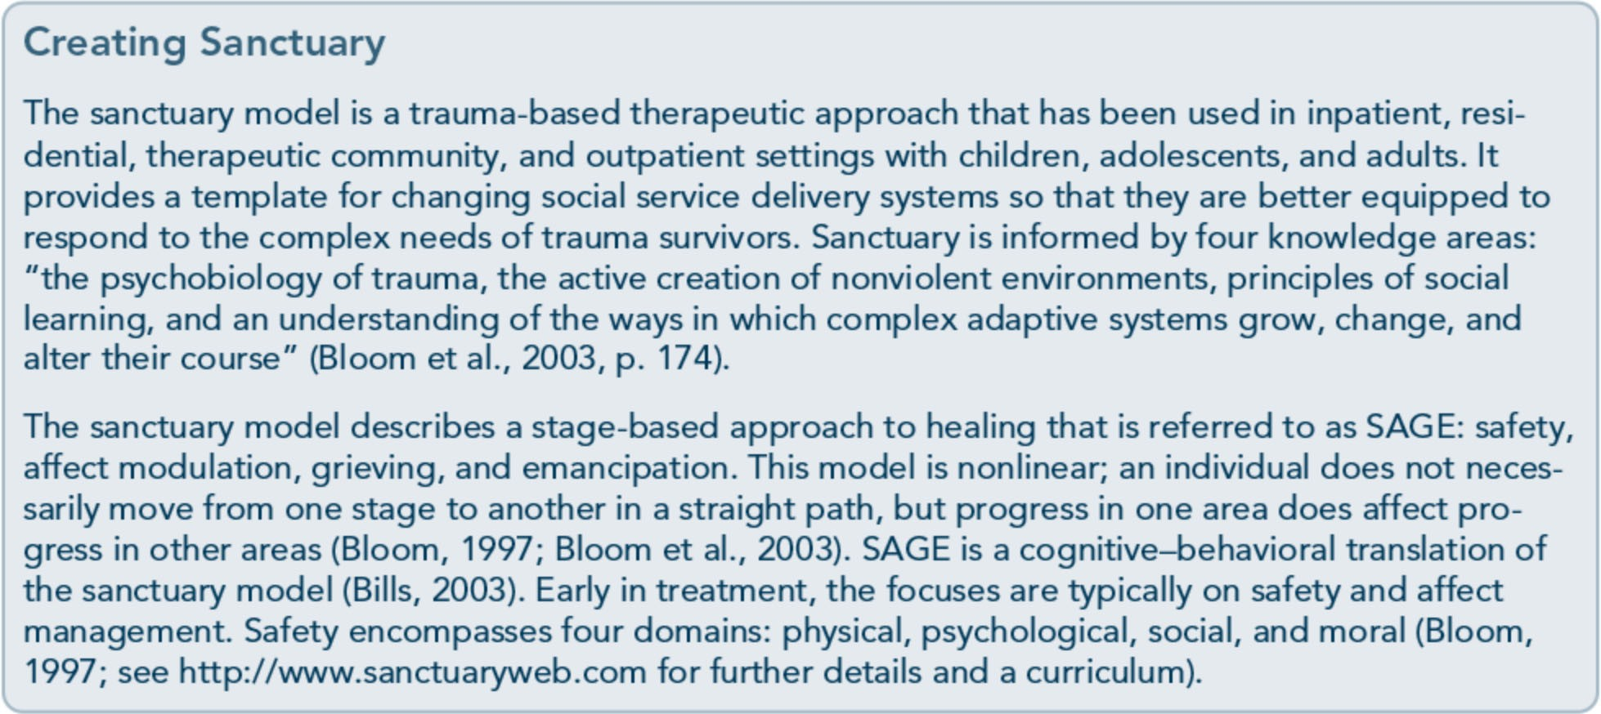

Building a Trauma­ Informed Workforce

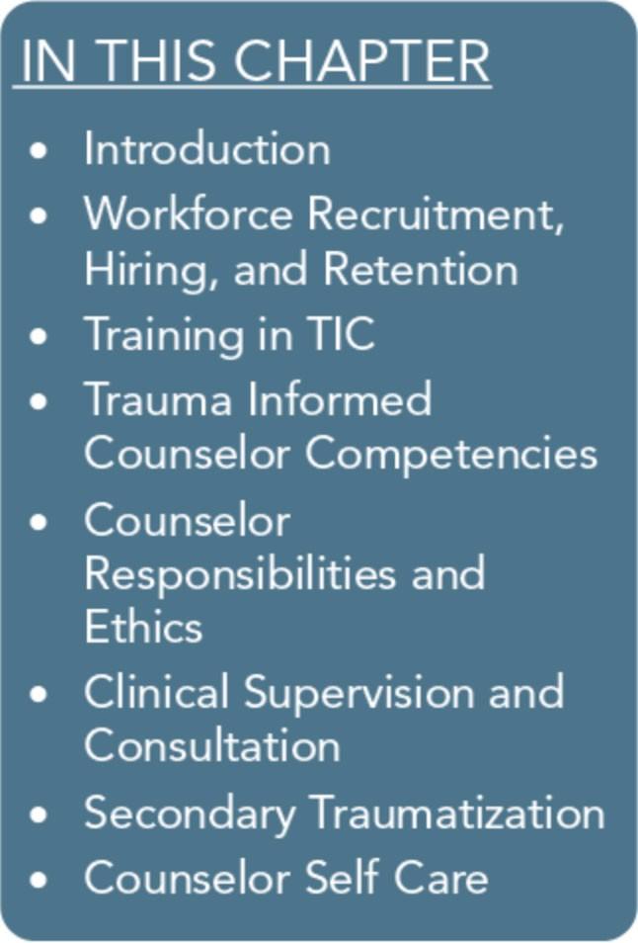
Introduction
For an organization to embrace a trauma-informed care (TIC) model fully, it must adopt a trauma-informed organizational mis­ sion and commit resources to support it. This entails implementing an agency-wide strategy for workforce development that is in alignment with the values and principles of TIC and the organiza­ tion's mission statement. Without a fully trained staff, an organiza­ tion will not be able to implement the TIC model. However, simply training behavioral health professionals in TIC is not enough. Counselors will not be able to sustain the kind of focus required to adopt and implement a trauma-informed philosophy and services without the ongoing support of administrators and clinical supervisors.
An organizational environment of care for the health, well-being, and safety of, as well as respect for, its staff will enhance the ability of counselors to provide the best possible trauma-informed behav­ ioral health services to clients. This culture of care must permeate the organization from top to bottom. Behavioral health program administrators should aim to strengthen their workforce; doing so "requires creating environments that support the health and well­ being, not only of persons with mental and substance use condi­ tions, but of the workforce as well" (Hoge, 2007, p. 58). An organi­ zational culture of care, safety, and respect demands activities that foster the development of trauma-informed counselors. This chap­ ter focuses on key workforce development activities, such as:
  - Recruiting, hiring, and retaining trauma-informed staff.
  - Training behavioral health service providers on the principles of, and evidence-based and emerging best practices relevant to, TIC.
  - Developing and promoting a set of counselor competencies spe­ cific to TIC.

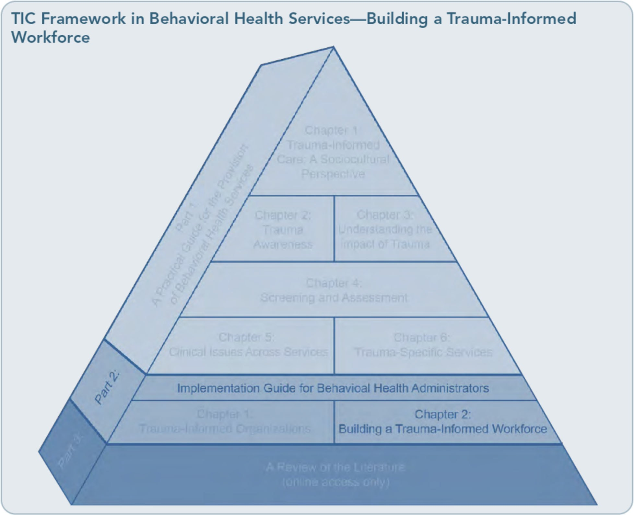

- Delineating the responsibilities of counse­ lors and addressing ethical considerations specifically relevant to promoting TIC.
- Providing trauma-informed clinical super­
vis10n.
- Committing to prevention and treatment of secondary trauma of behavioral health professionals within the organization.
Addressing each of these areas is essential to building a trauma-informed workforce and an organizational culture that supports TIC.

Workforce Recruitment, Hiring, and Retention
An Action Plan for Behavioral Health Workforce Development (Hoge et al., 2007) emphasizes
the importance of organization-wide support and active involvement in workforce recruit­ ment, hiring, and retention in behavioral health systems. One of the key findings of this report is that the work environment itself in many behavioral health settings can be toxic to the workforce and may hinder the delivery of individualized, respectful, collaborative, and client-centered care to service recipients. Fac­ tors such as the downward pressure on organi­ zations for higher productivity of counselors increase caseloads and decrease wages of be­ havioral health staff members and may create a high-stress environment that contributes to low morale and worker dissatisfaction. Other factors that often contribute to low retention of qualified counselors in behavioral health settings include the lack of professional career

ladders, fragile job security, the lack of clinical supervision, and an inability to influence the organization in which they are working (Hoge et al., 2007).
Added to this mix is the intensity of working with people with the co-occurring conditions of trauma-related mental and substance use disorders and the risk of secondary traumati­ zation of counselors. In creating and sustain­ ing a trauma-informed workforce, organizations need to foster a work environ­ ment that parallels the treatment philosophy of a trauma-informed system of care. Doing so allows counselors to count on a work envi­ ronment that values safety, endorses collabora­ tion in the making of decisions at all levels, and promotes counselor well-being.

Recruitment and Hiring in a Trauma-Informed System of Care In a 2007 technical report (Jennings, 20076), the National Center for Trauma-Informed Care identified several priorities for organiza­ tions with regard to recruitment and hiring trauma-informed staff, including:
- Active recruitment of and outreach to pro­ spective employees who are trauma­ informed or have formal education in providing trauma-informed or trauma­ specific services in settings such as universi­ ties, professional organizations, professional training and conference sites, peer support groups, and consumer advocacy groups.
- Hiring counselors and peer support staff members with educational backgrounds and training in trauma-informed and/or trauma-specific services and/or lived expe­ rience of trauma and recovery.
- Providing incentives, bonuses, and promo­ tions for staff members during recruitment and hiring that take into consideration prospective employees' trauma-related ed­ ucation, training, and job responsibilities.

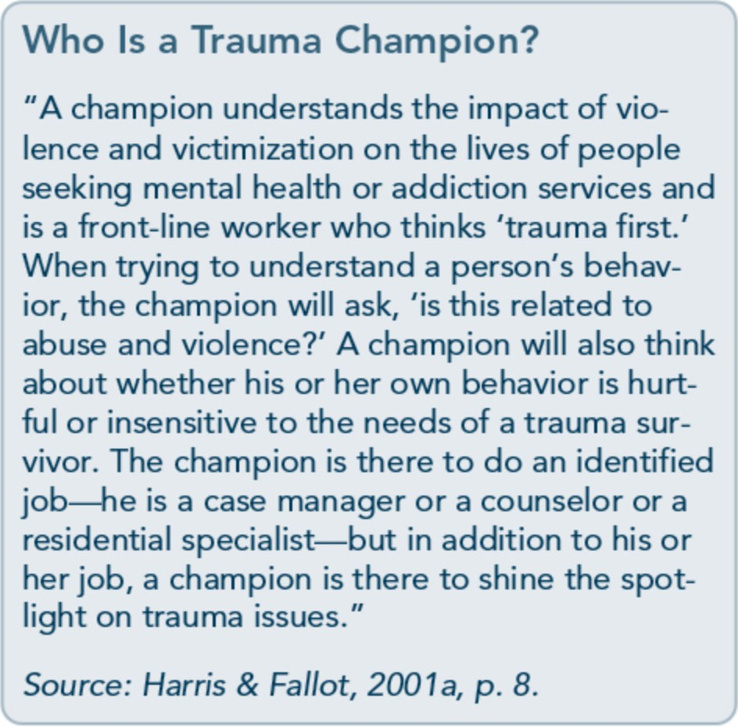
In addition to hiring behavioral health profes­ sionals with formal professional education and training, organizations should also "routinely survey the demographics and other character­ istics of the population served and recruit a workforce of similar composition" (Hoge et al., 2007, p. 297). Essentially, this means ac­ tively engaging in outreach to consumer advo­ cacy groups, recovery-oriented programs, community and faith-based organizations, and former clients/consumers with the intention of recruiting potential employees whose knowledge and expertise comes from their lived experience of trauma, resilience, and recovery. Support staff members, peer support workers, counselors in training, and appren­ tices can be recruited from this population and offered incentives, such as tuition reimburse­ ment, training stipends, and professional mentoring with the goal of developing a trau­ ma-informed workforce from within the de­ mographic served. Jennings (20076) calls these staff members "trauma champions" who can provide needed expertise in a trauma­ informed organization to promote trauma­ informed policies, staff development, and trauma-based services consistent with the mis­ sion of the organization (p. 135).

As with hiring behavioral health professionals who are in recovery from substance use disor­ ders, the organization should be transparent and explicit in its recruitment and hiring prac­ tices of trauma survivors in recovery. The or­ ganization can be transparent by advertising the mission statement of the organization as part of the recruitment process and inviting applicants who are in recovery from trauma to apply. The needs of behavioral health staff members who are in recovery from both sub­ stance use and trauma-related conditions and working in a trauma-informed system of care should be addressed in the organization's on­ going training, clinical supervision, and staff development policies and practices.

Workforce Retention
Staff turnover is rampant in behavioral health settings. It is costly to the organization, and as a result, it is costly to clients. A strong thera­ peutic relationship with a counselor is one of the largest factors in an individual's ability to recover from the overwhelming effects of trauma. When behavioral health professionals leave an organization prematurely or in crisis

as a result of chronic levels of high stress or secondary traumatization, clients must deal with disruptions in their relationships with counselors. Some of the organizational factors that contribute to chronic levels of high stress and often lead to high staff turnover include expecting counselors to maintain high case­ loads of clients who have experienced trauma; not providing trauma-informed clinical super­ vision and training to counselors; and failing to provide adequate vacation, health insur­ ance, and other reasonable benefits that sup­ port counselors' well-being. Other factors that may have a more profound impact on staff retention include failing to acknowledge the reality of secondary traumatization, promoting the view that counselors' stress reactions are a personal failure instead of a normal response to engaging with clients' traumatic material, and not supporting personal psychotherapy for counselors (Saakvitne, Pearlman, & Traumat­ ic Stress Institute/Center for Adult & Adoles­ cent Psychotherapy, 1996).
Research on promoting counselor retention in behavioral health settings demonstrates that

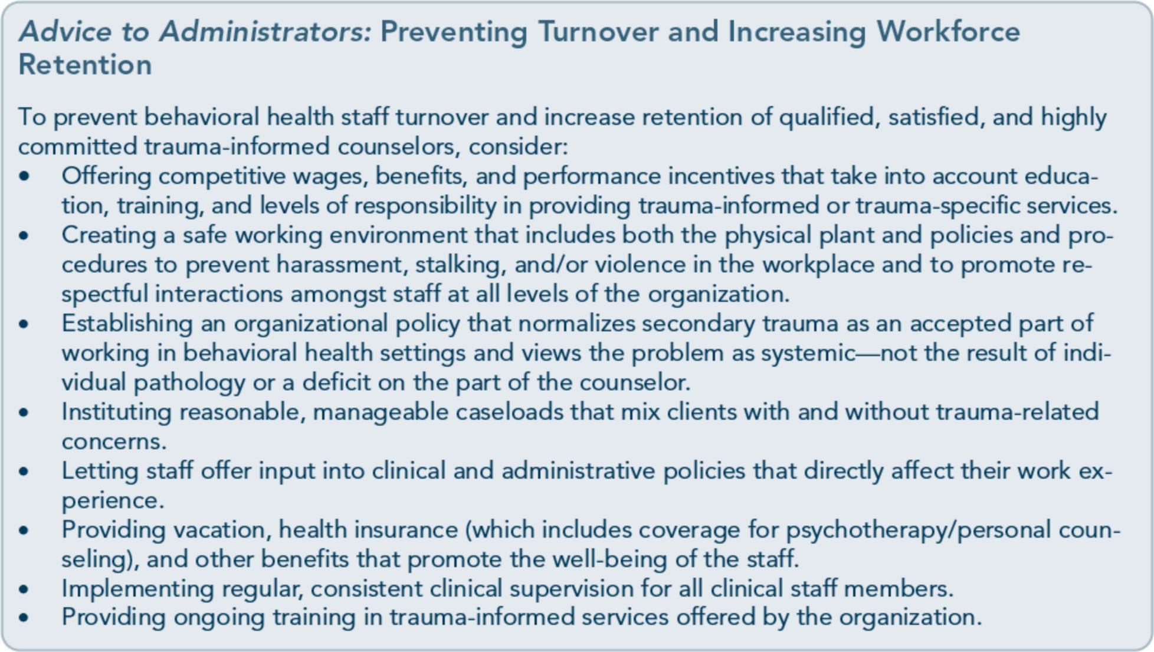

behavioral health staff members are interested in the same kind of work environment and benefits as employees in many other fields.
They include a "living wage with healthcare benefits; opportunities to grow and advance; clarity in a job role; some autonomy and input into decisions; manageable workloads; admin­ istrative support without crushing administra­ tive burden; basic orientation and training for assigned responsibilities; a decent and safe physical work environment; a competent and cohesive team of coworkers; the support of a supervisor; and rewards for exceptional per­ formance" (Hoge et al., 2007, p. 18).
When an organization's administration values its staff by providing competitive salaries and benefits, a safe working environment, area­ sonable and manageable workload, input into the making of clinical and administrative poli­ cy decisions, and performance incentives, it helps behavioral health workers feel connected to the mission of the organization and become dedicated to its sustainability and growth.
This type of work environment demonstrates both a level of respect for counselors (similar to the level of respect a trauma-informed or­ ganization displays toward clients) and an appreciation for the complexity of their job responsibilities and the stress they face when working with people who have experienced trauma in their lives. To retain behavioral health professionals working in a trauma­ informed setting, wages and performance in­ centives should be tied not only to education, training, and work experience, but also to lev­ els of responsibility in working with clients who have experienced trauma.

Training in TIC
Training for all staff members is essential in creating a trauma-informed organization. It may seem that training should simply focus on new counselors or on enhancing the skill level

of those who have no prior experience in working with trauma, but training should, in fact, be more systematic across the organiza­ tion to develop fully sustainable trauma­ informed services. All employees, including administrative staff members, should receive an orientation and basic education about the prevalence of trauma and its impact on the organization's clients. To ensure safety and reduction of harm, training should cover dy­ namics of retraumatization and how practice can mimic original sexual and physical abuse experiences, trigger trauma responses, and cause further harm to the person. Training for all employees must also educate them "about the impacts of culture, race, ethnicity, gender, age, sexual orientation, disability, and socio­ economic status on individuals' experiences of trauma" Gennings, 2007a, p. 5).
All clinical and direct service staff members, regardless of level of experience, should receive more indepth training in screening and as­ sessment of substance use and trauma-related disorders; the relationships among trauma, substance use disorders, and mental disorders; how to understand difficult client behaviors through a trauma-informed lens; how to avoid retraumatizing clients in a clinical setting; the development of personal and professional boundaries unique to clinical work with trau­ matized clients; how to identify the signs of secondary traumatization in themselves; and how to develop a comprehensive personal and professional self-care plan to prevent and/or ameliorate the effects of secondary traumati­ zation in the workplace. All clinical staff members who work with traumatized clients should receive additional training in evidence­ based and promising practices for the treat­ ment of trauma (for information on locating training, see Appendix B.) This might include training done within the agency by experts in the field or training received by attending ad­ vanced trauma trainings. Administrators

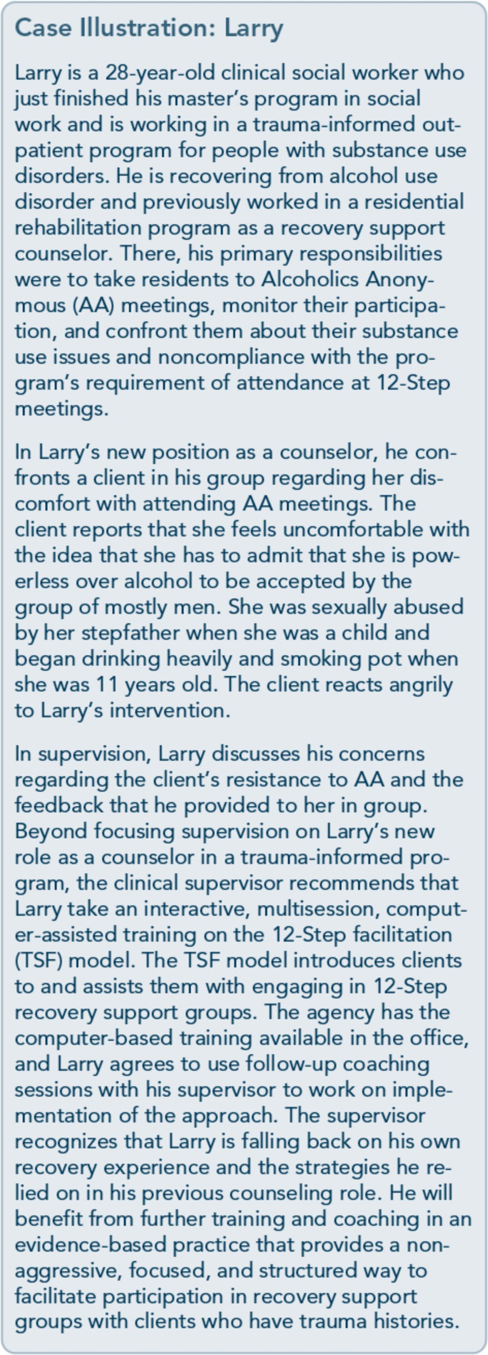

should provide the time and financial re­ sources to clinical staff members for this pro­ fessional development activity.Jennings (2007a) suggests that, whenever possible, "trainings should be multi-system, inclusive of staff in mental health and substance abuse, health care, educational, criminal justice, social services systems and agencies, and promoting systems integration and coordination'' (p. 5).
Moreover, criminal justice settings, schools, military/veteran programs, and other places in which behavioral health services are provided may benefit from approaches that are sensitive to the special circumstances and cultures of these environments. For example, in exploring trauma-informed correctional care, Miller and Najavits (2012, p. 1) observe:
Prisons are challenging settings for trauma­ informed care. Prisons are designed to house perpetrators, not victims. Inmates arrive shack­ led and are crammed into overcrowded hous­ ing units; lights are on all night, loud speakers blare without warning and privacy is severely limited. Security staff is focused on maintain­ ing order and must assume each inmate is po­ tentially violent. The correctional environment is full of unavoidable triggers, such as pat downs and strip searches, frequent discipline from authority figures, and restricted move­ ment....This is likely to increase trauma­ related behaviors and symptoms that can be difficult for prison staff to manage....Yet, if trauma-informed principles are introduced, all staff can play a major role in minimizing trig­ gers, stabilizing offenders, reducing critical in­ cidents, deescalating situations, and avoiding restraint, seclusion or other measures that may repeat aspects of past abuse.

The Need for Training
Behavioral health service providers working with clients who have mental, substance use, and trauma-related disorders need to have the best knowledge, skills, and abilities. Substance abuse counselors, in particular, require addition­ al training and skill development to be able to extend trauma-informed services (within the

limits of their professional licensure and scope of practice) to clients who have co-occurring substance use, trauma-related, or mental disor­ ders. Many clinical practice issues in traditional substance abuse treatment are inconsistent with trauma-informed practice, which needs to be addressed with further training. Similarly, men­ tal health clinicians often need training in substance abuse treatment, as they typically do

not have backgrounds or experience in that domain. Moreover, several surveys indicate that clinicians consistently perceive the com­ bination of trauma and substance abuse as harder to treat than either one alone (Najavits, Norman, Kivlahan, & Kosten, 2010). It is thus key to emphasize cross-training as part of TIC. Exhibit 2.2-1 addresses these issues and offers suggestions for additional training.

Exhibit 2.2-1: Clinical Practice Issues Relevant to Counselor Training in Trauma­ Informed Treatment Settings
  - Some substance abuse counseling strategies commonly used to work through clients' denial and minimization of their substance use issues may be inappropriate when working with trauma sur­ vivors (e.g., highly confrontational models can remind trauma survivors of emotional abuse).
Training: The Stages of Change model of addiction treatment can help counselors shift from the traditional confrontation of denial to conceptualizing clients' ambivalence about changing substance use patterns as a normal part of the precontemplation stage of change. This method is a respectful cognitive-behavioral approach that helps counselors match counseling strategies to their assessment of where each client is in each stage of change, with the ultimate goal of
helping clients make changes to health risk behaviors. (Connors, Donovan, & DiClemente, 2001 ).
  - The 12-Step concept of powerlessness (Step 1) may seem unhelpful to trauma survivors for whom the emotional reaction to powerlessness is a major part of their trauma (particularly for victims of repetitive trauma, such as child abuse or intimate partner violence). It can be confus- ing and counterproductive to dwell on this concept of powerlessness regarding trauma when the therapeutic objective for trauma-informed counseling methods should be to help clients empower themselves. For people in recovery, powerlessness is a paradox, sometimes misunder­ stood by both counselors and clients, in that the acknowledgment of powerlessness often cre- ates a sense of empowerment. Most clients, with support and respectful guidance from a counselor, will come to understand that powerlessness (as used in 12-Step programs) is not an
inability to stand up for oneself or express a need, and it does not mean for one to be powerless in the face of abuse. With this understanding, clients may become more open to participating in
12-Step groups as a resource for their recovery from substance use disorders. When clients con- 1
tinue to struggle with this concept and decline to participate in 12-Step recovery efforts, they
may benefit from referral to other forms of mutual-help programs or recovery support groups in which the concept of powerlessness over the substance of abuse is not such a significant issue.
Training: The TSF model can help counselors develop a more supportive and understanding approach to facilitating clients' involvement in 12-Step recovery groups (if this is a client­ generated recovery goal). "Although based on standard counseling models, TSF differs from them in several ways. These differences include TSF's strong emphasis on therapist support, dis­ couragement of aggressive 'confrontation of denial' and therapist self-disclosure, and highly fo­ cused and structured format" (Sholomskas & Carroll, 2006, p. 939).
Another well-intentioned, but often misguided, approach by counselors who have not had for­ mal or extensive training is "digging" for trauma memories without a clear therapeutic rationale or understanding of client readiness. In doing so, the counselor may unintentionally retraumatize the client or produce other harmful effects. In early intervention, it is sufficient simply to acknowledge and validate the pain and suffering of the client without uncovering or exploring specific trauma memories. The counselor who is insufficiently trained in trauma-informed clinical
(Continued on the next page.)

Trauma-Informed Care in Behavioral Health Services
l

Exhibit 2.2-1: Clinical Practice Issues Relevant to Counselor Training in Traum Informed Treatment Settings {continued)
a-
practice may also press agendas that are ultimately unhelpful, such as insisting that the client forgive an abuser, pursue a legal case against a perpetrator, or engage in trauma treatment, even when the client may not be ready for such steps. These efforts are particularly inappropriate for clients in early recovery from substance use disorders. The first goal in treatment is stabilization
Training: The Seeking Safety model of treating substance abuse and posttraumatic stress disor­ der (PTSD) can help counselors focus on the primary goal of stabilization and safety in TIC. This model emphasizes safety as the target goal, humanistic themes such as honesty and compassion, and making cognitive-behavioral therapy accessible and interesting to clients who may otherwise be difficult to engage (Najavits, 2002a).
  - Treatment should be client-centered; it should acknowledge the client's right to refuse counsel­ ing for trauma-related issues. It is important to discuss the advantages and disadvantages of ex­ ploring trauma-related concerns, and then, following an open discussion, to allow clients the right to choose their path. This discussion should be part of the informed consent process at the start of treatment. Clients also have the right to change their minds.
Training: Motivational interviewing, a client-centered, nonpathologizing counseling method, can aid clients in resolving ambivalence about and committing to changing health risk behaviors including substance use, eating disorders, self-injury, avoidant and aggressive behaviors associ­ ated with PTSD, suicidality, and medication compliance (Arkowitz, Miller, Westra, & Rollnick, 2008; Kress & Hoffman, 2008). Training in Ml can help counselors remain focused on the client's agenda for change, discuss the pros and cons of treatment options, and emphasize the personal choice and autonomy of clients.
j

In addition to the training needs of substance abuse counselors, all direct care workers in mental health settings, community-based pro­ grams, crisis intervention settings, and crimi­ nal justice environments should receive training in TIC. Guidelines for training in
assisting trauma-exposed populations are pre­ sented in Exhibit 2.2-2.

Continuing Education
Research on the effectiveness of single-session didactic and/or skill-building workshops

Exhibit 2.2-2: Guidelines for Training in Mental Health Interventions for Trauma­ Exposed Populations
After a year of collaboration in 2002, the Task Force on International Trauma Training of the International Society for Traumatic Stress Studies published a consensus-based set of recommen­ dations for training. Core curricular elements of the recommended training include:
- Competence in listening.
- Recognition of psychosocial and mental problems to promote appropriate assessment.
- Familiarity with established interventions in the client population.
- Full understanding of the local context, including help-seeking expectations, duration of treat­ ment, attitudes toward intervention, cost-effectiveness of intervention, and family attitudes and involvement.
- Strategies for solving problems on the individual, family, and community levels.
- Treatment approaches for medically unexplained somatic pain.
- Collaboration with existing local resources and change agents (e.g., clergy, traditional healers, informal leaders).
- Self-care components.
Source: Weine et al., 2002.

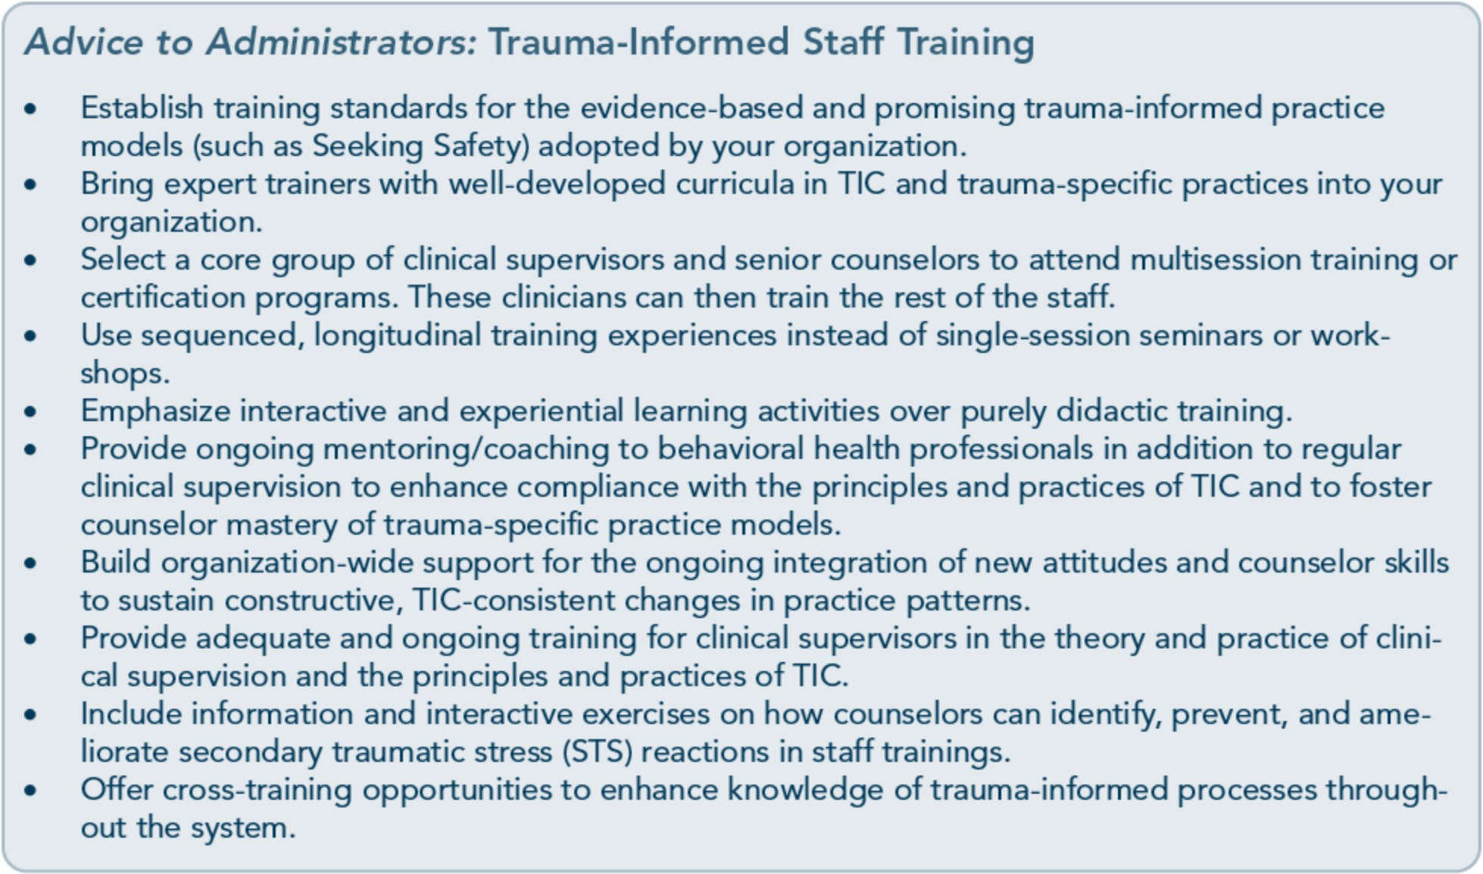

demonstrates that immediate gains in counse­ lor knowledge and skills diminish quickly after the training event (Martino, Canning-Ball, Carroll, & Rounsaville, 2011). Consequently, organizations may be spending their scarce financial resources on sending counselors to this kind of training but may not be reaping adequate returns with regard to long-lasting changes in counselor skills and the develop­ ment of trauma-informed and trauma-specific counselor competencies. Hoge et al. (2007) suggest the implementation of training strate­ gies for behavioral health professionals that have proven to be effective in improving coun­ selor skills, attitudes, and practice approaches. These strategies include: "interactive ap­ proaches; sequenced, longitudinal learning experiences; outreach visits, known as academ­ ic detailing; auditing of practice with feedback to the learner; reminders; the use of opinion leaders to influence practice; and patient­ mediated interventions, such as providing in­ formation on treatment options to persons in recovery, which in turn influences the practice patterns of their providers" (p. 124).

Trauma-Informed Counselor Competencies
Hoge et al. (2007) identified a number of counselor competencies in behavioral health practices that are consistent with the skills needed to be effective in a trauma-informed system of care. They include person-centered planning, culturally competent care, development of therapeutic alliances, shared responsibility for decisions, collaboratively developed recovery plans, evidence-based practices, recovery- and resilience-oriented care, interdisciplinary- and team-based practice, and consumer/client advocacy. In addition, counselor competencies critical to the effective delivery of services to clients with trauma-related disorders include:
- Screening for and assessment of trauma history and trauma-related disorders, such as mood and anxiety disorders.
- Awareness of differences between trauma­ informed and trauma-specific services.

  - Understanding the bidirectional relation­ ships among substance use and mental dis­ orders and trauma.
  - Engagement in person-centered counseling.
  - Competence in delivering trauma-informed and trauma-specific evidence-based inter­ ventions that lessen the symptoms associat­ ed with trauma and improve quality oflife for clients.
  - Awareness of and commitment to counse­ lor self-care practices that prevent or lessen the impact of secondary traumatization on behavioral health workers.
Exhibit 2.2-3 provides a checklist of competen­ cies for counselors working in trauma-informed behavioral health settings. Administrators and clinical supervisors can use this checklist to assess behavioral health professionals' under­ standing of trauma awareness and counseling skills and determine the need for additional training and clinical supervision.

Counselor Responsibilities and Ethics
Treating all clients in an ethical manner is an expectation of all healthcare providers. It is of special importance when working with clients who have trauma-related disorders, as their trust in others may have been severely shaken. Counselors who work with traumatized indi­ viduals on a regular basis have special respon­ sibilities to their clients because of the nature of this work. Administrators and clinical su­ pervisors in trauma-informed organizations should develop policies that clearly define the counselors' job and should provide education about the role of counselors in the organiza­ tion and their responsibilities to clients.

General Principles Regarding Counselor Responsibilities
The following are some general principles governing the responsibilities of counselors

who provide behavioral health services for clients with histories of trauma:
- Counselors are responsible for routinely
screening clients for traumatic experiences
and trauma-related symptoms (Ouimette & Brown, 2003; see also Treatment Im­ provement Protocol [TIP] 42, Substance Abuse Treatment far Persons With Co­ Occurring Disorders, Center for Substance Abuse Treatment [CSAT], 2005c).
- Counselors should offer clients with sub­
stance use and trauma-related disorders
continuing mental health services if it is within their professional license and scope of practice to do so.
- Counselors are responsible for referring clients with substance use disorders and co­ occurring trauma-related disorders to treatment that addresses both disorders when the treatment falls outside of the counselor's professional license and scope of practice (Ouimette & Brown, 2003).
- Counselors should refer clients with sub­ stance use disorders and co-occurring trauma-related disorders to concurrent par­ ticipation in mutual-help groups if appro­ priate (Ouimette & Brown, 2003).
- Counselors have a responsibility to practice the principles of confidentiality in all inter­ actions with clients and to respect clients' wishes not to give up their right to privi­ leged communication.
- Counselors are responsible for educating clients about the limits of confidentiality and what happens to protected health in­ formation, along with the client's privilege, when the client signs a release of infor­ mation or agrees to assign insurance bene­ fits to the provider.
- Counselors must inform clients that treat­ ment for trauma-related disorders is always voluntary.
- Counselors are responsible for being aware of their own secondary trauma and

Exhibit 2.2-3: Trauma-Informed Counselor Competencies Checklist
Trauma Awareness
_ Understands the difference between trauma-informed and trauma-specific services
_ Understands the differences among various kinds of abuse and trauma, including: physical, emo­ tional, and sexual abuse; domestic violence; experiences of war for both combat veterans and survivors of war; natural disasters; and community violence
_ Understands the different effects that various kinds of trauma have on human development and the development of psychological and substance use issues
_ Understands how protective factors, such as strong emotional connections to safe and non­ judgmental people and individual resilience, can prevent and ameliorate the negative impact trauma has on both human development and the development of psychological and substance use issues
_ Understands the importance of ensuring the physical and emotional safety of clients
_ Understands the importance of not engaging in behaviors, such as confrontation of substance use or other seemingly unhealthy client behaviors, that might activate trauma symptoms or acute stress reactions
_ Demonstrates knowledge of how trauma affects diverse people throughout their lifespans and with different mental health problems, cognitive and physical disabilities, and substance use is­ sues
_ Demonstrates knowledge of the impact of trauma on diverse cultures with regard to the mean­ ings various cultures attach to trauma and the attitudes they have regarding behavioral health treatment
_ Demonstrates knowledge of the variety of ways clients express stress reactions both behaviorally (e.g., avoidance, aggression, passivity) and psychologically/emotionally (e.g., hyperarousal, avoidance, intrusive memories)
Counseling Skills
_ Expedites client-directed choice and demonstrates a willingness to work within a mutually em­ powering (as opposed to a hierarchical) power structure in the therapeutic relationship
_ Maintains clarity of roles and boundaries in the therapeutic relationship
_ Demonstrates competence in screening and assessment of trauma history (within the bounds of his or her licensing and scope of practice), including knowledge of and practice with specific screening tools
_ Shows competence in screening and assessment of substance use disorders (within the bounds of his or her licensing and scope of practice), including knowledge of and practice with specific screening tools
_ Demonstrates an ability to identify clients' strengths, coping resources, and resilience
_ Facilitates collaborative treatment and recovery planning with an emphasis on personal choice and a focus on clients' goals and knowledge of what has previously worked for them
_ Respects clients' ways of managing stress reactions while supporting and facilitating taking risks to acquire different coping skills that are consistent with clients' values and preferred identity and way of being in the world
_ Demonstrates knowledge and skill in general trauma-informed counseling strategies, including, but not limited to, grounding techniques that manage dissociative experiences, cognitive­ behavioral tools that focus on both anxiety reduction and distress tolerance, and stress man­ agement and relaxation tools that reduce hyperarousal
(Continued on the next page.)

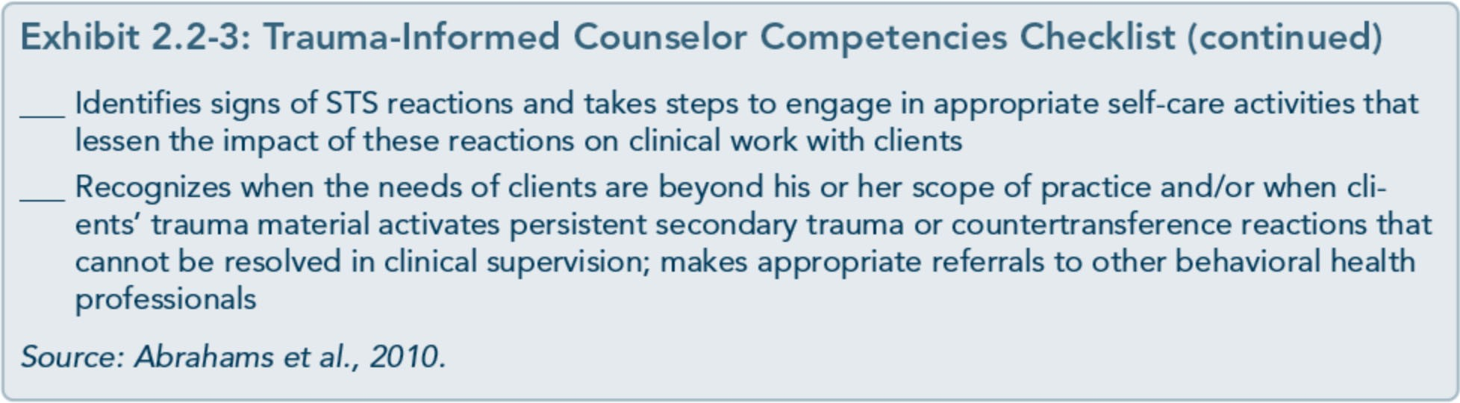

countertransference reactions and seeking appropriate help in responding to these re­ actions so that they do not interfere with the best possible treatment for clients.
TIC organizations have responsibilities to clients in their care, including:
  - Protecting client confidentiality, particularly in relation to clients' trauma histories. Or­ ganizations should comply with the State and Federal laws that protect the confiden­ tiality of clients being treated for mental and substance use disorders.
  - Providing clients with an easy-to-read statement of their rights as consumers of mental health and substance abuse services, including the right to confidentiality (Ex­ hibit 2.2-4).
  - Providing quality clinical supervision to all counselors and direct-service workers, with an emphasis on TIC. Organizations should, at minimum, comply with State licensing requirements for the provision of clinical supervision to behavioral health workers.
  - Establishing and maintaining appropriate guidelines and boundaries for client and counselor behavior in the program setting.
  - Creating and maintaining a trauma­ informed treatment environment that respects the clients' right to self­ determination and need to be treated with dignity and respect.
- Maintaining a work environment that rein- forces and supports counselor self-care.
All behavioral health professionals are respon­ sible for abiding by professional standards of care that protect the client. Breaches of confi­ dentiality, inappropriate conduct, and other violations of trust can do further harm to cli­ ents who already have histories of trauma.
Many treatment facilities have a Client Bill of Rights (or a similar document) that describes the rights and responsibilities of both the counselors and the participants; it often is part of the orientation and informed consent pro­ cess when a client enters treatment. However, simply reading and acknowledging the receipt of a piece of paper is not a substitute for the dialog that needs to happen in a collaborative therapeutic partnership. Administrators are responsible for providing clients with easy-to­ read information describing counselor respon­ sibilities and client rights. Clinical supervisors are responsible for helping counselors engage in a respectful dialog with clients about those rights and responsibilities as part of a compre­ hensive informed consent process.
Exhibit 2.2-4 is an excerpt from a Client Bill of Rights that outlines clients' right to confi­ dentiality in plain language that is readable and easily understood.

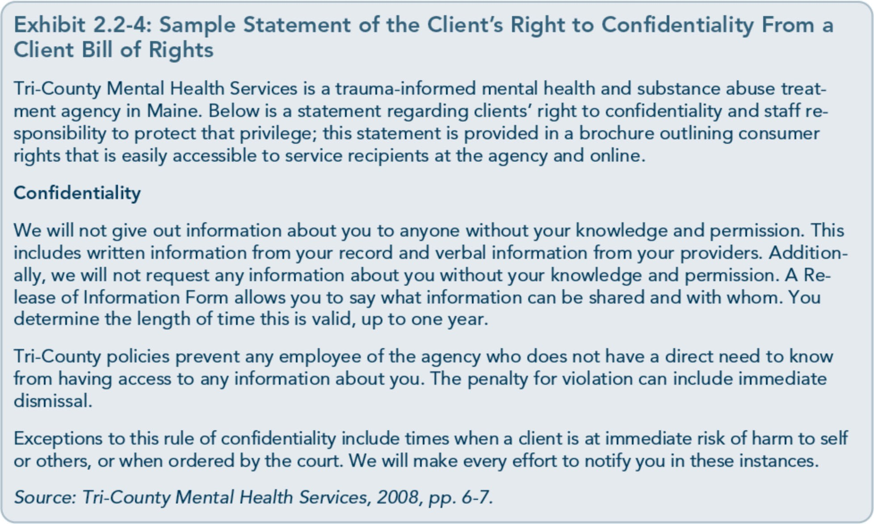

Ethics in Treating Traumatized Clients
All behavioral health professionals must con­ form to the ethical guidelines established by their profession's State licensing boards and/or certifying organizations. State licensing boards for substance abuse counseling, psychiatry, social work, psychology, professional counsel­ ing, and other behavioral health professions provide regulatory standards for ethical prac­ tice in these professions. These boards also have specific procedures for responding to complaints regarding the actions of profes­ sional caregivers. Additionally, national profes­ sional societies have standards for ethical practices. Members of these organizatio s are expected to practice within the boundaries and scope of these standards. Some of these stand­ ards are quite explicit, whereas others are more general; most approach professional ethics not as a rigid set of rules, but rather, as a process of making ethical decisions.
Clinical supervisors are responsible for in­ forming counselors of their ethical responsi­ bilities with regard to their own organization's policies and procedures, monitoring supervi­ sees' reading and understanding the codes of ethics of professional organizations and State licensing boards, and promoting counselor understanding of ethics and how to make de­ cisions ethically as a regular part of clinical supervision, team meetings, and couns lor training. Administrators can support high ethical standards by creating an organization­ wide ethics task group consisting of counse­ lors, supervisors, and administrators who meet regularly to review and revise clinical policies in line with State and Federal law and profes­ sional codes of ethics. Administrators may also act as a support mechanism for counselors who need additional consultation regarding potential ethical dilemmas with clients. The Green Cross Academy ofTraumatology pro­ vides ethical guidelines for the treatment of clients who have experienced trauma; these guidelines are adapted in Exhibit 2.2-5.

Exhibit 2.2-5: Green Cross Academy of Traumatology Ethical Guidelines for the Treatment of Clients Who Have Been Traumatized
Respect for the dignity of clients
  - Recognize and value the personal, social, spiritual, and cultural diversity present in society, with­ out judgment. As a primary ethical commitment, make every effort to provide interventions with respect for the dignity of those served.
Responsible caring
  - Take the utmost care to ensure that interventions do no harm.
  - Have a commitment to the care of those served until the need for care ends or the responsibility for care is accepted by another qualified service provider.
  - Support colleagues in their work and respond promptly to their requests for help.
  - Recognize that service to survivors of trauma can exact a toll in stress on providers. Maintain vigilance for signs in self and colleagues of such stress effects, and accept that dedication to the service of others imposes an obligation to sufficient self-care to prevent impaired functioning.
  - Engage in continuing education in the appropriate areas of trauma response. Remain current in the field and ensure that interventions meet current standards of care.
Integrity in relationships
  - Clearly and accurately represent your training, competence, and credentials. Limit your practice to methods and problems for which you are appropriately trained and qualified. Readily refer to or consult with colleagues who have appropriate expertise; support requests for such referrals or consultations from clients.
  - Maintain a commitment to confidentiality, ensuring that the rights of confidentiality and privacy are maintained for all clients.
  - Do not provide professional services to people with whom you already have either emotional ties or extraneous relationships of responsibility. The one exception is in the event of an emer­ gency in which no other qualified person is available.
  - Refrain from entering other relationships with present or former clients, especially sexual rela­ tionships or relationships that normally entail accountability.
  - Within agencies, ensure that confidentiality is consistent with organizational policies; explicitly inform individuals of the legal limits of confidentiality.
Responsibility to society
  - Be committed to responding to the needs generated by traumatic events, not only at the indi­ vidual level, but also at the level of community and community organizations in ways that are consistent with your qualifications, training, and competence.
  - Recognize that professions exist by virtue of societal charters in expectation of their functioning as socially valuable resources. Seek to educate government agencies and consumer groups about your expertise, services, and standards; support efforts by these agencies and groups to ensure social benefit and consumer protection.
  - If you become aware of activities of colleagues that may indicate ethical violations or impairment of functioning, seek first to resolve the matter through direct expression of concern and offers of help to those colleagues. Failing a satisfactory resolution in this manner, bring the matter to the attention of the officers of professional societies and of governments with jurisdiction over pro­ fessional misconduct.
Clients' universal rights
All clients have the right to:
  - Not be judged for any behaviors they used to cope, either at the time of the trauma or after the trauma.
  - Be treated at all times with respect, dignity, and concern for their well-being.
  - Refuse treatment, unless failure to receive treatment places them at risk of harm to self or others.
(Continued on the next page.)

Exhibit 2.2-5: Academy of Traumatology Ethical Guidelines for the Treatment of Clients Who Have Been Traumatized (continued)
  - Be regarded as collaborators in their own treatment plans.
  - Provide their informed consent before receiving any treatment.
  - Not be discriminated against based on race, culture, sex, religion, sexual orientation, socioeco­ nomic status, disability, or age.
  - Have promises kept, particularly regarding issues related to the treatment contract, role of coun- selor, and program rules and expectations.
Procedures for introducing clients to treatment
Obtain informed consent, providing clients with information on what they can expect while receiving professional services. In addition to general information provided to all new clients, clients present­ ing for treatment who have histories of trauma should also receive information on:
  - The possible short-term and long-term effects of trauma treatment on the client and the client's relationships with others.
  - The amount of distress typically experienced with any particular trauma treatment.
  - Possible negative effects of a particular trauma treatment.
  - The possibility of lapses and relapses when doing trauma work, and the fact that these are a normal and expected part of healing.
Reaching counseling goals through consensus
Collaborate with clients in the design of a clearly defined contract that articulates a specific goal in a specific time period or a contract that allows for a more open-ended process with periodic evalua­ tions of progress and goals.
Informing clients about the healing process
  - Clearly explain to clients the nature of the healing process, making sure clients understand.
  - Encourage clients to ask questions about any and all aspects of treatment and the therapeutic relationship. Provide clients with answers in a manner they can understand.
  - Encourage clients to inform you if the material discussed becomes overwhelming or intolerable.
  - Inform clients of the necessity of contacting you or emergency services if they feel suicidal or homicidal, are at risk of self-injury, or have a sense of being out of touch with reality.
  - Give clients written contact information about available crisis or emergency services.
  - Inform clients about what constitutes growth and recovery and about the fact that some trauma symptoms may not be fully treatable.
  - Address unrealistic expectations clients may have about counseling and/or the recovery process.
Level of functioning
  - Inform clients that they may not be able to function at the highest level of their ability-or even at their usual level-when working with traumatic material.
  - Prepare clients to experience trauma-related symptoms, such as intrusive memories, dissociative reactions, reexperiencing, avoidance behaviors, hypervigilance, or unusual emotional reactivity.
Source: Green Cross Academy of Traumatology, 2007. Adapted with permission.

Boundaries in therapeutic relationships
Maintaining appropriate therapeutic bounda­ ries is a primary ethical concern for behavioral health professionals. Counselors working with clients who have substance use, trauma­ related, and other mental disorders may feel challenged at times to maintain boundaries
that create a safe therapeutic container. Some clients, especially those with longstanding disorders, bring a history of client-counselor relationships to counseling. Clients who have been traumatized may need help understand­ ing the roles and responsibilities of both the counselor and the client. Clients with trauma­ related conditions may also have special needs

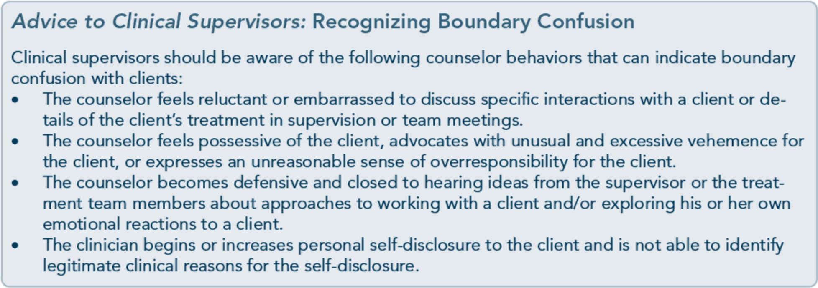

in establishing appropriate boundaries in the counseling setting; they may be particularly vulnerable and not understand or appreciate the need for professional boundaries, includ­ ing not engaging in dual relationships. For example, some clients might experience a counselor's boundary around not giving the client his or her personal phone number for emergency calls as a rejection or abandon­ ment. Cultural considerations also influence therapeutic boundaries.
Administrators, in collaboration with clinical supervisors, are responsible for creating poli­ cies regarding counselor and client boundaries for various issues (e.g., giving and receiving gifts, counselor personal disclosure, and coun­ selor roles and responsibilities when attending the same 12-Step meetings as clients); policies should be specific to their organization and conform to State and Federal law and behav­ ioral health professional codes of ethics. Clini­ cal supervisors are responsible for training counselors in the informed consent process and effective ways to discuss boundaries with clients when they enter treatment.
Guidelines for establishing and maintaining boundaries in therapeutic relationships, adapted from the Green Cross Academy of Traumatology, are given in Exhibit 2.2-6.
Clients with trauma histories may be especial­ ly vulnerable to counselor behaviors that are
inconsistent or that are experienced by the client as boundary violations. Examples of such behavior include: being late for appoint­ ments, ending counseling sessions early, re­ peatedly and excessively extending the session time, canceling or "forgetting" appointments multiple times, spending time in the session talking about their own needs and life experi­ ences, exploring opportunities for contact out­ side the therapeutic relationship (including making arrangements to meet at AA or other 12-Step recovery group meetings), and enforc­ ing rules differently for one client than for another.
Due to the complex dynamics that can arise in the treatment of clients with trauma histories, regularly scheduled clinical supervision, where issues of ethics and boundaries can be dis­ cussed, is recommended for counselors. For more information on how clinical supervision can be effectively used, see TIP 52, Clinical Supervision and the Professional Development of the Substance Abuse Counselor (CSAT, 20096).

Boundary crossing and boundary violation
Although guidelines and codes of ethics are useful tools in helping clinical supervisors and counselors understand the boundaries between counselors and clients, they are open to inter­ pretation and are context-bound. Given these limitations, it is crucial to educate counselors

Exhibit 2.2-6: Boundaries in Therapeutic Relationships
Procedures for Establishing Safety
Roles and boundaries
Counselor roles and boundaries should be established at the start of the counseling relationship and reinforced periodically, particularly at times when the client is experiencing high stress.
Ongoing Relationships and the Issue of Boundaries
Dual relationships
Dual relationships and inappropriate interactions with clients are to be avoided. It is important to tell clients at the beginning of counseling that contact between the counselor and the client can only occur within the boundaries of the professional relationship. This information is part of the informed consent process. Relationships outside these boundaries include sexual or romantic relationships, a counselor also serving as a client's sponsor in 12-Step programs, and any kind of relationship in which the counselor exploits the client for financial gain.
Sexual contact
  - Never engage in any form of sexual contact with clients.
  - Do not reward sexualized behaviors with attention or reactivity.
  - Directly clarify the boundaries of the therapeutic relationship, and address the underlying moti­ vations of persisting sexualized behavior.
  - Set limits on a client's inappropriate behaviors while maintaining an ethos of care. Maintain re­ spect for the dignity and worth of the client at all times.
  - Understand that a client's attempt to sexualize a therapeutic relationship may reflect an early history of abuse, difficulty understanding social norms, or a variety of psychological problems.
  - Readdress the absolute inappropriateness of sexual and/or romantic behavior in a nonlecturing, nonpunitive manner.
  - If sexual behavior between clients occurs in a treatment program, counselors should consult with a clinical supervisor. Document the nature of the contact and how the issue is addressed.
  - If a counselor has sexual contact with a client, he or she should take responsibility by ceasing counseling practice, referring clients to other treatment providers, and notifying legal and pro­ fessional authorities. If a counselor is at risk for engaging with a client sexually but has not acted on it, the counselor should immediately consult with a supervisor, colleague, or psychotherapist.
Boundaries
Counselors should use care with self-disclosure or any behaviors that may be experienced as intru­ sive by the client, including:
  - Personal disclosures made for the counselor's own gratification.
  - Sexualized behavior with the client.
  - Excessively intrusive questions or statements.
  - Interrupting the client frequently.
  - Violating the client's personal space.
  - Interpersonal touch, which might activate intrusive memories or dissociative reactions or be ex­ perienced as a boundary violation by the client.
  - Being consistently late for appointments or allowing outside influences (such as telephone calls) to interrupt the client's time in a counseling session.
Source: Green Cross Academy of Traumatology, 2007. Adapted with permission.

in TIC settings regarding the boundary issues that may arise for clients who have been trau­ matized and to give counselors a conceptual
framework for understanding the contextual nature of boundaries. For example, it would be useful for clinical supervisors to discuss with

counselors the distinction between boundary crossings and boundary violations in clinical practice. Gutheil and Brodsky (2008) define boundary crossing as a departure from the customary norms of counseling practice in relation to psychological, physical, or social space "that are harmless, are nonexploitative, and may even support or advance the therapy" (p. 20). Examples of boundary crossings in­ clude taking phone calls from a client between sessions if the client is in crisis or telling a client a story about the counselor's recovery from trauma (without offering specific per­ sonal information or graphic/detailed descrip­ tion of the trauma) with the intention of offering hope that it is possible to recover.
Gutheil and Brodsky (2008) define boundary violations as boundary crossings that are un­ wanted and dangerous and which exploit the client, stating that "some boundary crossings are inadvisable because of their intent (i.e., they are not done in the service of the patient's well-being and growth, involve extra thera­ peutic gratification for the therapist) and/or their effect (i.e., they are not likely to benefit

the patient and entail a significant risk of harming the patient)" (pp. 20-21). An exam­ ple of a boundary violation would be when a counselor invites a client to attend the same AA meetings the counselor attends or shares drinking and drugging "war stories" for the counselor's own gratification. Two key ele­ ments in understanding when a boundary crossing becomes a boundary violation are the intent of the counselor and the damaging ef­ fect on the client. Maintaining a standard of practice of nonexploitation of the client is the primary focus for clinical supervisors and counselors in determining when boundary crossings become boundary violations.
Context is also an important consideration in determining the acceptability of boundary crossings. For example, it may be acceptable for a counselor in a partial hospitalization pro­ gram for serious mental illness to have a cup of coffee at the kitchen table with a resident, whereas for a counselor in an outpatient men­ tal health program, having a cup of coffee with a client at the local coffee shop would be a much more questionable boundary crossing.

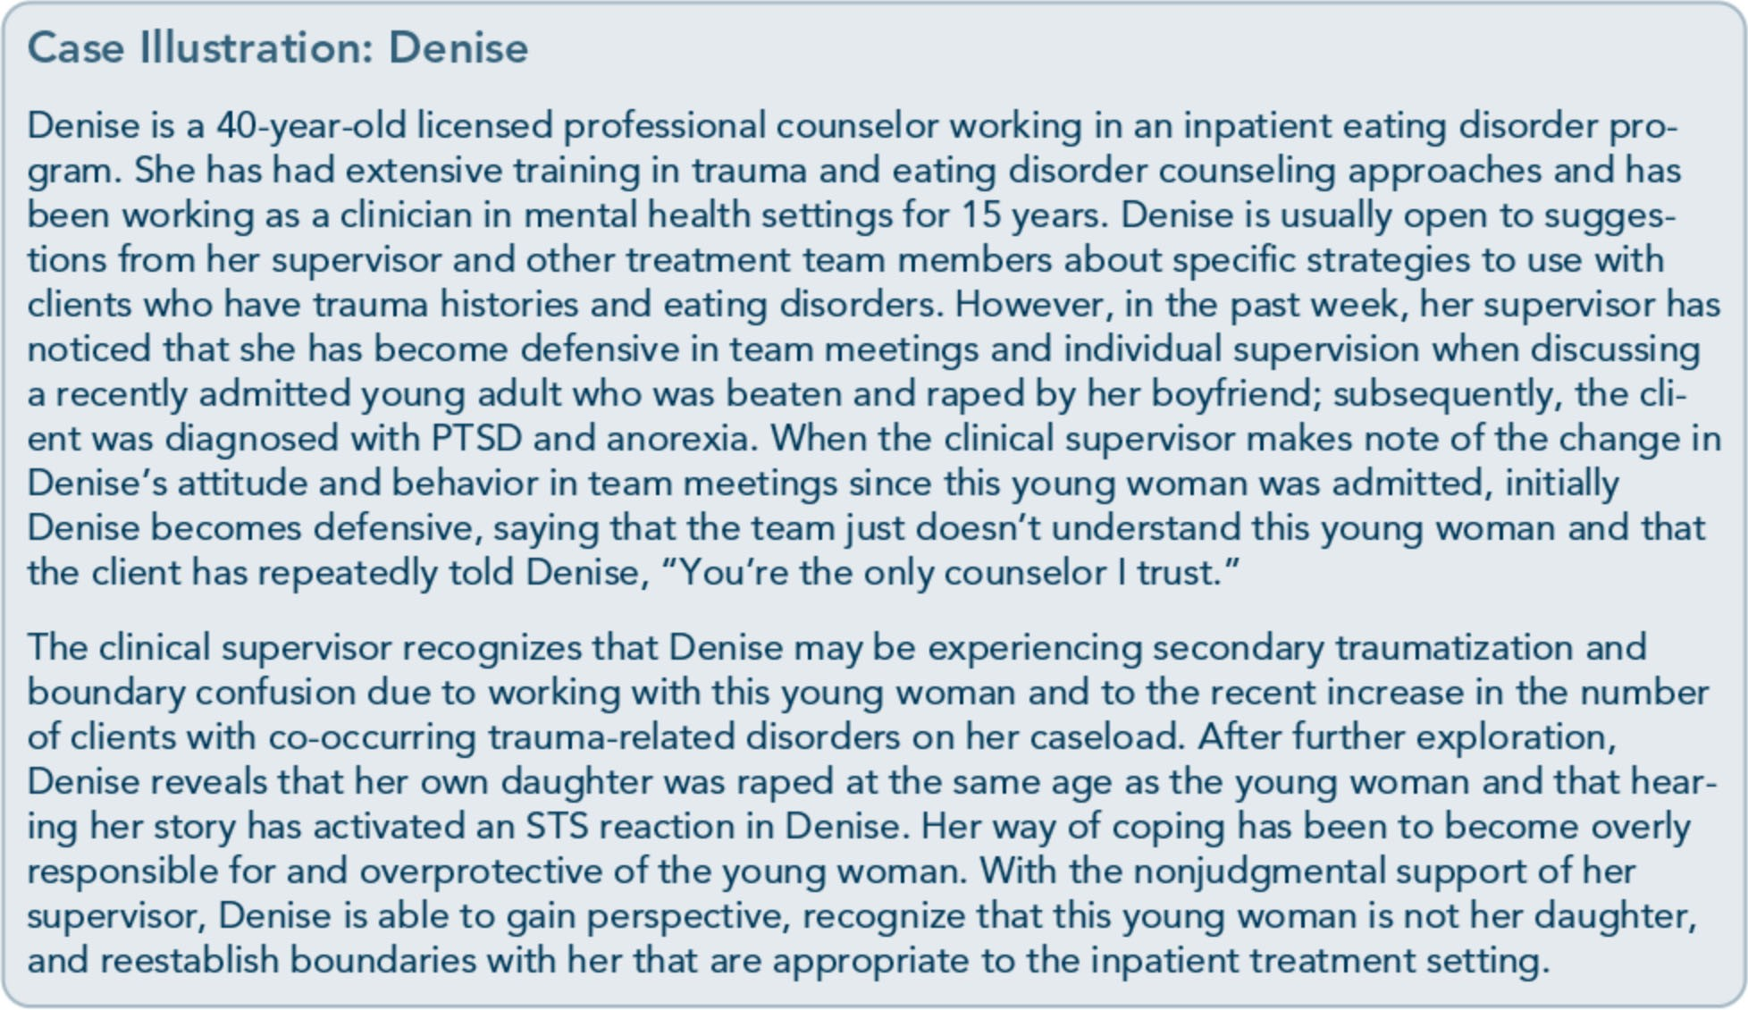

Clinical Supervision and Consultation
Organizational change toward a TIC model doesn't happen in isolation. Ongoing support, supervision, and consultation are key ingredi­ ents that reinforce behavioral health profes­ sionals' training in trauma-informed and trauma-specific counseling methods and en-

sure compliance with practice standards and consistency over time. Often, considerable energy and resources are spent on the transi­ tion to new clinical and programmatic ap­ proaches, but without long-range planning to support those changes over time. The new treatment approach fades quickly, making it hard to recognize and lessening its reliability.

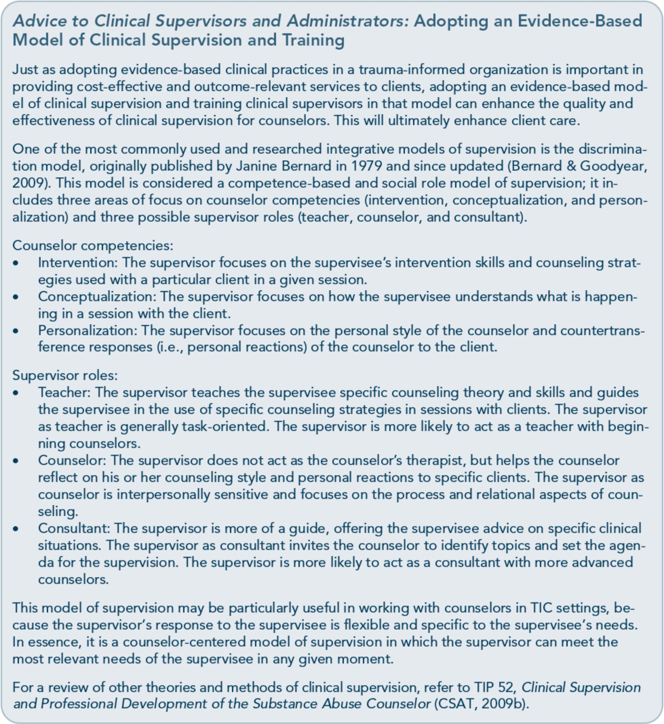

Ongoing supervision and consultation sup­ ports the organizational message that TIC is the standard of practice. It normalizes second­ ary traumatization as a systemic issue (not the individual pathology of the counselor) and reinforces the need for counselor self-care to prevent and lessen the impact of secondary traumatization. Qyality clinical supervision for direct care staff demonstrates the organiza­ tion's commitment to implementing a fully integrated, trauma-informed system of care.

Supervision and Consultation Historically, there was an administrative belief that counselors who had extensive clinical experience and training would naturally be the best clinical supervisors. However, research

does not support this idea (Falender & Shafranske, 2004). Although a competent clinical supervisor needs to have an extensive clinical background in the treatment of sub­ stance use, trauma-related, and other mental disorders, it is also essential for any counselor moving into a supervisory role to have exten­ sive training in the theory and practice of clin­ ical supervision before taking on this role. In particular, clinical supervisors in trauma­ informed behavioral health settings should be educated in how to perform clinical supervi­ sion (not just administrative supervision) of direct service staff and in the importance of providing continuous clinical supervision and support for staff members working with indi­ viduals affected by trauma. Clinical

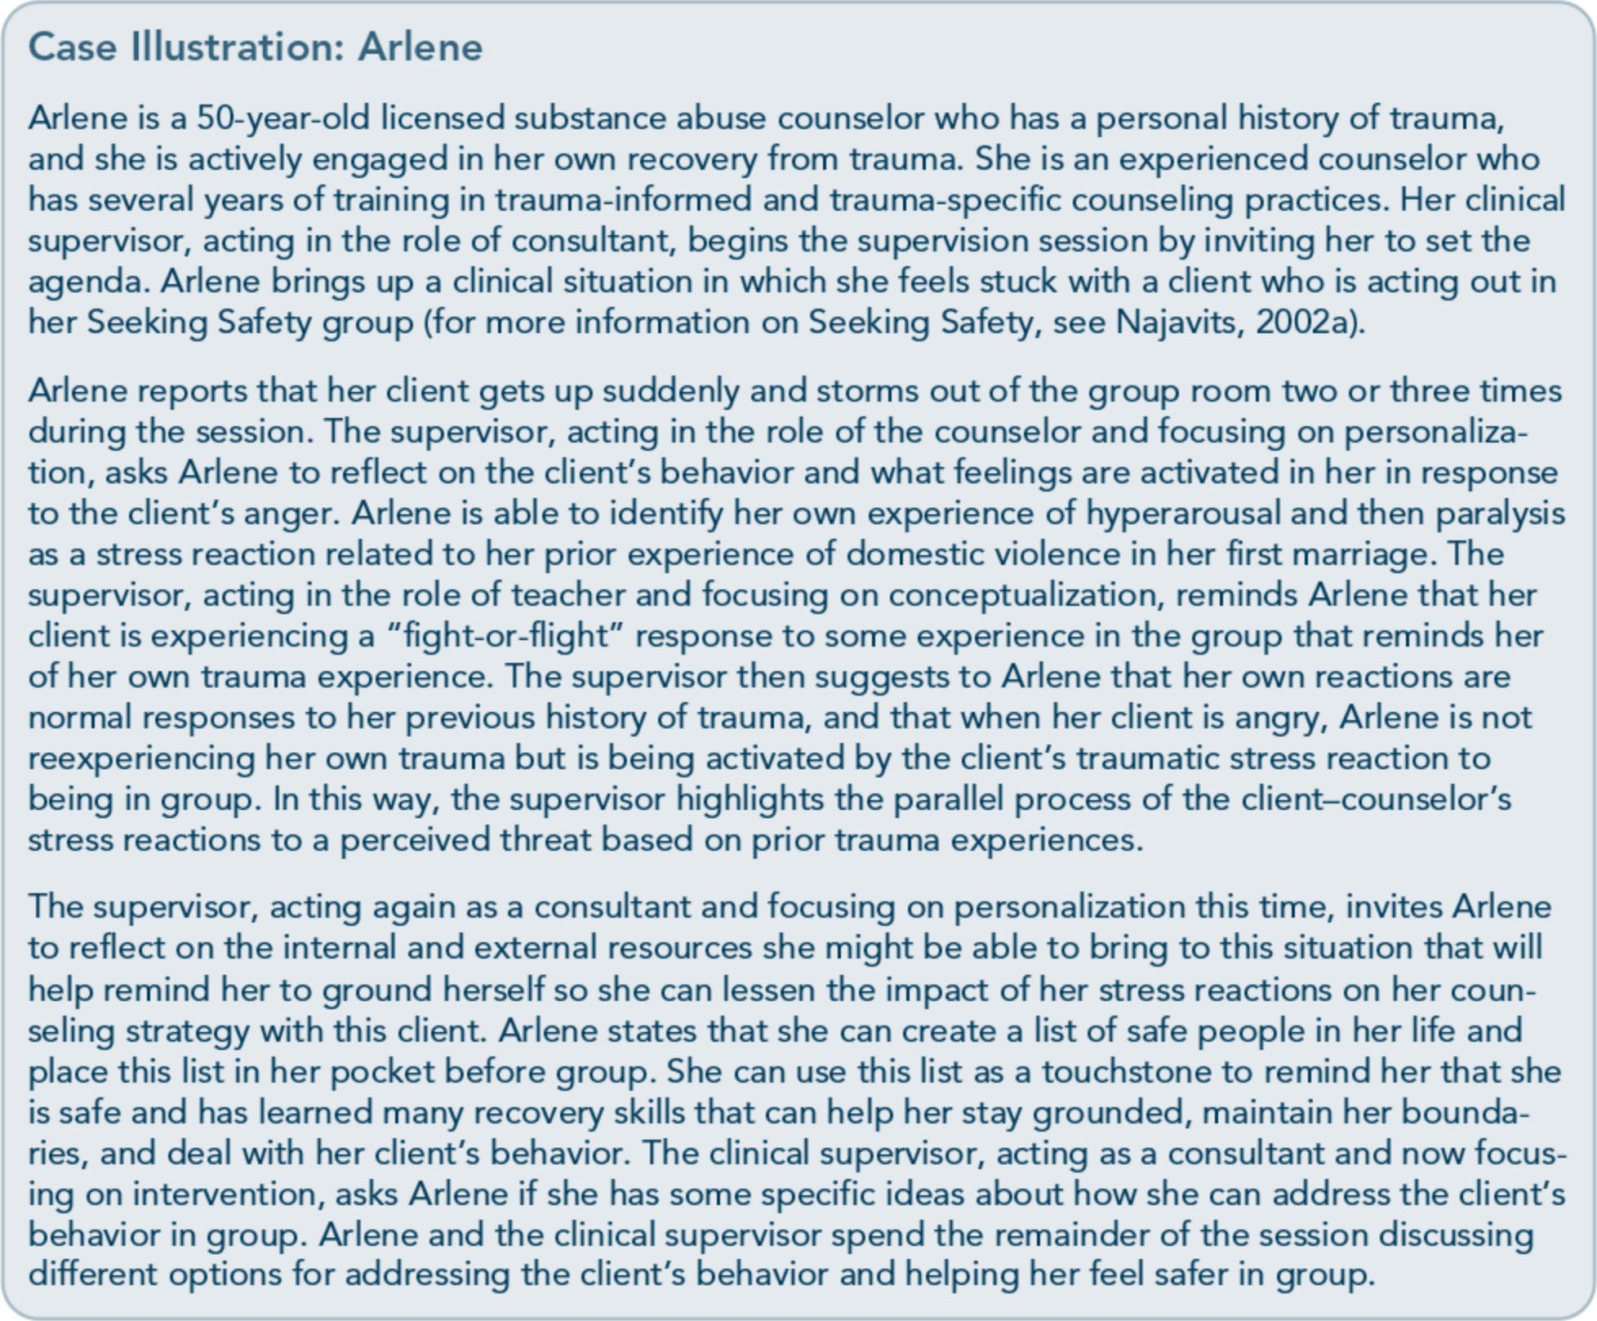

supervision in a TIC organization should fo­ cus on the following priorities:
- General case consultation
- Specialized consultation in specific and unusual cases
- Opportunities to process clients' traumatic material
- Boundaries in the therapeutic and supervi- sory relationship
- Assessment of secondary traumatization
- Counselor self-care and stress management
- Personal growth and professional devel- opment of the counselor
Supervision of counselors working with trau­ matized clients should be regularly scheduled, with identified goals and with a supervisor who is trained and experienced in working with trauma survivors. The styles and types of supervision and consultation may vary accord­ ing to the kind of trauma work and its context. For instance, trauma counseling in a major natural disaster would require a different ap­ proach to supervision and consultation than would counseling adults who experienced childhood developmental trauma or counsel­ ing clients in an intensive early recovery treatment program using a manualized
trauma-specific counseling protocol.
Competence-based clinical supervision is rec­ ommended for trauma-informed organiza­ tions. Competence-based clinical supervision models identify the knowledge and clinical skills each counselor needs to master, and they use targeted learning strategies and evaluation procedures, such as direct observation of coun­ selor sessions with clients, individualized coaching, and performance-based feedback.
Studies on competence-based supervision ap­ proaches have demonstrated that these models improve counselor treatment skills and profi­ ciency (Martino et al., 2011).
Whichever model of clinical supervision an organization adopts, the key to successful

trauma-informed clinical supervision is the recognition that interactions between the su­ pervisor and the counselor may parallel those between the counselor and the client. Clinical supervisors need to recognize counselors' trauma reactions (whether they are primary or secondary to the work with survivors of trau­ ma) and understand that a confrontational or punitive approach will be ineffective and likely retraumatize counselors.
Clinical supervisors should adopt a respectful and collaborative working relationship with counselors in which role expectations are clearly defined in an informed consent process similar to that used in the beginning of the counselor-client relationship and in which exploring the nature of boundaries in both client-counselor and counselor-supervisor relationships is standard practice. Clear role boundaries, performance expectations, open dialog, and supervisor transparency can go a long way toward creating a safe and respectful relationship container for the supervisor and supervisee and set the stage for a mutually enhancing, collaborative relationship. This respectful, collaborative supervisory relation­ ship is the main source of training and profes­ sional growth for the counselor and for the provision of quality care to people with behav­ ioral health disorders.

Secondary Traumatization
The demands of caregiving exact a price from behavioral health professionals that cannot be ignored; otherwise, they may become ineffec­ tive in their jobs or, worse, emotionally or psychologically impaired. In a study of Mas­ ter's level licensed social workers, 15.2 percent of respondents to a survey reported STS as a result of indirect exposure to trauma material at a level that meets the diagnostic criteria for PTSD. This rate is almost twice the rate of PTSD in the general population. The author

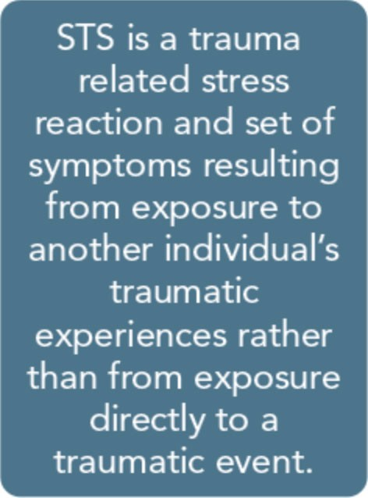
concluded that be­ havioral health pro­ fessionals' experience of STS is a contrib­ uting factor in staff turnover and one reason why many behavioral health service professionals leave the field (Bride, 2007). Sec-
ondary traumatization of behavioral health workers is a significant organizational issue for clinical supervisors and administrators in sub­ stance abuse and mental health treatment pro­ grams to address.
To prevent or lessen the impact of secondary traumatization on behavioral health profes­ sionals, clinical supervisors and administrators need to understand secondary trauma from the ecological perspective described in Part 1, Chapter 1 of this TIP. The organization itself creates a social context with risk factors that can increase the likelihood of counselors expe­ riencing STS reactions, but it also contains protective factors that can lessen the risk and impact of STS reactions on staff members.
Organizations can lessen the impact of the risk factors associated with working in trauma-informed organizations by mixing caseloads to contain clients both with and without trauma-related issues, supporting ongoing counselor training, providing regular clinical supervision, recognizing counselors' efforts, and offering an empowering work environment in which counselors share in the responsibility of making decisions and can offer input into clinical and program policies that affect their work lives.
When organizations support their counselors in their work with clients who are trauma­ tized, counselors can be more effective, more productive, and feel greater personal and pro-

fessional satisfaction. In addition, counselors develop a sense of allegiance toward the or­ ganization, thus decreasing staff turnover. If organizations do not provide this support, counselors can become demoralized and have fewer emotional and psychological resources to manage the impact of clients' traumatic
material and outward behavioral expressions of trauma on their own well-being. Providing counselors with the resources to help them build resilience and prevent feeling over­ whelmed should be a high priority for admin­ istrators and clinical supervisors in TIC organizations.

Risk and Protective Factors Associated With Secondary Traumatization
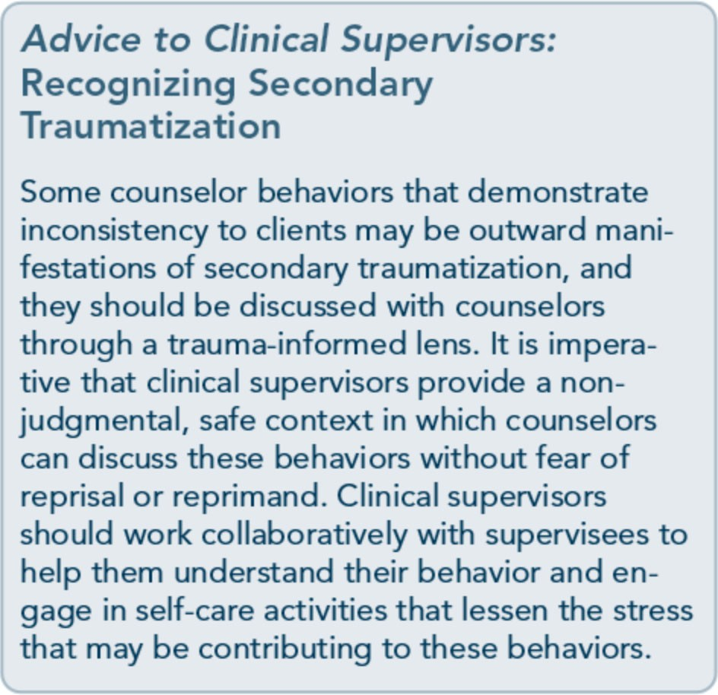
Clinical and research literature on trauma de­ scribes a number of factors related to the de­ velopment of secondary trauma reactions and psychological distress in behavioral health professionals across a wide range of practice settings, as well as individual and organiza­ tional factors that can prevent or lessen the impact of STS on staff. The risk and protec­ tive factors model of understanding secondary trauma is based on the ecological perspective

outlined in Part 1, Chapter 1 of this TIP. The terms "compassion fatigue," "vicarious trauma­ tization," "secondary traumatization," and "burnout" are used in the literature, sometimes interchangeably and sometimes as distinct constructs. As stated in the terminology por­ tion of the "How This TIP Is Organized" sec­ tion that precedes Part 1, Chapter 1, of this TIP, the term "secondary traumatization'' re­ fers to traumatic stress reactions and psycho­ logical distress from exposure to another individual's traumatic experiences; this term will be used throughout this section, although the studies cited may use other terms.

Risk factors
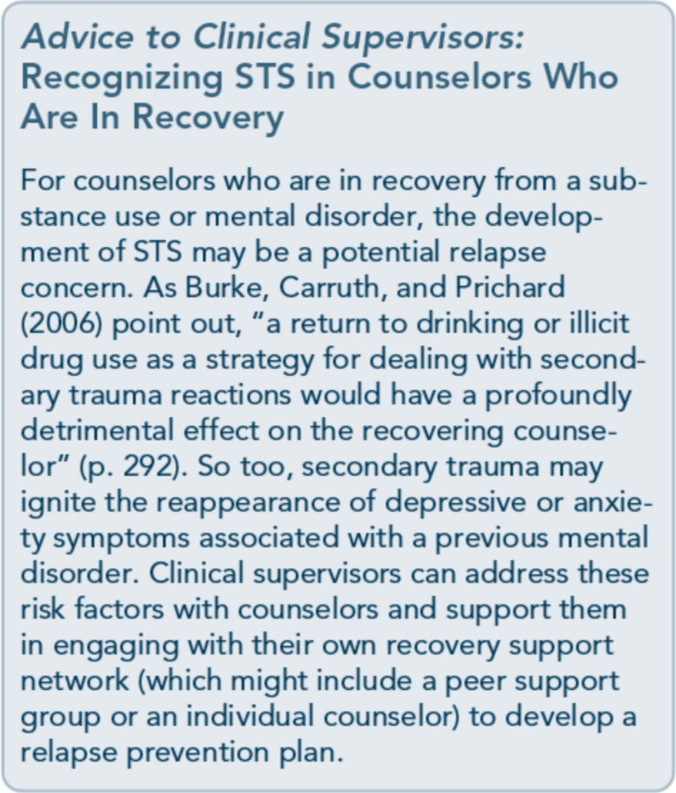
Individual risk factors that may contribute to the development of STS in behavioral health professionals include preexisting anxiety or mood disorders; a prior history of personal trauma; high caseloads of clients with trauma­ related disorders; being younger in age and new to the field with little clinical experience or training in treating trauma-related conditions; unhealthy coping styles, including distancing and detachment from clients and co-workers;

and a lack of tolerance for strong emotions (Newall & MacNeil, 2010). Other negative coping strategies include substance abuse, oth­ er addictive behaviors, a lack of recreational activities not related to work, and a lack of engagement with social support. A recent study of trauma nurses found that low use of support systems, use of substances, and a lack of hobbies were among the coping strategies that differed between nurses with and without STS (Von Rueden et al., 2010). Other re­ searchers found that clinicians who engaged in negative coping strategies, such as alcohol and illicit drug use, were more likely to experience intrusive trauma symptoms (Way, Van
Deusen, Martin, Applegate, & Janle, 2004).
Numerous organizational factors can contrib­ ute to the development of STS in counselors who work with clients with trauma-related disorders. These risk factors include organiza­ tional constraints, such as lack of resources for clients, lack of clinical supervision for counse­ lors, lack of support from colleagues, and lack of acknowledgment by the organizational cul­ ture that secondary traumatization exists and is a normal reaction of counselors to client trauma (Newall & MacNeil, 2010). In a study of 259 individuals providing mental health counseling services, counselors who spent more time in session with clients with trauma­ related disorders reported higher levels of traumatic stress symptoms (Bober & Regehr, 2006). Counselors may be more at risk for developing secondary traumatization if the organization does not allow for balancing the distribution of trauma and nontrauma cases amongst staff members.

Protective factors
Much of the clinical and research literature focuses on individual factors that may lessen the impact of STS on behavioral health pro­ fessionals, including male gender, being older, having more years of professional experience,

having specialized training in trauma­ informed and trauma-specific counseling practices, lacking a personal trauma history, exhibiting personal autonomy in the work­ place, using positive personal coping styles, and possessing resilience or the ability to find meaning in stressful life events and to rebound from adversity (Sprang, Clark, & Whitt­ Woosley, 2007). Some of these factors, like positive personal coping styles and the ability to find meaning in adversity, can be developed and enhanced through personal growth work, psychotherapy, engagement with spiritual practices and involvement in the spiritual community, and stress reduction strategies like mindfulness meditation. A recent multi­ method study of an 8-week workplace mind­ fulness training group for social workers and other social service workers found that mind­ fulness meditation increased coping strategies, reduced stress, and enhanced self-care of the participants; findings suggested that workers were more likely to practice stress manage­ ment techniques like mindfulness at their place of work than at home (McGarrigle & Walsh, 2011). Organizations can support counselors' individual efforts to enhance posi­ tive personal coping styles, find meaning in adversity, and reduce stress by providing time for workers during the workday for personal self-care activities, like mindfulness meditation and other stress reduction practices.
One of the organizational protective factors identified in the literature that may lessen the negative impact of secondary traumatization on behavioral health professionals is providing adequate training in trauma-specific counsel­ ing strategies, which increases providers' sense of efficacy in helping clients with trauma­ related disorders and reduces the sense of hopelessness that is often a part of the work (Bober & Regehr 2006). One study found that specialized trauma training enhanced job sat­ isfaction and reduced levels of compassion

fatigue, suggesting that "knowledge and train­ ing might provide some protection against the deleterious effects of trauma exposure" (Sprang et al., 2007, p. 272). Another protec­ tive factor that may lessen the chances of de­ veloping secondary traumatization is having a diverse caseload of clients. Organizations "must determine ways of distributing work­ load in order to limit the traumatic exposure of any one worker. This may not only serve to reduce the impact of immediate symptoms but may also address the potential longitudinal effects" (Bober & Regehr, 2006, p. 8).
Emotional support from professional col­ leagues can be a protective factor. A study of substance abuse counselors working with cli­ ents who were HIV positive found that work­ place support from colleagues and supervisors most effectively prevented burnout (Shoptaw, Stein, & Rawson, 2000). This support was associated with less emotional fatigue and depersonalization, along with a sense of great­ er personal accomplishment.In a study of do­ mestic violence advocates, workers who received more support from professional peers were less likely to experience secondary trau­ matization (Slattery & Goodman, 2009).
In addition, counselor engagement in relation­ ally based clinical supervision with a trauma­ informed supervisor acts as a protective agent. Slattery and Goodman (2009) note that "for the trauma worker, good supervision can nor­ malize the feelings and experiences, provide support and information about the nature and course of the traumatic reaction, help in the identification of transference and counter­ transference issues, and reveal feelings or symptoms associated with the trauma" (p.
1362). Workers who reported "engaging, au­ thentic, and empowering relationships with their supervisors" were less likely to experience STS (p. 1369). Thus, it is not simply the fre­ quency and regularity of clinical supervision,

but also the quality of the supervision and the quality of the supervisor-counselor relation­ ship that can lessen the impact of STS on behavioral health professionals.
Engagement with a personal practice of spirit­ uality that provides a sense of connection to a larger perspective and meaning in life is an­ other protective factor that can lessen the im­ pact of STS on counselors (Trippany, Kress, & Wilcoxon, 2004). Although recovering coun­ selors may look to support groups for connec­ tion to a spiritual community, other behavioral health professionals might find support for enhancing spiritual meaning and connection in church, a meditation group, creative en­ deavors, or even volunteer work. The key is for counselors to develop their own unique re­ sources and practices to enhance a sense of meaningful spirituality in their lives. Clinical supervisors should be aware of spiritual en­ gagement as a protective factor in preventing and lessening the impact of STS and should support clinicians in including it in their self­ care plans, but they should take care not to promote or reject any particular religious belief system or spiritual practice.
Another protective factor that may lessen the impact of workers' STS is a culture of empow­ erment in the organization that offers counse­ lors a sense of autonomy, a greater ability to participate in making decisions about clinical and organizational policies, and obtaining support and resources that further their pro­ fessional development. Slattery & Goodman (2009) surveyed 148 domestic violence advo­ cates working in a range of settings. The au­ thors found that those workers "who reported a high level of shared power were less likely to report posttraumatic stress symptoms, despite their own personal abuse history or degree of exposure to trauma" (p. 1370). To the degree that organizations can provide a cultural con­ text within which behavioral health profes-

sionals have autonomy and feel empowered, they will be able to lessen the impact of STS on their professional and personal lives. Self­ efficacy and empowerment are antidotes to the experience of powerlessness that often accom­ panies trauma.

Strategies for Preventing Secondary Traumatization
The key to prevention of secondary traumati­ zation for behavioral health professionals in a trauma-informed organization is to reduce risk and enhance protective factors. Organiza­ tional strategies to prevent secondary trauma­ tization include:
- Normalize STS throughout all levels of the organization as a way to help counselors feel safe and respected, enhancing the like­ lihood that they will talk openly about their experiences in team meetings, peer supervi­ sion, and clinical supervision.
- Implement clinical workload policies and practices that maintain reasonable stand­ ards for direct-care hours and emphasize balancing trauma-related and nontrauma­ related counselor caseloads.
- Increase the availability of opportunities for supportive professional relationships by promoting activities such as team meetings, peer supervision groups, staff retreats, and counselor training that focuses on under­ standing secondary traumatization and self­ care. Administrators and clinical supervi­ sors should provide time at work for coun­ selors to engage in these activities.
- Provide regular trauma-informed clinical supervision that is relationally based. Su­ pervisors should be experienced and trained in trauma-informed and trauma-specific practices and provide a competence-based model of clinical supervision that promotes counselors' professional and personal devel­ opment. Supervision limited to case consul­ tation or case management is insufficient to

reduce the risk for secondary traumatiza­ tion and promote counselor resilience.
  - Provide opportunities for behavioral health professionals to enhance their sense of au­ tonomy and feel empowered within the organization. Some of these activities in­ clude soliciting input from counselors on clinical and administrative policies that af­ fect their work lives, including how to best balance caseloads of clients with and with­ out histories of trauma; inviting represent­ atives of the counseling staff to attend selected agency board of directors and/or management team meetings to offer input on workforce development; and inviting counselors to participate in organizational task forces that develop trauma-informed services, plan staff retreats, or create mech­ anisms to discuss self-care in team meet­ ings. Administrators and clinical supervisors should assess the organization's unique culture and develop avenues for counselor participation in activities that will enhance their sense of empowerment and efficacy within the organization.

Exhibit 2.2-7 highlights some specific strate­ gies that individual counselors can engage in to prevent secondary traumatization.

Assessment of Secondary Traumatization
Counselors with unacknowledged STS can harm clients, self, and family and friends by becoming unable to focus on and attend to their needs or those of others. They may feel helpless or cynical and withdraw from support systems. Exhibit 2.2-8 describes some emo­ tional, cognitive, and behavioral signs that may indicate that a counselor is experiencing secondary traumatization. Clinical supervisors should be familiar with the manifestations of STS in their counselors and should address signs of STS immediately.
Stamm (2009-2012) has developed and re­ vised a self-assessment tool, the Professional Qiality of Life Scale (ProQOL), that measures indicators of counselor compassion fatigue and compassion satisfaction. Compas­ sion fatigue "is best defined as a syndrome consisting of a combination of the symptoms

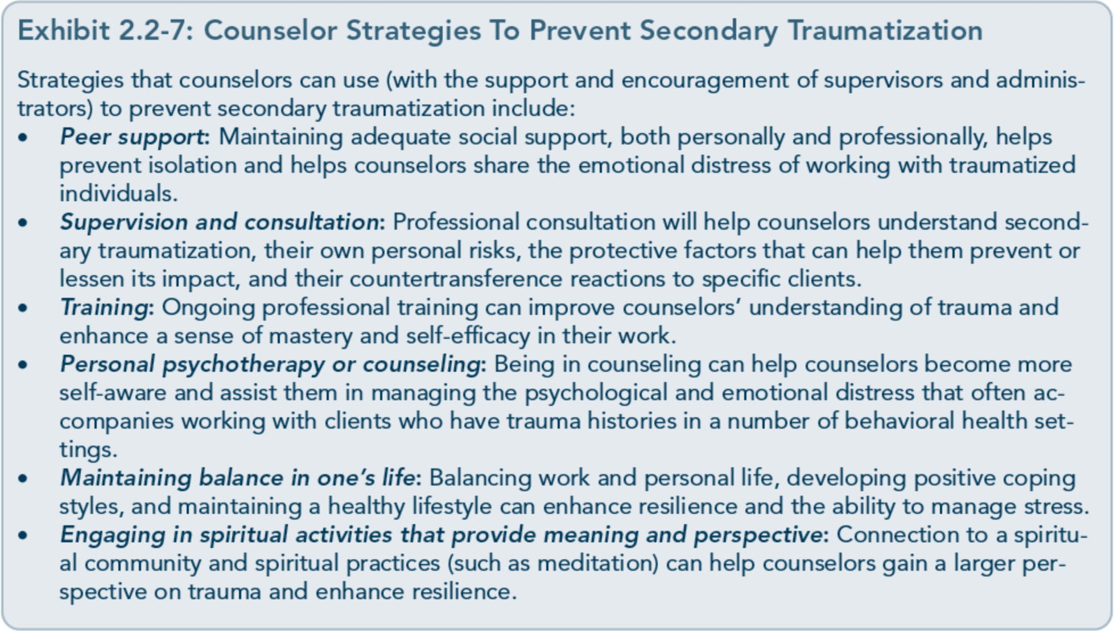

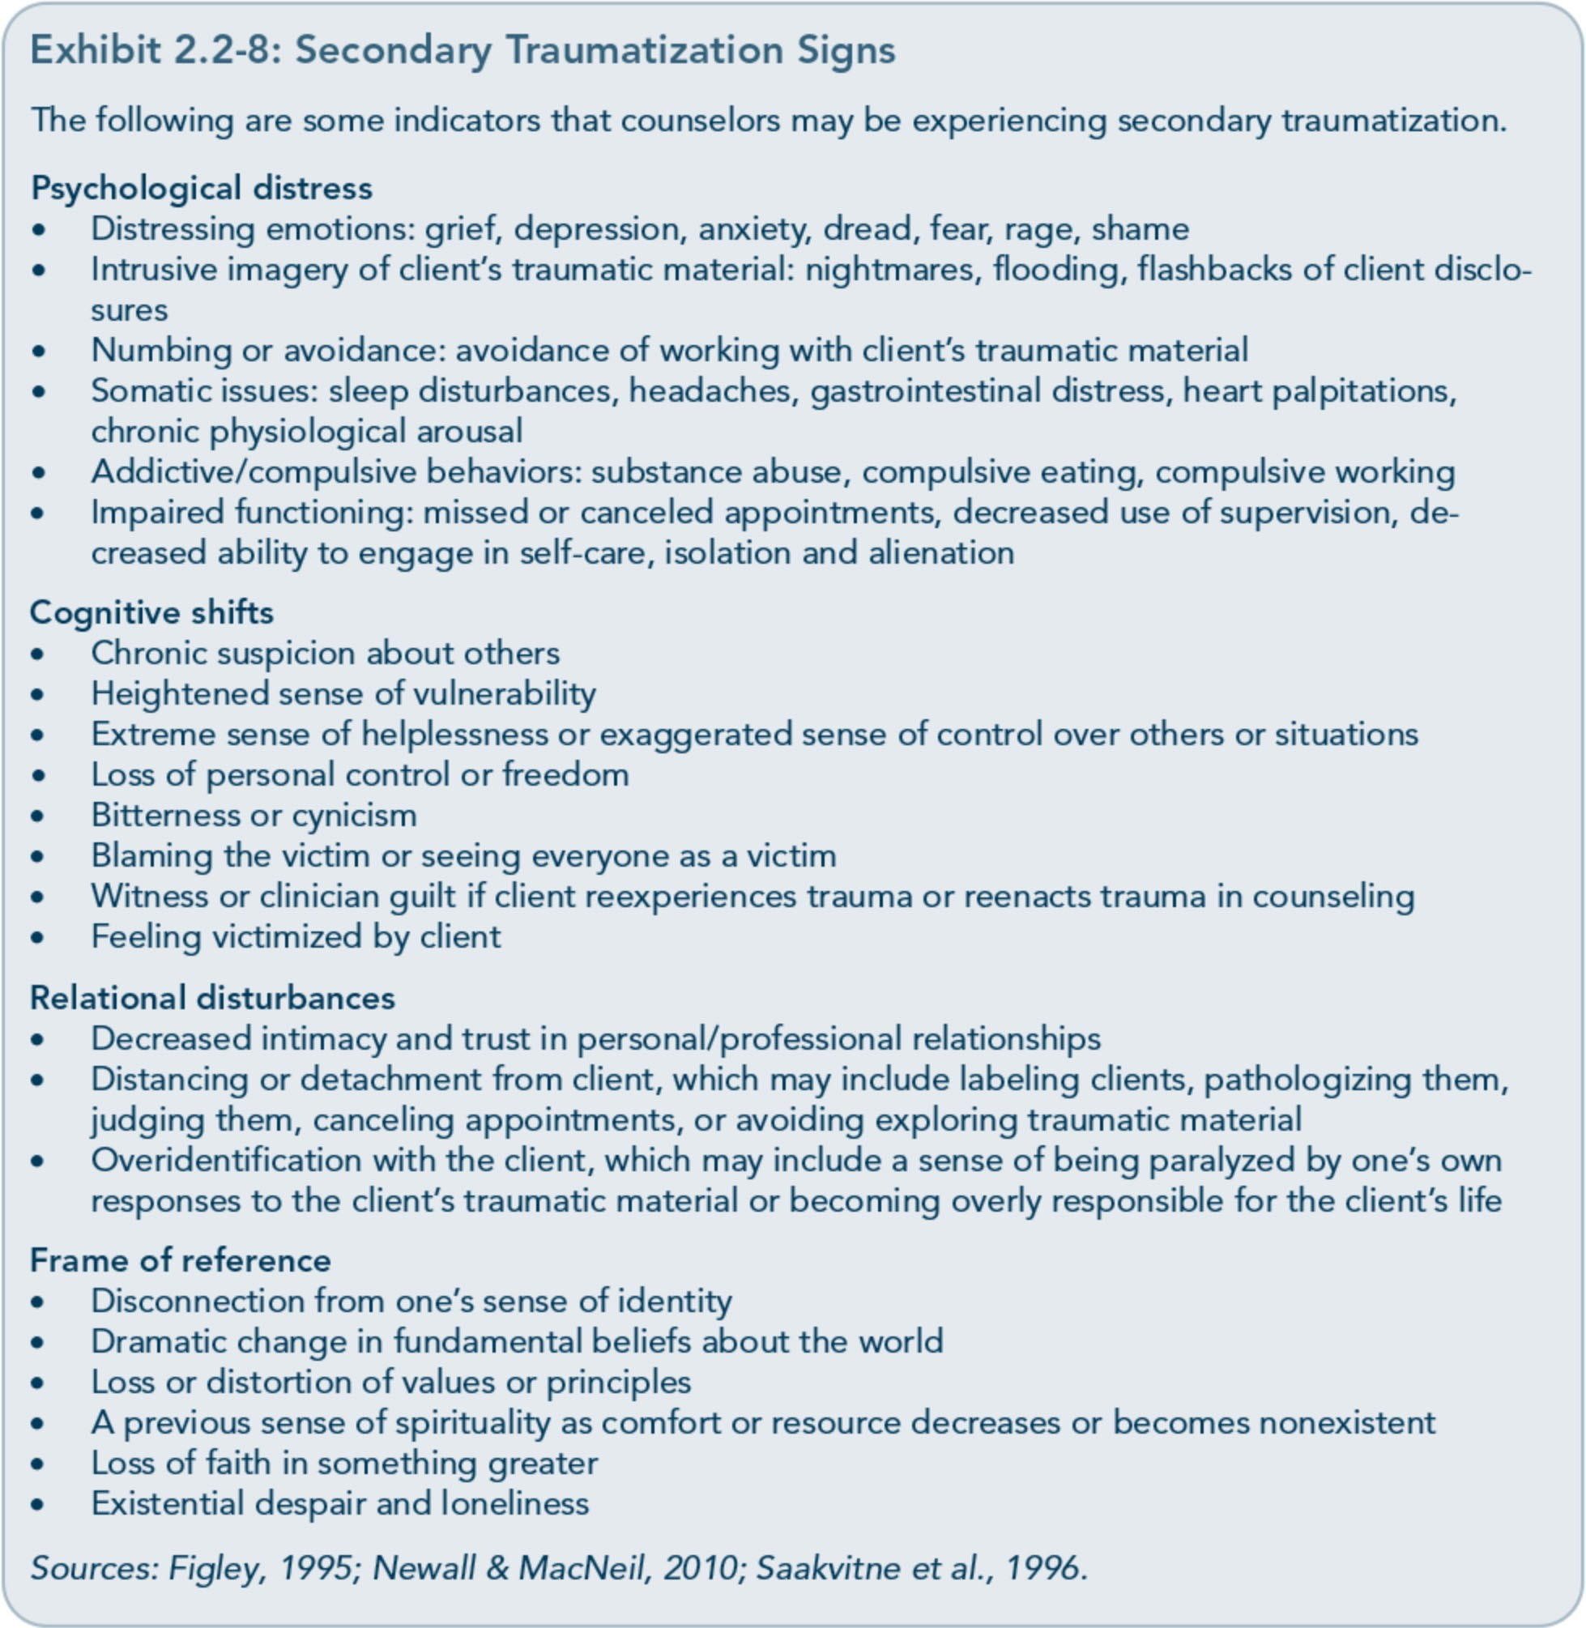

of secondary traumatic stress and professional burnout" (Newall &MacNeil, 2010, p. 61). Although secondary traumatization as a reac­ tion to exposure to clients' trauma material is similar to PTSD, burnout is a more general type of psychological distress related to the pressures of working in high-stress environ­ ments over time. Burnout may be a result of secondary traumatization and/or a contrib­ uting factor in the development of secondary
traumatization. The ProQOL includes STS and burnout scales that have been validated in research studies (Adams, Figley, & Boscarino, 2008; Newall &MacNeil, 2010).
This tool can be used in individual and group clinical supervision, trainings on self-care, and team meetings as a way for counselors to check in with themselves on their levels of stress and potential signs of secondary traumatization.

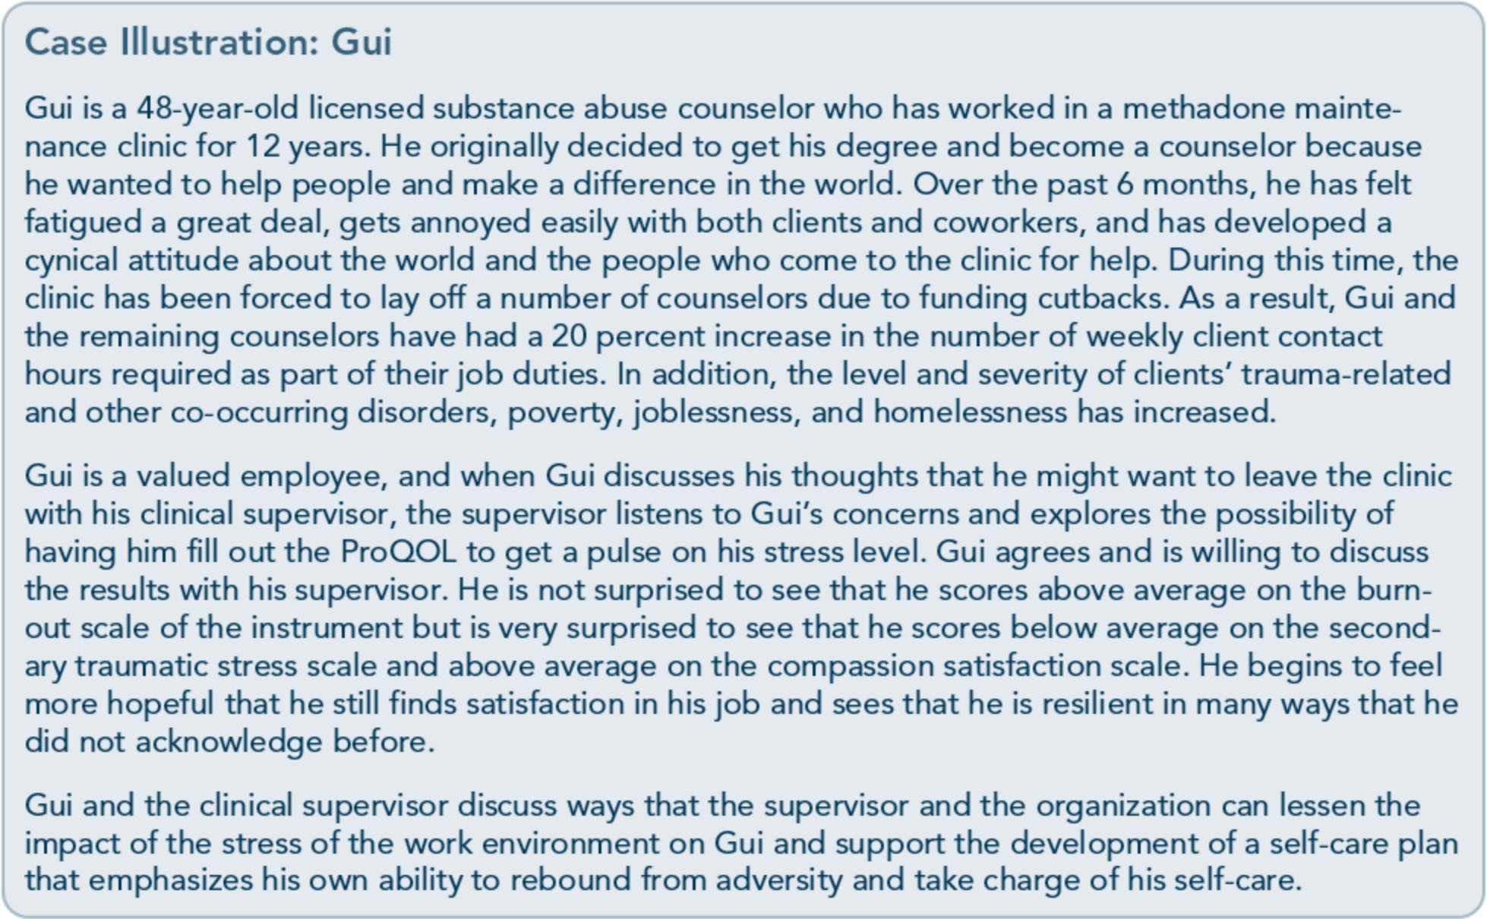

The compassion satisfaction scale allows counselors to reflect on their resilience and reminds them of why they choose to work with people with substance use and trauma-related disorders, despite the fact that this work can lead to secondary traumatization. The compas­ sion satisfaction subscale reminds counselors that they are compassionate, that one of the reasons they are in a helping profession is that they value service to others, and that helping brings meaning and fulfillment to their lives.
Exhibits 2.2-9 through 2.2-11 present the most recent version of the ProQOL.

Addressing Secondary Traumatization
If a counselor is experiencing STS, the organi­ zation should address it immediately. Clinical supervisors can collaborate with counselors to devise an individualized plan that is accessible, acceptable, and appropriate for each counselor and that addresses the secondary stress reac­ tions the counselor is experiencing, providing specific self-care strategies to counteract the
stress. Decisions about strategies for address­ ing secondary traumatization should be based on the personal preferences of the counselor, the opportunity for an immediate intervention following a critical incident, and the counse­ lor's level of awareness regarding his or her experience of STS. Counselors may need to talk about what they are experiencing, feeling, and thinking. These experiences can be pro­ cessed in teams, in consultations with col­ leagues, and in debriefing meetings to integrate them effectively (Myers & Wee, 2002).
If a critical incident evokes secondary trauma­ tization among staff-such as a client suicide, a violent assault in the treatment program, or another serious event-crisis intervention should be available for workers who would like to participate. Any intervention should be voluntary and tailored to each worker's indi­ vidual needs (e.g., peer, group, or individual sessions); if possible, these services should be offered continuously instead of just one time.

Exhibit 2.2-9: PRoOOL Scale
COMPASSION SATISFACTION AND COMPASSION FATIGUE (PRoQOL) VERSION 5 (2009)
When you [help] people you have direct contact with their lives. As you may have found, your com­
passion for those you [help] can affect you in positive and negative ways. Below are some questions about your experiences, both positive and negative, as a [helper]. Consider each of the following questions about you and your current work situation. Select the number that honestly reflects how frequently you experienced these things in the past 30 days.
1=Never 2=Rarely 3=Sometimes 4=Often S=Very Often
_ 1. I am happy.
_ 2. I am preoccupied with more than one person I [help].
_ 3. I get satisfaction from being able to [help] people.
4. I feel connected to others.
_ 5. I jump or am startled by unexpected sounds.
_ 6. I feel invigorated after working with those I [help].
_ 7. I find it difficult to separate my personal life from my life as a [helper].
_ 8. I am not as productive at work because I am losing sleep over traumatic experiences of a per- son I [help].
_ 9. I think that I might have been affected by the traumatic stress of those I [help].
_ 10. I feel trapped by my job as a [helper].
_ 11. Because of my [helping], I have felt "on edge" about various things.
_ 12. I like my work as a [helper].
_ 13. I feel depressed because ofthe traumatic experiences ofthe people I [help].
_ 14. I feel as though I am experiencing the trauma of someone I have [helped].
15. I have beliefs that sustain me.
_ 16. I am pleased with how I am able to keep up with [helpingJtechniques and protocols.
_ 17. I am the person I always wanted to be.
_ 18. My work makes me feel satisfied.
_ 19. I feel worn out because of my work as a [helper].
_ 20. I have happy thoughts and feelings about those I [help] and how I could help them.
_ 21. I feel overwhelmed because my case [work] load seems endless.
_ 22. I believe I can make a difference through my work.
_ 23. I avoid certain activities or situations because they remind me of frightening experiences of the people I [help].
_ 24. I am proud of what I can do to [help].
_ 25. As a result of my [helping], I have intrusive, frightening thoughts.
_ 26. I feel "bogged down" by the system.
_ 27. I have thoughts that I am a "success" as a [helper].
_ 28. I can't recall important parts of my work with trauma victims.
_ 29. I am a very caring person.
_ 30. I am happy that I chose to do this work.

© B. Hudnall Stamm, 2009-2012. Professional Quality of Life: Compassion Satisfaction and Fatigue Version 5 (ProOOL). http://www.proqol.org. This test may be freely copied as long as (a) author is credited, (b) no changes are made, and (c) it is not sold. Those interested in using the test should visit http://www.proqol.org to verify that the copy they are using is the most current version of the test.
Source: Stamm, 2012. Used with permission.

Exhibit 2.2-10: Your Scores on the ProQOL: Professional Quality of Life Screening
Based on your responses, place your personal scores below. If you have any concerns, you should discuss them with a physical or mental healthcare professional.
Compassion Satisfaction _
Compassion satisfaction is about the pleasure you derive from being able to do your work well. For example, you may feel like it is a pleasure to help others through your work. You may feel positively about your colleagues or your ability to contribute to the work setting or even the greater good of society. Higher scores on this scale represent a greater satisfaction related to your ability to be an effective caregiver in your job.
The average score is 50 (SD 10; alpha scale reliability .88). About 25% of people score higher than 57 and about 25% of people score below 43. If you are in the higher range, you probably derive a good deal of professional satisfaction from your position. If your scores are below 40, you may either find problems with your job, or there may be some other reason-for example, you might derive your satisfaction from activities other than your job.
Burnout _
Most people have an intuitive idea of what burnout is. From the research perspective, burnout is one of the elements of Compassion Fatigue (CF). It is associated with feelings of hopelessness and difficulties in dealing with work or in doing your job effectively. These negative feelings usually have a gradual onset. They can reflect the feeling that your efforts make no difference, or they can be associated with a very high workload or a non-supportive work environment. Higher scores on this scale mean that you are at higher risk for burnout.
The average score on the burnout scale is 50 (SD 10; alpha scale reliability .75). About 25% of peo­ ple score above 57 and about 25% of people score below 43. If your score is below 43, this probably reflects positive feelings about your ability to be effective in your work. If you score above 57 you may wish to think about what at work makes you feel like you are not effective in your position. Your score may reflect your mood; perhaps you were having a "bad day" or are in need of some time off. If the high score persists or if it is reflective of other worries, it may be a cause for concern.
Secondary Traumatic Stress _
Thsecond component of Compassion Fatigue (CF) is secondary traumatic stress (STS). It is about your work related, secondary exposure to extremely or traumatically stressful events. Developing problems due to exposure to other's trauma is somewhat rare but does happen to many people who care for those who have experienced extremely or traumatically stressful events. For example, you may repeatedly hear stories about the traumatic things that happen to other people, commonly called Vicarious Traumatization. If your work puts you directly in the path of danger, for example, field work in a war or area of civil violence, this is not secondary exposure; your exposure is primary. However, if you are exposed to others' traumatic events as a result of your work, for example, as a therapist or an emergency worker, this is secondary exposure. The symptoms of STS are usually rapid in onset and associated with a particular event. They may include being afraid, having difficulty sleeping, having images of the upsetting event pop into your mind, or avoiding things that remind you of the event.
The average score on this scale is 50 (SD 10; alpha scale reliability .81). About 25% of people score below 43 and about 25% of people score above 57. If your score is above 57, you may want to take some time to think about what at work may be frightening to you or if there is some other reason for the elevated score. While higher scores do not mean that you do have a problem, they are an indi­ cation that you may want to examine how you feel about your work and your work environment. You may wish to discuss this with your supervisor, a colleague, or a healthcare professional.
© B. Hudnall Stamm, 2009-2012. Professional Quality of Life: Compassion Satisfaction and Fatigue Version 5 (ProOOL). http://www.proqol.org. This test may be freely copied as long as (a) author is credited, (b) no changes are made, and (c) it is not sold. Those interested in using the test should visit http://www.proqol.org to verify that the copy they are using is the most current version of the test.
Source: Stamm, 2012. Used with permission.

Exhibit 2.2-11: What Is My Score and What Does It Mean?
In this section, you will score your test so you understand the interpretation for you. To find your score on each section, total the questions listed on the left and then find your score in the table on the right of the section.
Compassion Satisfaction Scale
The sum of my
Compassion Satisfaction uestions is
So my score equals
And my Compassion Satisfaction level is
High
57 or more
42 or more
Average
Around 50
Between 23 and 41
Low
43 or less
22 or less

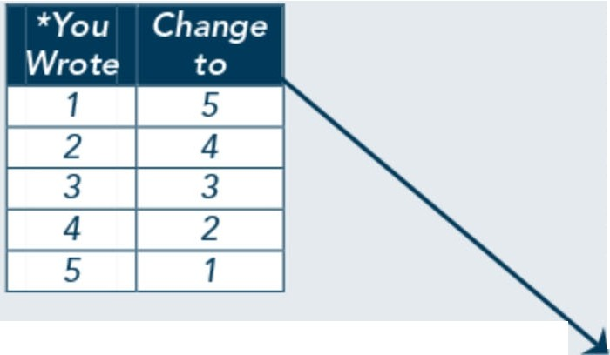Copy your rating on each of these questions on to this table and add them up. When you have added then up you can find your score on the table to the right.

Burnout Scale

On the burnout scale you will need to take an extra step. Starred items are "reverse scored." If you scored the item 1, write a 5 beside it. The reason we ask you to reverse the scores is because scientifically the measure works better when these questions are asked in a positive way though they can tell us more about their negative form. For example, question 1. "I am happy" tells us more about the effects of helping when you are not happy so you reverse the score.
Secondary Traumatic Stress Scale Just like you did on Compassion Satisfaction, copy your rating on each of these questions on to this table and add the[m] up. When you have added them up you can find your score on the table to the right.
3.
6.
12.
16.
18.
20.
22.
24.
27.
30.
Total:

*1.
 | The sum of my Burnout  questions is | So my And my  score Burnout  equals level is
22 or less |  |  | 43 or less | Low
Between 23 and 41 |  |  | Around 50 | Average
42 or more |  |  | 57 or more | High

*4.
8.
10.
*15.
*17. 19.
21.
26.
*29.
Total:

2.
The sum of my Secondary Trauma
uestions is 22 or less
Between
So my score e uals
43 or less
And my Secondary Traumatic Stress level is
Low
Around 50
Average
5.
7.
9.
11.
13.

14. | 23 and 41
23. | 42 or more | 57 or more | High
25.
28.
Total:
© B. Hudnall Stamm, 2009-2012. Professional Quality of Life: Compassion Satisfaction and Fatigue Version 5 (ProOOL). http://www.proqol.org. This test may be freely copied as long as (a) author is credited, (b) no changes are made, and (c) it is not sold. Those interested in using the test should visit http://www.proqol.org to verify that the copy they are using is the most current version of the test.
Source: Stamm, 2012. Used with permission.

The objective of debriefing a critical incident that evokes STS reactions in counselors is to help them dissipate the hyperarousal associat­ ed with traumatic stress and prevent long­ term aftereffects that might eventually lead to counselor impairment. Because clinical super­ visors may also be experiencing secondary traumatization, it is advisable for administra­ tors to invite an outside trauma consultant

into the organization to provide a safe space for all staff members (including clinical super­ visors) to address and process the critical stress incident. For noncrisis situations, secondary traumatization should be addressed in clinical supervision. Clinical supervisors and counse­ lors should work collaboratively to incorporate regular screening and self-assessment of STS into supervision sessions.

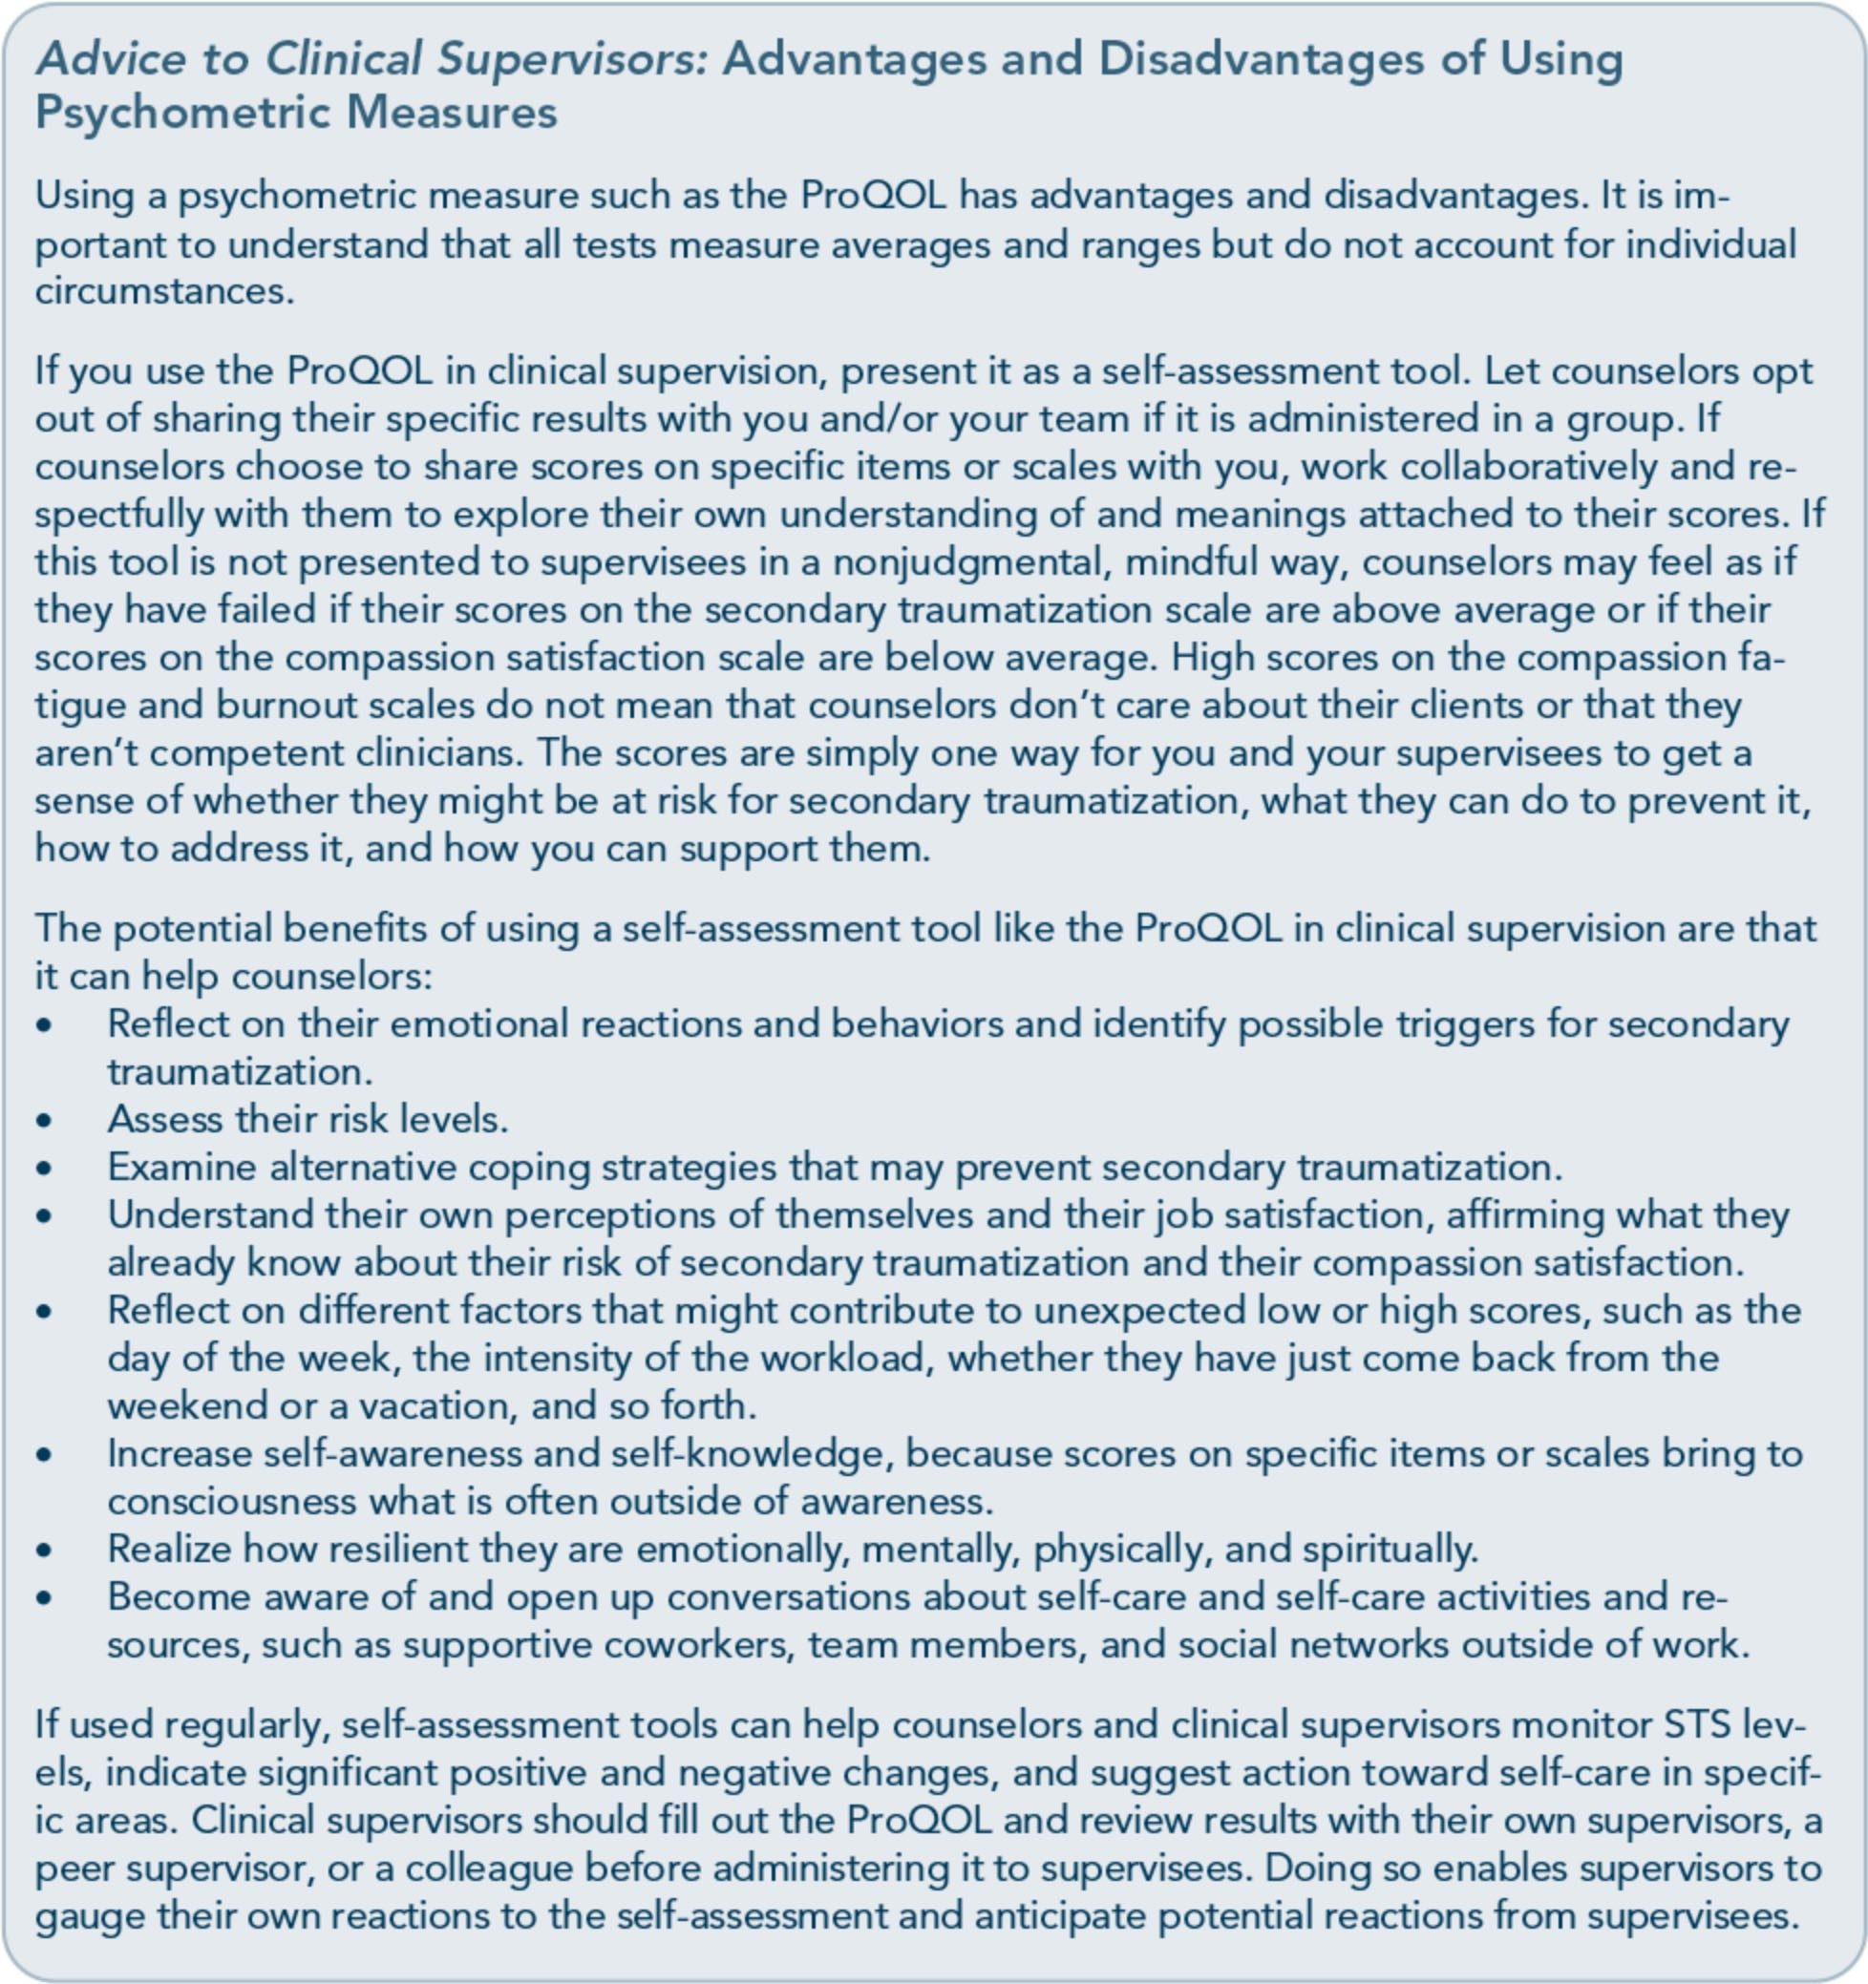

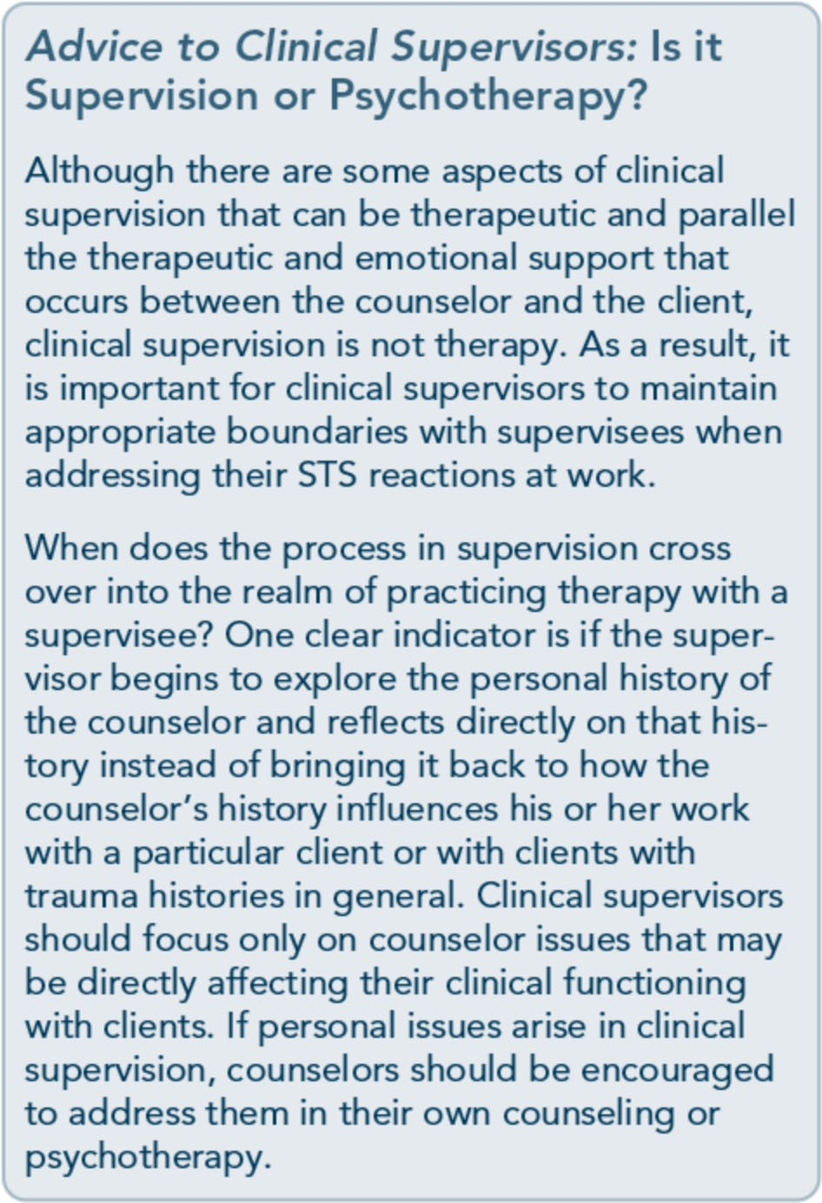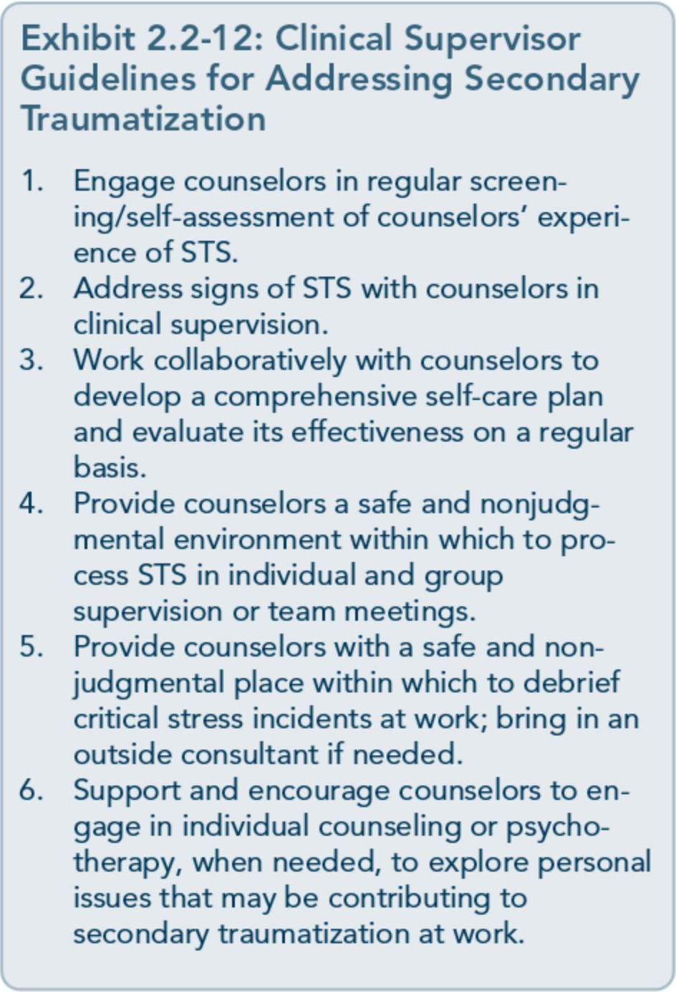

When STS issues arise, the clinical supervisor should work with counselors to review and revise their self-care plans to determine what strategies are working and whether additional support, like individual psychotherapy or counseling, may be warranted.
Exhibit 2.2-12 outlines some guidelines for clinical supervisors in addressing secondary trauma in behavioral health professionals work­ ing with clients who have substance use, men­ tal, and trauma-related disorders.

Counselor Self-Care
In light of the intensity of therapeutic work with clients with co-occurring substance use, mental, and trauma-related disorders and the vulnerability of counselors to secondary trau­ matization, a comprehensive, individualized self-care plan is highly recommended. Balance is the key to the development of a self-care
plan-a balance between home and work, a balance between focusing on self and others, and a balance between rest and activity (Saakvitne, Perlman, & Traumatic Stress Institute/ Center for Adult & Adolescent Psychotherapy 1996). Counselor self-care is also about balancing vulnerability, which al­ lows counselors to be present and available when clients address intensely painful content, with reasonable efforts to preserve their sense of integrity in situations that may threaten the counselors' faith or worldview (Burke et al., 2006). A comprehensive self-care plan should include activities that nourish the physical, psychological/mental, emotional/relational, and spiritual aspects of counselors' lives.
The literature on counselor self-care advocates for individual, team, and organizational strat­ egies that support behavioral health profes­ sionals working with clients who have

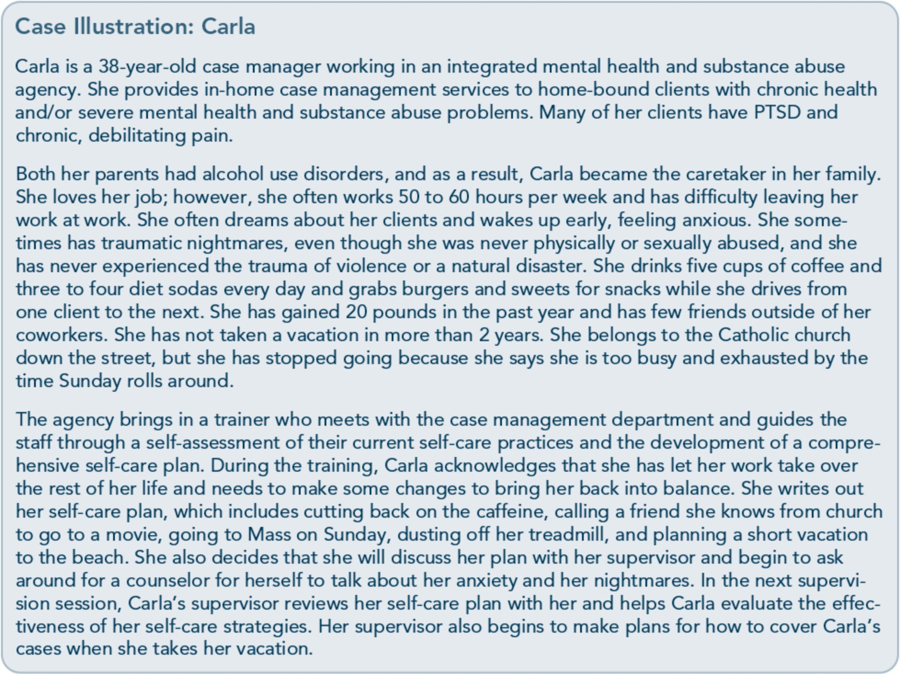

substance use and trauma-related disorders. Counselors are responsible for developing comprehensive self-care plans and committing to their plans, but clinical supervisors and ad­ ministrators are responsible for promoting counselor self-care, supporting implementa­ tion of counselor self-care plans, and modeling self-care. Counselor self-care is an ethical im­ perative; just as the entire trauma-informed organization must commit to other ethical issues with regard to the delivery of services to clients with substance use, mental, and trauma­ related disorders, it must also commit to the self-care of staff members who are at risk for secondary traumatization as an ethical con­ cern. Saakvitne and colleagues (1996) suggest that when administrators support counselor­ self-care, it is not only cost-effective in that it reduces the negative effects of secondary traumatization on counselors (and their cli-
ents), but also promotes "hope-sustaining be­ haviors" in counselors, making them more motivated and open to learning, and thereby improving job performance and client care.
A Comprehensive Self-Care Plan A self-care plan should include a self­ assessment of current coping skills and strategies and the development of a holistic, comprehensive self-care plan that addresses the following four domains:
- Physical self-care
- Psychological self-care (includes cogni­ tive/mental aspects)
- Emotional self-care (includes relational aspects)
- Spiritual self-care
Activities that may help behavioral health workers find balance and cope with the stress

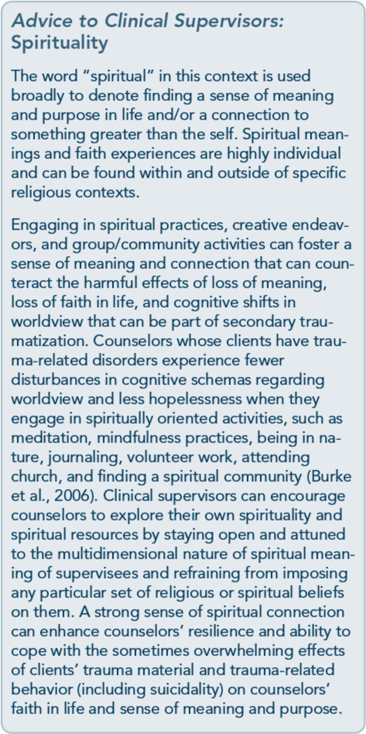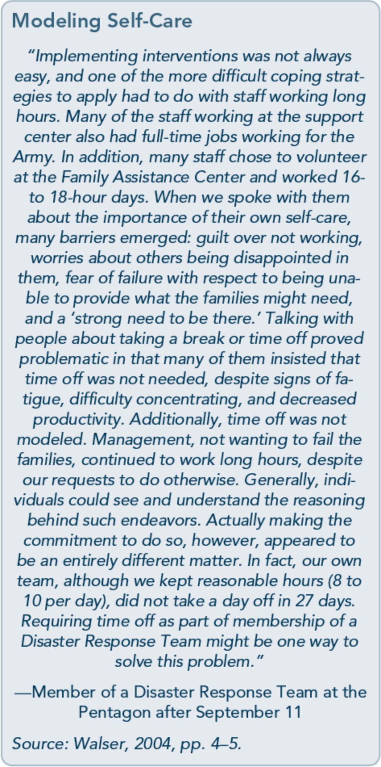

of working with clients with trauma-related disorders include talking with colleagues about difficult clinical situations, attending work­ shops, participating in social activities with family and friends, exercising, limiting client sessions, balancing caseloads to include clients with and without trauma histories, making sure to take vacations, taking breaks during the workday, listening to music, walking in nature, and seeking emotional support in both their personal and professional lives (Saakvitne et al., 1996). In addition, regular clinical su­ pervision and personal psychotherapy or coun-
seling can be positive coping strategies for lessening the impact of STS on counselors. Still, each counselor is unique, and a self-care approach that is helpful to one counselor may not be helpful to another. Exhibits 2.2-13 and 2.2-14 offer tools for self-reflection to help counselors discover which specific self-care activities might best suit them. The worksheet can be used privately by counselors or by clini­ cal supervisors as an exercise in individual su­ pervision, group supervision, team meetings, or trainings on counselor self-care.

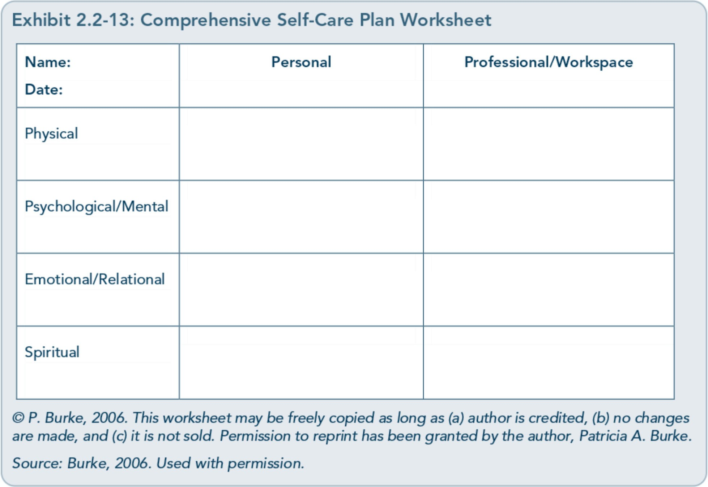

Review the questions in Exhibit 2.2-14, and then write down specific self-care strategies in the form (given in Exhibit 2.2-13) that you're confident you will practice in both personal and professional realms.
The Comprehensive Seif-Care Worksheet is a tool to help counselors (and clinical supervi­ sors) develop awareness of their current coping strategies and where in the four domains they need to increase their engagement in self-care activities. Once completed, clinical supervisors should periodically review the plan with their supervisees for effectiveness in preventing and/or ameliorating secondary traumatization and then make adjustments as needed.
Essential Components of Self-Care Saakvitne and colleagues (1996) describe three essential components, the ''ABCs," of self-care that effectively address the negative impact of secondary traumatization on counselors:
- Awareness of one's needs, limits, feelings, and internal/external resources. Awareness involves mindful/nonjudgmental attention to one's physical, psychological, emotional, and spiritual needs. Such attention re­ quires quiet time and space that supports self-reflection.
- Balance of activities at work, between work and play, between activity and rest, and between focusing on self and focusing on others. Balance provides stability and helps counselors be more grounded when stress levels are high.
- Connection to oneself, to others, and to something greater than the self. Connec­ tion decreases isolation, increases hope, diffuses stress, and helps counselors share the burden of responsibility for client care.
It provides an anchor that enhances coun­
selors' ability to witness tremendous suf­ fering without getting caught up in it.

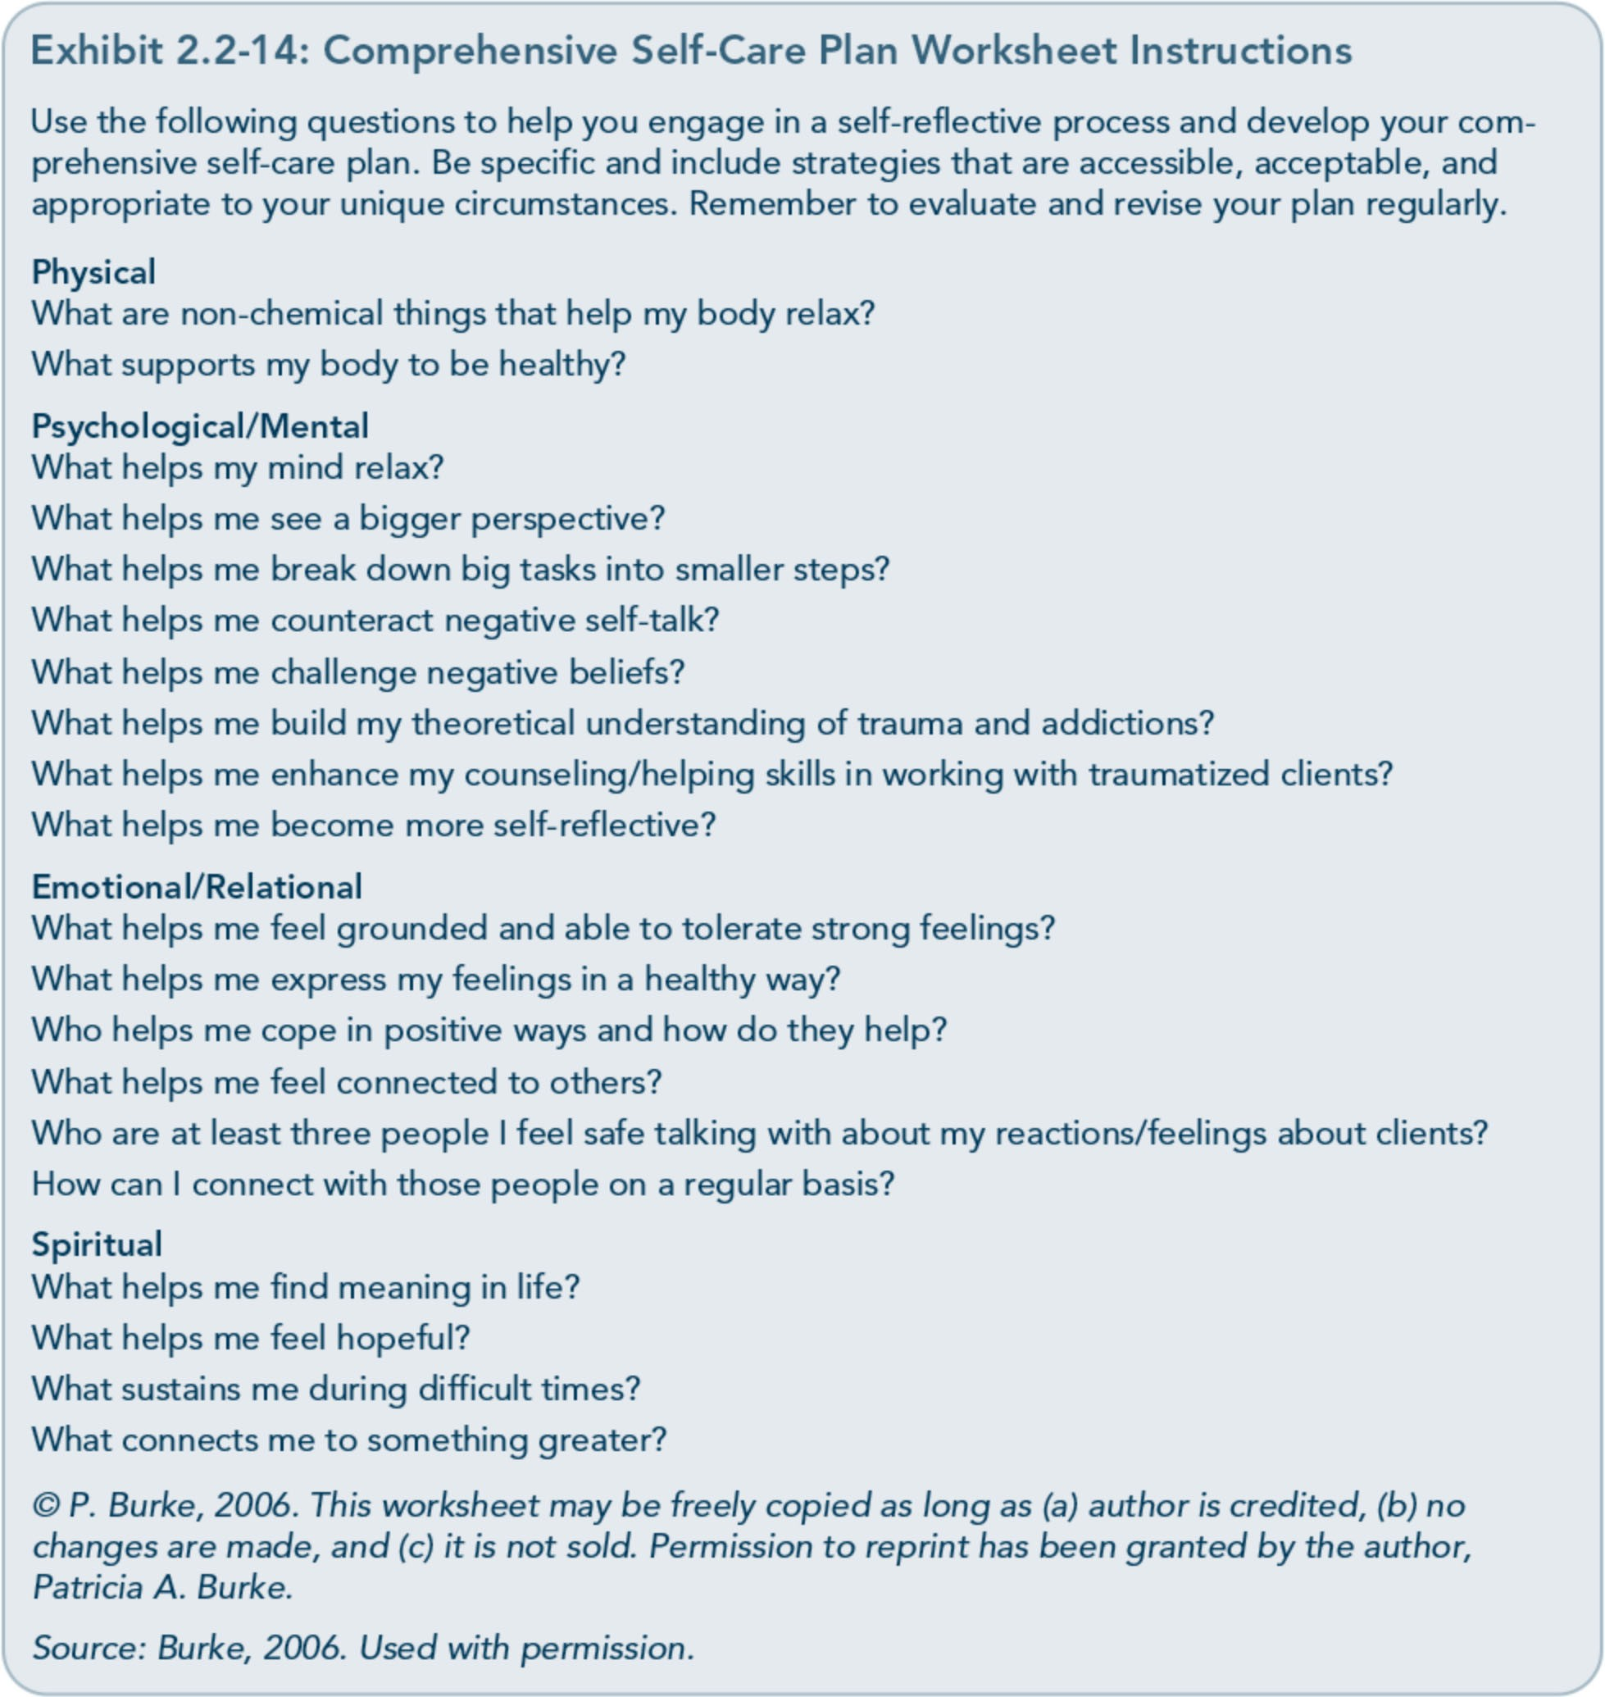

Clinical supervisors can help counselors re­ view their self-care plans through the ABCs by reflecting on these questions:
  - Has the counselor accurately identified his or her needs, limits, feelings, and internal and external resources in the four domains (physical, psychological/mental, emotion­ al/relational, spiritual)?
  - Has the counselor described self-care ac­ tivities that provide a balance between
work and leisure, activity and rest, and a focus on self and others?
  - Has the counselor identified self-care ac­ tivities that enhance connection to self, others, and something greater than self (or a larger perspective on life)?
Supervisors should make their own self-care plans and review them periodically with their clinical supervisors, a peer supervisor, or a colleague.

Commitment to Self-Care
One of the major obstacles to self-care is giv­ ing in to the endless demands of others, both at work and at home. It is therefore essential for counselors with the support of clinical su­ pervisors to become "guardians of [their] boundaries and limits" (Saakvitne et al., 1996, p 136). Creating a daily schedule that includes breaks for rest, exercise, connection with coworkers, and other self-care activities can support counselors in recognizing that they are valuable individuals who are worthy of taking the time to nourish and nurture themselves, thus increasing commitment to self-care. An-

other way to support counselors in commit­ ting to self-care is for supervisors and admin­ istrators to model self-care in their own professional and personal lives.
Understanding that counselor self-care is not simply a luxury or a selfish activity, but rather, an ethical imperative (Exhibit 2.2-15) can foster counselors' sense of connection to their own values and accountability to the people they serve as competent and compassionate caregivers. Clinical supervisors and adminis­ trators can reinforce this sense of accountabil­ ity while supporting counselors by providing a caring, trauma-informed work environment

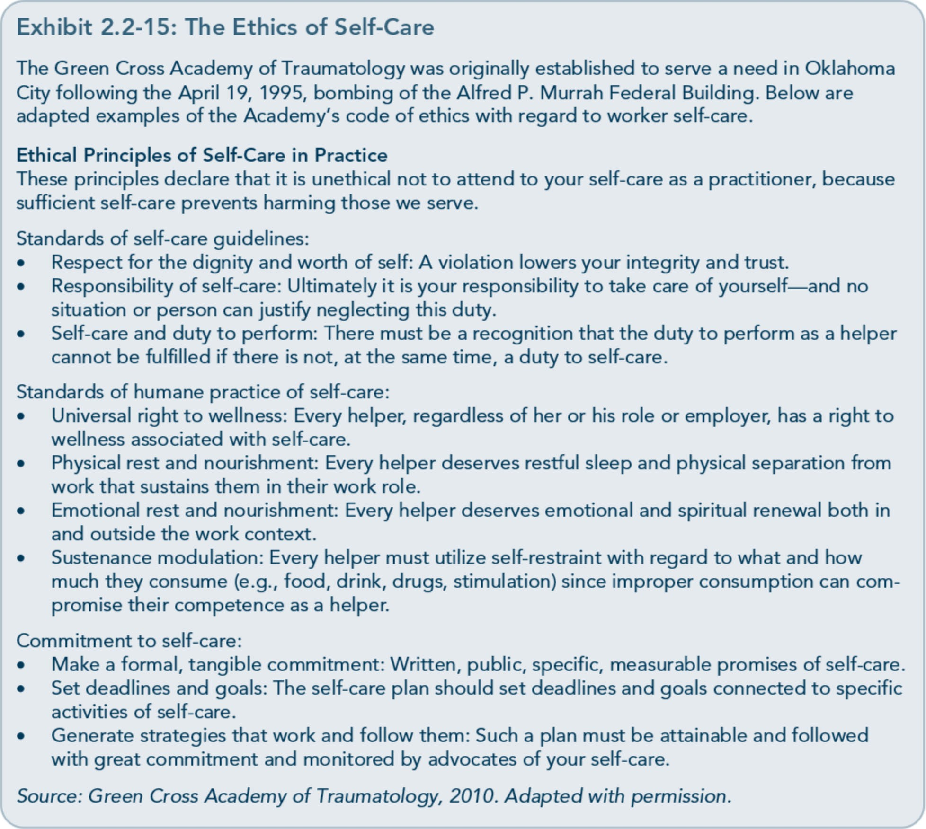

that acknowledges and normalizes secondary traumatization and by offering reasonable re­ sources that make it possible for counselors to do their work and take care of themselves at the same time. Preventing secondary traumati­ zation and lessening its impact on counselors

once it occurs is not only cost-effective with regard to decreasing staff turnover and poten­ tial discontinuity of services to clients; it is also the ethical responsibility of a trauma­ informed organization.



Appendix A-Bibliography

Abrahams, I. A., Ali, 0., Davidson, L., Evans, A. C., King,]. K., Poplawski, P., et al. (2010).
Philadelphia behavioral health services traniformation: Practice guidelines for recovery and resilience oriented treatment. Philadelphia: Department of Behavioral Health and Intellectual Disability Services.
Adams, R. E., Figley, C.R., & Boscarino,]. A. (2008). The Compassion Fatigue Scale: Its use with social workers following urban disaster. Research on Social Work Practice, 18, 238-250.
Adler, A. B., Litz, B. T., Castro, C. A., Suvak, M., Thomas,]. L., Burrell, L., et al. (2008). A group randomized trial of critical incident stress debriefing provided to U.S. peacekeepers.journalof Traumatic Stress, 21, 253-263.
Administration on Children, Youth, and Families. (2002). Sexual abuse among homeless adolescents: Prevalence, correlates, and sequelae. Washington, DC: Administration on Children, Youth, and Families.
Advanced Trauma Solutions, Inc. (2012). Trauma affect regulation: Guide for education & therapy.
Farmington, CT: Advanced Trauma Solutions, Inc.
Allen,]. G. (2001). Traumatic relationships and serious mental disorders. New York: John Wiley &
Sons Ltd.
American Psychiatric Association. (1980). Diagnostic and statistical manual of mental disorders. (3rd ed.). Washington, DC: American Psychiatric Association.
American Psychiatric Association. (2000a). Diagnostic and statistical manual of mental disorders.
(4th ed., text rev.). Washington, DC: American Psychiatric Association.
American Psychiatric Association. (20006). Position statement on therapies focused on memories of
childhood physical and sexual abuse. Washington, DC: American Psychiatric Association.
American Psychiatric Association. (2012a). G 03 posttraumatic stress disorder. Washington, DC:
American Psychiatric Association.
American Psychiatric Association. (20126). Proposed draft revisions to DSM disorders and criteria.
Washington, DC: American Psychiatric Association.
American Psychiatric Association. (2013a). Diagnostic and statistical manual of mental disorders.
(5th ed.). Arlington, VA: American Psychiatric Association.

American Psychiatric Association. (2013b). Highlights of changes from DSM-IV-TR to DSM-5.
Arlington, VA: American Psychiatric Association.
American Psychological Association & The Ad Hoc Committee on Legal and Ethical Issues in the Treatment oflnterpersonal Violence. (2003). Potential problems far psychologists working with the area of interpersonal violence. Washington, DC: American Psychiatric Association.
Anda, R. F., Felitti, V.J., Bremner,]. D., Walker,]. D., Whitfield, C., Perry, B. D., et al. (2006). The enduring effects of abuse and related adverse experiences in childhood. A convergence of evidence from neurobiology and epidemiology. European Archives of Psychiatry and Clinical Neuroscience, 256 (3), 174-86.
Anda, R. F., Felitti, V.J., Brown, D., Chapman, D., Dong, M., Dube, S. R., et al. (2006). Insights into intimate partner violence from the adverse childhood experiences (ACE) study. In The physician's guide to intimate partner violence and abuse (pp. 77-88). Volcano, CA: Volcano Press.
Andreasen, N. C. (2010). Posttraumatic stress disorder: A history and a critique.Annals of the New YorkAcademy of Sciences, 1208, 67-71.
Antony, M. M., Orsillo, S. M., & Roemer, L. (2001). Practitioner's guide to empirically based measures of anxiety. New York: Plenum Press.
Arkowitz, H., Miller, W.R., Westra, H. A., & Rollnick, S. (2008). Motivational interviewing in the treatment of psychological problems: Conclusions and future directions. In Motivational interviewing in the treatment of psychological problems (pp. 324-342). New York: Guilford Press.
Auerbach, S. (2003). Sleep disorders related to alcohol and other drug use. In A.W. Graham, T. K. Schultz, M. F. Mayo-Smith, R. K. Ries, & B. B. Wilford (Eds.), Principles of addiction medicine. (3rd ed.). (pp. 1179-1193). Chevy Chase, MD: American Society of Addiction Medicine.
Baer, R. A. (2003). Mindfulness training as a clinical intervention: A conceptual and empirical review. Clinical Psychology: Science and Practice, 10, 125-143.
Baker, K. G. & Gippenreiter,J. B. (1998). Stalin's purge and its impact on Russian families: A pilot study. In Y. Danieli (Ed.), International handbook of multigenerational legacies of trauma (pp.
403-434). New York: Plenum Press.
Bartone, P. T., Roland, R.R., Picano,J.J., & Williams, T. (2008). Psychological hardiness predicts success in US Army Special Forces candidates. International journal of Selection and Assessment, 16, 78-81.
Batten, S. V. & Hayes, S. C. (2005). Acceptance and commitment therapy in the treatment of comorbid substance abuse and post-traumatic stress disorder: A case study. Clinical Case Studies, 4, 246-262.
Beck, A. T. (1993). Beck anxiety inventory. San Antonio, TX: The Psychological Corporation. Beck, A. T., Rush, A.]., Shaw, B. F., & Emery, G. (1979). Cognitive therapy of depression. New York:
Guilford Press.
Beck, A. T., Steer, R. A., & Brown, G. K. (1996). Beck depression inventory -II manual. San Antonio, TX: The Psychological Corporation.

Beck, A. T., Wright, F. D., Newman, C. F., & Liese, B. F. (1993). Cognitive therapy of substance abuse. New York: Guilford Press.
Bell, C. C. (2011). Trauma, culture, and resiliency. In S. M. Southwick, B. T. Litz, D. Charney, &
M.J. Friedman (Eds.), Resilience and mental health: Challenges across the lifespan (pp. 176-187). New York: Cambridge University Press.
Benedek, D. M. & Ursano, R.J. (2009). Posttraumatic stress disorder: From phenomenology to clinical practice. FOCUS: The journal of Lifelong Learning in Psychiatry, 7, 160-175.
Bernard,]. M. & Goodyear, R. K. (2009). Fundamentals of clinical supervision. (4th ed.). Upper Saddle River, NJ: Merrill/Pearson.
Bernstein, D. P. (2000). Childhood trauma and drug addiction: Assessment, diagnosis, and
treatment.Alcoholism Treatment Quarterly, 18, 19-30.
Bernstein, E. M. & Putnam, F. W. (1986). Development, reliability, and validity of a dissociation
scale.journal of Nervous and Mental Disease, 174, 727-735.
Bills, L.J. (2003). Using trauma theory and S.A.G.E. in outpatient psychiatric practice. Psychiatric Quarterly, 74, 191-203.
Blackburn, C. (1995). Family and relapse. Counselor. Alexandria, VA: National Association of Alcoholism and Drug Abuse Counselors.
Blake, D., Weathers, F., Nagy, L., Koloupek, D., Klauminzer, G., Charney, D., et al. (1990). Clinician Administered PTSD Scale (CAPS). Boston: National Center for Post-Traumatic Stress Disorder.
Bleich, A., Gelkopf, M., & Solomon, Z. (2003). Exposure to terrorism, stress-related mental health symptoms, and coping behaviors among a nationally representative sample in Israel. journal of the American Medical Association, 290, 612-620.
Bloom, S. L. (1997). Creating sanctuary: Toward the evolution of sane societies. New York: Routledge. Bloom, S. L., Bennington-Davis, M., Farragher, B., McCorkle, D., Nice-Martini, K., & Wellbank,
K. (2003). Multiple opportunities for creating sanctuary. Psychiatric Quarterly, 74, 173-190.
Bloom, S. L., Foderaro,]. F., & Ryan, R. (2006). S.E.L.F: A trauma-informed psychoeducational group Curriculum. Retrieved on November 18, 2013, from: http://sanctuaryweb.com/PDFs_new/COMPLETE%20INTRODUCTO RY%20MATERI AL.pdf
Bober, T. & Regehr, C. (2006). Strategies for reducing secondary or vicarious trauma: Do they work? Brie/Treatment and Crisis Intervention, 6, 1-9.
Bonanno, G. A. (2004). Loss, trauma, and human resilience: Have we underestimated the human capacity to thrive after extremely aversive events? American Psychologist, 29, 20-28.
Bonanno, G. A. & Mancini, A. D. (2011). Toward a lifespan approach to resilience and potential trauma. In S. M. Southwick, B. T. Litz, D. Charney, &M.J. Friedman (Eds.), Resilience and mental health: Challenges across the lifespan (pp. 120-134). New York: Cambridge University Press.

Bowman, C. G. &Mertz, E. (1996). A dangerous direction: Legal intervention in sexual abuse survivor therapy. Harvard Law Review, 109, 551-639.
Brady, K. T., Killeen, T., Saladin, M. E., Dansky, B., & Becker, S. (1994). Comorbid substance abuse and posttraumatic stress disorder: Characteristics of women in treatment. American journal on Addictions, 3, 160-164.
Breslau, N. (2002). Gender differences in trauma and posttraumatic stress disorder.journal of
Gender Specific Medicine, 5, 34-40.
Brewin, C.R. (2007). Remembering and forgetting. In M.J. Friedman, T. M. Keane, & P.A. Resick (Eds.), Handbook of PTSD: Science and practice (pp. 116-134). New York: Guilford Press.
Brewin, C.R., Andrews, B., & Valentine,]. D. (2000). Meta-analysis of risk factors for posttraumatic stress disorder in trauma-exposed adults.journal of Consulting and Clinical
Psychology, 68, 748-766.
Bride, B. E. (2007). Prevalence of secondary traumatic stress among social workers. Social Work, 52,
63-70.
Briere,]. (1995). Trauma symptom inventory professional manual. Odessa, FL: Psychological Assessment Resources.
Briere, J. (1996a). Therapy far adults molested as children: Beyond survival (2nd ed.). New York: Springer Pub.
Briere,]. (19966). Trauma symptom checklist far children professional manual. Odessa, FL: Psychological Assessment Resources.
Briere,]. (1997). Psychological assessment of adult posttraumatic states. (1st ed.). Washington, DC: American Psychological Association.
Briere, J. & Scott, C. (2006a). Central issues in trauma treatment. In Principles of trauma therapy: A guide to symptoms, evaluation, and treatment (pp. 67-85). Thousand Oaks, CA: Sage Publications.
Briere,]. & Scott, C. (20066). Principles of trauma therapy: A guide to symptoms, evaluation, and treatment. Thousand Oaks, CA: Sage Publications.
Briere,]., & Scott, C. (2012). Principles of trauma therapy: A guide to symptoms, evaluation, and treatment. (2nd ed.). Thousand Oaks, CA: Sage Publications.
Bronfenbrenner,U. (1979). The ecology of human development: Experiments by nature and design.
Cambridge, MA: Harvard University Press.
Bronfenbrenner,U. & Ceci, S.J. (1994). Nature-nurture reconceptualized in developmental perspective: A bioecological model. Psychological Review, 101, 568-586.
Brown, L. S. (2008). Feminist therapy. InJ. L. Lebow (Ed.), Twenty-first century psychotherapies: Contemporary approaches to theory and practice (pp. 277-306). Hoboken, NJ: John Wiley & Sons, Inc.

Brown, P. J., Read,]. P., & Kahler, C. W. (2003). Comorbid posttraumatic stress disorder and substance use disorders: Treatment outcomes and the role of coping. In P. Ouimette & P. J. Brown (Eds.), Trauma and substance abuse: Causes, consequences, and treatment of comorbid disorders (pp. 171-188). Washington, DC: American Psychological Association.
Bryant, R. A. & Harvey, A. G. (2000). Acute stress disorder: A handbook of theory, assessment, and treatment. (1st ed.). Washington, DC: American Psychological Association.
Bryant, R. A. & Harvey, A.G. (2003). Gender differences in the relationship between acute stress disorder and posttraumatic stress disorder following motor vehicle accidents.Australian and New Zealand journal of Psychiatry, 37, 226-229.
Burke, P.A., Carruth, B., & Prichard, D. (2006). Counselor self-care in work with traumatized addicted people. In B. Carruth (Ed.), Psychological trauma and addiction treatment (pp. 283- 302). New York: Haworth Press.
Cahill, S. P., Rothbaum, B. 0., Resick, P.A., & Follette, V. M. (2009). Cognitive-behavioral therapy for adults. In E. B. Foa, T. M. Keane, M.J. Friedman, &J. A. Cohen (Eds.), Effective treatments far PTSD: Practice guidelines from the International Society far Traumatic Stress Studies. (2nd ed.). (pp. 139-222). New York: Guilford Press.
Caldwell, B. A. & Redeker, N. (2005). Sleep and trauma: An overview. Issues in Mental Health Nursing, 26, 721-738.
Campbell-Sills, L. & Stein, M. B. (2007). Psychometric analysis and refinement of the Connor­ Davidson Resilience Scale (CD-RISC): Validation of a 10-item measure of resilience.journal of Traumatic Stress, 20, 1019-1028.
Capezza, N. M. & Najavits, L. M. (2012). Rates of trauma-informed counseling at substance abuse treatment facilities: Reports from over 10,000 programs. Psychiatric Services, 63, 390- 394.
Cardena, E., Koopman, C., Classen, C., Waelde, L. C., & Spiegel, D. (2000). Psychometric properties of the Stanford Acute Stress Reaction Qyestionnaire (SASRQ2: a valid and reliable measure of acute stress.journal ofTraumatic Stress, 13, 719-734.
Carlson, E. B. & Putnam, F. W. (1993). An update on the Dissociative Experiences Scale.
Dissociation, 6, 16-27.
Carroll,]. F. X. & McGinley,J.J. (2001). A screening form for identifying mental health problems in alcohol/other drug dependent persons. Alcoholism Treatment Quarterly, 19, 33-47.
Catalano, S. (2012). Intimate partner violence in the US. Washington, DC: Bureau ofJustice Statistics.
Catalano, S. M. (2004). Criminal victimization, 2003: National crime victimization survey.
Washington, DC: Bureau of Justice Statistics.
Centers for Disease Control and Prevention. (2009). The social-ecological model· A framework far prevention. Retrieved on November 20, 2013, from: http://www.cdc.gov/violenceprevention/overview/social-ecologicalmodel.html

Centers for Disease Control and Prevention. (2012). Publications by health outcome: Adverse childhood experiences (ACE) study. Atlanta, GA: Centers for Disease Control and Prevention.
Centers for Disease Control and Prevention. (2013,January 18). Adverse Childhood Experiences (ACE) Study. Retrieved on August 14, 2013, from http://www.cdc.gov/ace/about.htm
Center for Mental Health Services. (1996). Responding to the needs of people with serious and persistent mental illness in times of major disaster (Rep. No. SMA 96-3077). Rockville, MD: Substance Abuse and Mental Health Services Administration.
Center for Mental Health Services, Division of Prevention, Traumatic Stress and Special Programs, Emergency Mental Health and Traumatic Stress Services Branch. (2003). Fact sheet (Rep. No. KEN 95-0011). Rockville, MD: Substance Abuse and Mental Health Services Administration.
Center for Mental Health Services, Substance Abuse and Mental Health Services Administration. (2005). Roadmap to seclusion and restraint free mental health services. Rockville, MD: Substance Abuse and Mental Health Services Administration.
Center for Substance Abuse Treatment. (1993a). Improving treatment far drug-exposed infants. Treatment Improvement Protocol (TIP) Series 5. HHS Publication No. (SMA) 95-3057. Rockville, MD: Substance Abuse and Mental Health Services Administration.
Center for Substance Abuse Treatment. (19936). Pregnant, substance-using women. Treatment Improvement Protocol (TIP) Series 2. HHS Publication No. (SMA) 93-1998. Rockville, MD: Substance Abuse and Mental Health Services Administration.
Center for Substance Abuse Treatment. (1993c). Screening/or infectious diseases among substance abusers. Treatment Improvement Protocol (TIP) Series 6. HHS Publication No. (SMA) 95- 3060. Rockville, MD: Substance Abuse and Mental Health Services Administration.
Center for Substance Abuse Treatment. (1994). Simple screening instruments far outreach far alcohol and other drug abuse and infectious diseases. Treatment Improvement Protocol (TIP) Series 11. HHS Publication No. (SMA) 94-2094. Rockville, MD: Substance Abuse and Mental Health Services Administration.
Center for Substance Abuse Treatment. (1995a). Alcohol and other drug screening of hospitalized trauma patients. Treatment Improvement Protocol (TIP) Series 16. HHS Publication No. (SMA) 95-3041. Rockville, MD: Substance Abuse and Mental Health Services Administration.
Center for Substance Abuse Treatment. (19956). Combining alcohol and other drug treatment with diversion far juveniles in the justice system. Treatment Improvement Protocol (TIP) Series 21. HHS Publication No. (SMA) 95-3051. Rockville, MD: Substance Abuse and Mental Health Services Administration.
Center for Substance Abuse Treatment. (1995c). Developing state outcomes monitoring systems far alcohol and other drug abuse treatment. Treatment Improvement Protocol (TIP) Series 14. HHS Publication No. (SMA) 95-3031. Rockville, MD: Substance Abuse and Mental Health Services Administration.

Center for Substance Abuse Treatment. (1995d). The role and current status of patient placement criteria in the treatment of substance use disorders. Treatment Improvement Protocol (TIP) Series
13. HHS Publication No. (SMA) 95-3021. Rockville, MD: Substance Abuse and Mental Health Services Administration.
Center for Substance Abuse Treatment. (1995e). The tuberculosis epidemic: Legal and ethical issues far alcohol and other drug abuse treatment providers. Treatment Improvement Protocol (TIP) Series 18. HHS Publication No. (SMA) 95-3047. Rockville, MD: Substance Abuse and Mental Health Services Administration.
Center for Substance Abuse Treatment. (1996). Treatment drug courts: Integrating substance abuse treatment with legal case processing. Treatment Improvement Protocol (TIP) Series 23. HHS Publication No. (SMA) 96-3113. Rockville, MD: Substance Abuse and Mental Health Services Administration.
Center for Substance Abuse Treatment. (1997a). A guide to substance abuse services far primary care clinicians. Treatment Improvement Protocol (TIP) Series 24. HHS Publication No. (SMA) 97-3139. Rockville, MD: Substance Abuse and Mental Health Services Administration.
Center for Substance Abuse Treatment. (1997b). Substance abuse treatment and domestic violence. Treatment Improvement Protocol (TIP) Series 25. HHS Publication No. (SMA) 97-3163. Rockville, MD: Substance Abuse and Mental Health Services Administration.
Center for Substance Abuse Treatment. (1998a). Comprehensive case management far substance abuse treatment. Treatment Improvement Protocol (TIP) Series 27. HHS Publication No. (SMA) 98-3222. Rockville, MD: Substance Abuse and Mental Health Services Administration.
Center for Substance Abuse Treatment. (1998b). Continuity of offender treatment far substance use disorders from institution to community. Treatment Improvement Protocol (TIP) Series 30.
HHS Publication No. (SMA) 98-3245. Rockville, MD: Substance Abuse and Mental Health Services Administration.
Center for Substance Abuse Treatment. (1998c). Naltrexone and alcoholism treatment. Treatment Improvement Protocol (TIP) Series 28. HHS Publication No. (SMA) 98-3206. Rockville, MD: Substance Abuse and Mental Health Services Administration.
Center for Substance Abuse Treatment. (1998d). Substance abuse among older adults. Treatment Improvement Protocol (TIP) Series 26. HHS Publication No. (SMA) 98-3179. Rockville, MD: Substance Abuse and Mental Health Services Administration.
Center for Substance Abuse Treatment. (1998e). Substance use disorder treatment far people with physical and cognitive disabilities. Treatment Improvement Protocol (TIP) Series 29. HHS Publication No. (SMA) 98-3249. Rockville, MD: Substance Abuse and Mental Health Services Administration.
Center for Substance Abuse Treatment. (1999a). Brief interventions and brief therapies far substance abuse. Treatment Improvement Protocol (TIP) Series 34. HHS Publication No. (SMA) 99- 3353. Rockville, MD: Substance Abuse and Mental Health Services Administration.

Center for Substance Abuse Treatment. (1999b). Enhancing motivation far change in substance abuse treatment. Treatment Improvement Protocol (TIP) Series 35. HHS Publication No. (SMA) 99-3354. Rockville, MD: Substance Abuse and Mental Health Services Administration.
Center for Substance Abuse Treatment. (1999c). Screening and assessing adolescents far substance use disorders. Treatment Improvement Protocol (TIP) Series 31. HHS Publication No. (SMA) 99-3282. Rockville, MD: Substance Abuse and Mental Health Services Administration.
Center for Substance Abuse Treatment. (1999d). Treatment of adolescents with substance use disorders. Treatment Improvement Protocol (TIP) Series 32. HHS Publication No. (SMA) 99- 3283. Rockville, MD: Substance Abuse and Mental Health Services Administration.
Center for Substance Abuse Treatment. (1999e). Treatment far stimulant use disorders. Treatment Improvement Protocol (TIP) Series 33. HHS Publication No. (SMA) 99-3296. Rockville, MD: Substance Abuse and Mental Health Services Administration.
Center for Substance Abuse Treatment. (2000a). Integrating substance abuse treatment and vocational services. Treatment Improvement Protocol (TIP) Series 38. HHS Publication No. (SMA) 00-3470. Rockville, MD: Substance Abuse and Mental Health Services Administration.
Center for Substance Abuse Treatment. (2000b). Substance abuse treatment far persons with child abuse and neglect issues. Treatment Improvement Protocol (TIP) Series 36. HHS Publication No. (SMA) 00-3357. Rockville, MD: Substance Abuse and Mental Health Services Administration.
Center for Substance Abuse Treatment. (2000c). Substance abuse treatment far persons with HIV/AIDS. Treatment Improvement Protocol (TIP) Series 37. HHS Publication No. (SMA) 00-3459. Rockville, MD: Substance Abuse and Mental Health Services Administration.
Center for Substance Abuse Treatment. (2004a). Clinical guidelines far the use of buprenorphine in the treatment of opioid addiction. Treatment Improvement Protocol (TIP) Series 40. HHS Publication No. (SMA) 04-3939. Rockville, MD: Substance Abuse and Mental Health Services Administration.
Center for Substance Abuse Treatment. (2004b). Substance abuse treatment and family therapy. Treatment Improvement Protocol (TIP) Series 39. HHS Publication No. (SMA) 04-3957. Rockville, MD: Substance Abuse and Mental Health Services Administration.
Center for Substance Abuse Treatment. (2005a). Medication-assisted treatment far opioid addiction.
Treatment Improvement Protocol (TIP) Series 43. HHS Publication No. SMA 05-4048. Rockville, MD: Substance Abuse and Mental Health Services Administration.
Center for Substance Abuse Treatment. (2005b). Substance abuse treatment far adults in the criminal justice system. Treatment Improvement Protocol (TIP) Series 44. HHS Publication No. (SMA) 05-4056. Rockville, MD: Substance Abuse and Mental Health Services Administration.
Center for Substance Abuse Treatment. (2005c). Substance abuse treatment far persons with co­ occurring disorders. Treatment Improvement Protocol (TIP) Series 42. HHS Publication No. SMA 05-3992. Rockville, MD: Substance Abuse and Mental Health Services Administration.

Center for Substance Abuse Treatment. (2005d). Substance abuse treatment: Group therapy.
Treatment Improvement Protocol (TIP) Series 41. HHS Publication No. SMA 05-4056. Rockville, MD: Substance Abuse and Mental Health Services Administration.
Center for Substance Abuse Treatment. (2006a). Detoxification and substance abuse treatment. Treatment Improvement Protocol (TIP) Series 45. HHS Publication No. SMA 06-4131. Rockville, MD: Substance Abuse and Mental Health Services Administration.
Center for Substance Abuse Treatment. (2006b). Substance abuse:Administrative issues in intensive outpatient treatment. Treatment Improvement Protocol (TIP) Series 46. HHS Publication No. SMA 06-4151. Rockville, MD: Substance Abuse and Mental Health Services Administration.
Center for Substance Abuse Treatment. (2006c). Substance abuse: Clinical issues in intensive outpatient treatment. Treatment Improvement Protocol (TIP) Series 47. HHS Publication No. SMA 06-4182. Rockville, MD: Substance Abuse and Mental Health Services Administration.
Center for Substance Abuse Treatment. (2008). Managing depressive symptoms in substance abuse clients during early recovery. Treatment Improvement Protocol (TIP) Series 48. HHS Publication No. SMA 08-4353. Rockville, MD: Substance Abuse and Mental Health Services Administration.
Center for Substance Abuse Treatment. (2009a).Addressing suicidal thoughts and behaviors in substance abuse treatment. Treatment Improvement Protocol (TIP) Series 50. HHS Publication No. SMA 09-4381. Rockville, MD: Substance Abuse and Mental Health Services Administration.
Center for Substance Abuse Treatment. (2009b). Clinical supervision and the professional development of the substance abuse counselor. Treatment Improvement Protocol (TIP) Series 52. HHS Publication No. SMA 09-4435. Rockville, MD: Substance Abuse and Mental Health Services Administration.
Center for Substance Abuse Treatment. (2009c). Incorporating alcohol pharmacotherapies into medical practice. Treatment Improvement Protocol (TIP) Series 49. HHS Publication No. SMA 09-4380. Rockville, MD: Substance Abuse and Mental Health Services Administration.
Center for Substance Abuse Treatment. (2009d). Substance abuse treatment:Addressing the specific needs of women. Treatment Improvement Protocol (TIP) Series 51. HHS Publication No.
SMA 09-4426. Rockville, MD: Substance Abuse and Mental Health Services Administration.
Center for Substance Abuse Treatment. (2009e). What are peer recovery support services? HHS Publication No. SMA 09-4454. Rockville, MD: Substance Abuse and Mental Health Services Administration, U.S. Department of Health and Human Services.
Chambless, D. L. & Hollon, S. D. (1998). Defining empirically supported therapies.journal of
Consulting and Clinical Psychology, 66, 7-18.
Chilcoat, H. D. & Breslau, N. (1998). Posttraumatic stress disorder and drug disorders: Testing causal pathways.Archives of General Psychiatry, 55, 913-917.
Christensen, R. C., Hodgkins, C. C., Garces, L. K., Estlund, K. L., Miller, M. D., & Touchton, R. (2005). Homeless, mentally ill and addicted: The need for abuse and trauma services.journal of Health Care far the Poor and Underserved, 16, 615-621.

Claes, L. & Vandereycken, W. (2007). Is there a link between traumatic experiences and self­ injurious behaviours in eating-disordered patients? Eating Disorders, 15, 305-315.
Claes, L., Vandereycken, W., & Vertommen, H. (2005). Self-care versus self-harm: Piercing, tattooing, and self-injuring in eating disorders. European Eating Disorders Review, 13, 11-18.
Clark, C. & Fearday, F. E. (2003). Triad women's project: Group facilitator's manual. Tampa, FL: Louis de la Parte Florida Mental Health Institute, University of South Florida.
Cloitre, M., Koenen, K. C., Cohen, L. R., & Han, H. (2002). Skills training in affective and interpersonal regulation followed by exposure: A phase-based treatment for PTSD related to childhood abuse.journal of Consulting and Clinical Psychology, 70, 1067-1074.
Coffey, S. F., Dansky, B. S., & Brady, K. T. (2003). Exposure-based, trauma focused therapy for comorbid posttraumatic stress disorder-substance use disorder. In P. Ouimette & P.J. Brown (Eds.), Trauma and substance abuse: Causes, consequences, and treatment of comorbid disorders. (pp.
127-146). Washington, DC: American Psychological Association.
Coffey, S. F., Schumacher,]. A., Brady, K. T., &Dansky, B. S. (2003). Reductions in trauma symptomalogy during acute and protracted alcohol and cocaine abstinence. Symposium conducted at the Annual Meeting of the International Society for Traumatic Stress Studies, Chicago, IL.
Coffey, S. F., Schumacher,]. A., Brimo, M. L., & Brady, K. T. (2005). Exposure therapy for substance abusers with PTSD: Translating research to practice. Behavior Modification, 29, 10- 38.
Connor, K. M. & Davidson,]. R. T. (2003). Development of a new resilience scale: The Connor­ Davidson Resilience Scale (CD-RISC). Depression and Anxiety, 18, 76-82.
Connors, G.J., Donovan, D. M., & DiClemente, C. C. (2001). Substance abuse treatment and the stages of change selecting and planning interventions. New York: Guilford Press.
Cottler, L.B., Nishith, P., & Compton, W. M. (2001). Gender differences in risk factors for trauma exposure and post-traumatic stress disorder among inner-city drug abusers in and out of treatment. Comprehensive Psychiatry, 42, 111-117.
Courtois, C. A. & Ford,]. D. (Eds.). (2009). Treating complex traumatic stress disorders:An evidence­ based guide. New York: Guilford Press.
Covington, S.S. (2003). Beyond trauma:A healingjourneyfar women: Facilitator's guide. Center City, MN: Hazelden.
Covington, S.S. (2008). Helping women recover: A program far treating addiction. (Revised loose leaf ed.). San Francisco:Jossey-Bass.
Cross, T. L., Bazron, B.J., Dennis, K. W., &Isaacs, M. R. (1989). Towards a culturally competent system of care: A monograph on effective services far minority children who are severely emotionally disturbed (Vol. 1). Washington, DC: Georgetown University Child Development Center.
Danieli, Y., Brom, D., & Sills,]. (2005). Sharing knowledge and shared care.journal ofAggression, Maltreatment &Trauma, 10, 775-790.

Daniels, A., Grant, E., Filson, B., Powell, I., Fricks, L., & Goodale, L. (2010). Pillars of peer support: Traniforming mental health systems of care through peer support services. Retrieved on November 21, 2013, from: http://www.pillarsofpeersupport.org/final%20%20PillarsofPeerSupportService%20Report.pdf
Daniels, A. S., Tunner, T. P., Ashenden, P., Bergeson, S., Fricks, L., & Powell, I. (2012). Pillars of peer support -III- Whole health peer support services. Retrieved on November 21, 2013, from: http://www.pillarsofpeersupport.org/P.O.PS2011.pdf
Dass-Brailsford, P. &Myrick, A. C. (2010). Psychological trauma and substance abuse: The need for an integrated approach. Trauma, Violence, & Abuse, 11, 202-213.
Daoust,]. P., Renaud, M., Bruyere, B., Lemieux, V., Fleury, G., & Najavits, L. M. (2012). Posttraumatic stress disorder and substance use disorder: Evaluation of the effectiveness of a specialized clinic far French-Canadians based in a teaching hospital Retrieved on November 21, 2013, from: http://www.seekingsafety.org/3-03-06/studies.html
Davidson,]. R., Book, S. W., Colket,J. T., Tupler, L.A., Roth, S., David, D., et al. (1997).
Assessment of a new self-rating scale for post-traumatic stress disorder. Psychological Medicine, 27, 153-160.
De Bellis, M. D. (2002). Developmental traumatology: A contributory mechanism for alcohol and substance use disorders. Psychoneuroendocrinology, 27, 155-170.
de Fabrique, N., Van Hasselt, V. B., Vecchi, G. M., & Romano, S.J. (2007). Common variables associated with the development of Stockholm syndrome: Some case examples. Victims & Offenders, 2, 91-98.
de Girolamo, G. (1993). lnternational perspectives on the treatment and prevention of posttraumatic stress disorder. In J.P. Wilson & Raphael Beverley (Eds.), International handbook of traumatic stress syndrome (pp. 935-946). New York: Plenum Press.
dePanfilis, D. (2006). Child neglect: A guide far prevention, assessment, and intervention. Washington, DC: U.S. Department of Health and Human Services, Administration for Children and Families, Administration on Children, Youth and Families Children's Bureau, Office on Child Abuse and Neglect.
DeWolfe, D.J. (2000). Training manual· For mental health and human service workers in major disasters (Rep. No. ADM 90-538). Rockville, MD: Substance Abuse and Mental Health Services Administration.
Dillon,]. R. (2001). lnternalized homophobia, attributions of blame, and psychological distress among lesbian, gay, and bisexual trauma victims. Dissertation Abstracts International· Section B: The Sciences & Engineering, 62, 2054.
Dom, G., De, W. B., Hulstijn, W., & Sabbe, B. (2007). Traumatic experiences and posttraumatic stress disorders: differences between treatment-seeking early- and late-onset alcoholic patients. Comprehensive Psychiatry, 48, 178-185.
Driessen, M., Schulte, S., Luedecke, C., Schaefer, I., Sutmann, F., Ohlmeier, M., et al. (2008).
Trauma and PTSD in patients with alcohol, drug, or dual dependence: A multi-center study.
Alcoholism: Clinical & Experimental Research, 32, 481-488.

Dube, S. R., Anda, R. F., Felitti, V.J., Edwards, V.J., & Croft,]. B. (2002). Adverse childhood experiences and personal alcohol abuse as an adult. Addictive Behaviors, 27, 713-725.
Duckworth, M. P. & Follette, V. M. (2011). Retraumatization: Assessment, treatment, and prevention. New York: Brunner-Routledge.
Ehlers, A. & Clark, D. (2003). Early psychological interventions for adult survivors of trauma: A review. Biological Psychiatry, 53, 817-826.
El-Gabalawy, R. (2012).Association between traumatic experiences and physical health conditions in a nationally representative sample. Retrieved on November 21, 2013, from: http://www.adaa.org/sites/default/files/El-Gabalawy0Ai20331.pdf
Ellis, A. & Harper, R. A. (1975). A new guide to rational living. Oxford, England: Prentice-Hall.
Elliott, D. E., Bjelajac, P., Fallot, R. D., Markoff, L. S., & Reed, B. G. (2005). Trauma-informed or trauma-denied: Principles and implementation of trauma-informed services for women.
journal of Community Psychology, 33, 461-477.
EMDR Network. (2012).A brief description of EMDR therapy. Retrieved on November 21, 2013, Retrieved on November 21from: http://www.emdrnetwork.org/description.html
Falck, R. S., Wang,]., Siegal, H. A., & Carlson, R. G. (2004). The prevalence of psychiatric disorder among a community sample of crack cocaine users: An exploratory study with practical implications.journal of Nervous and Mental Disease, 192, 503-507.
Falender, C. A. & Shafranske, E. P. (2004). Clinical supervision: A competency-based approach. (1st ed.). Washington, DC: American Psychological Association.
Fallot, R. D. & Harris, M. (2001). A trauma-informed approach to screening and assessment. In
M. Harris & R. D. Fallot (Eds.), Using trauma theory to design service systems (pp. 23-31). San Francisco: Jossey-Bass.
Fallot, R. D. & Harris, M. (2002). The trauma recovery and empowerment model (TREM): Conceptual and practical issues in a group intervention for women. Community Mental Health journal, 38, 475-485.
Fallot, R. D. & Harris, M. (2009). Creating cultures of trauma-informed care (CCTIC): A se!f­ assessment and planning protocol. Washington, DC: Community Connections.
Falsetti, S. A., Resnick, H. S., Resnick, P.A., & Kilpatrick, D. (1993). The Modified PTSD Symptom Scale: A brief self-report measure of posttraumatic stress disorder. Behavior Therapist, 16, 161-162.
Farley, M., Golding,]. M., Young, G., Mulligan, M., &Minkoff,]. R. (2004). Trauma history and relapse probability among patients seeking substance abuse treatment.journal of Substance Abuse Treatment, 27, 161-167.
Feder, A., Charney, D., & Collins, K. (2011). Neurobiology of resilience. In S. M. Southwick, B. T. Litz, D. Charney, &M.J. Friedman (Eds.), Resilience and mental health: Challenges across the lifespan (pp. 1-29). New York: Cambridge University Press.

Feldner, M. T., Monson, C. M., & Friedman, M.J. (2007). A critical analysis of approaches to targeted PTSD prevention: Current status and theoretically derived future directions. Behavior Modification, 31, 80-116.
Felitti, V.J., Anda, R. F., Nordenberg, D., Williamson, D. F., Spitz, A. M., Edwards, V., et al. (1998). Relationship of childhood abuse and household dysfunction to many of the leading causes of death in adults: The Adverse Childhood Experiences (ACE) study.American journal of Preventive Medicine, 14, 245-258.
Figley, C.R. (1995). Compassion fatigue: Toward a new understanding of the costs of caring. In B.
H. Stamm (Ed.), Secondary traumatic stress: Se!f-care issues far clinicians, researchers, and educators
(pp. 3-28). Lutherville, MD: Sidran Press.
Figley, C.R. (2002). Origins of traumatology and prospects for the future, part i.journal of Trauma Practice, 1, 17-32.
First, M. B., Spitzer, R. L., Gibbon, M., & Williams,]. B. W. (2011a). Structured clinical interview far DSM-IV-TR axis I disorders, research version, non-patient edition. New York: Biometrics Research, New York State Psychiatric Institute.
First, M. B., Spitzer, R. L., Gibbon, M., & Williams,]. B. W. (20116). Structured clinical interview far DSM-IV-TR axis I disorders, research version, patient edition. New York: Biometrics Research, New York State Psychiatric Institute.
Foa, E. B., Dancu, C. V., Hembree, E. A.,Jaycox, L. H., Meadows, E. A., & Street, G. P. (1999). A comparison of exposure therapy, stress inoculation training, and their combination for reducing posttraumatic stress disorder in female assault victims.journal of Consulting and Clinical Psychology, 67, 194-200.
Foa, E. B., Hembree, E. A., & Rothbaum, B. 0. (2007). Prolonged exposure therapy far PTSD: Emotional processing of traumatic experiences: Therapist guide. New York: Oxford University Press.
Foa, E. B., Keane, T. M., Friedman, M.J., & Cohen,]. A. (2009). Introduction. In E. B. Foa, T. M. Keane, M. J. Friedman, & J. A. Cohen (Eds.), Effective treatments far PTSD: Practice guidelines from the International Society far Traumatic Stress Studies. (2nd ed.). (pp.1-20). New York: Guilford Press.
Foa, E. B., Rothbaum, B. 0., Riggs, D.S., &Murdock, T. B. (1991). Treatment of posttraumatic stress disorder in rape victims: A comparison between cognitive-behavioral procedures and counseling.journal of Consulting & Clinical Psychology, 59, 715-723.
Foa, E. B., Stein, D.J., &McFarlane,A. C. (2006). Symptomatology and psychopathology of mental health problems after disaster.journal of Clinical Psychiatry, 67 Supplement 2, 15-25.
Ford,]. D. & Fournier, D. (2007). Psychological trauma and post-traumatic stress disorder among women in community mental health aftercare following psychiatric intensive care.journal of Psychiatric Intensive Care, 3, 27-34.
Ford,]. D. & Russo, E. (2006). Trauma-focused, present-centered, emotional self-regulation approach to integrated treatment for posttraumatic stress and addiction: Trauma adaptive recovery group education and therapy (TARGET).Americanjournal of Psychotherapy, 60, 335-355.

Foy, D. W., Ruzek,J. I., Glynn, S. M., Riney, S.J., & Gusman, F. D. (2002). Trauma focus group therapy for combat-related PTSD: An update.journal of Clinical Psychology, 58, 907-918.
Frank, B., Dewart, T., Schmeidler,]., &Demirjian,A. (2006). The impact of9/11 on New York City's substance abuse treatment programs: A study of program administrators.journalof Addictive Diseases, 25, 5-14.
Frankl, V. E. (1992). Man's search far meaning: An introduction to logotherapy. (4th ed.). Boston: Beacon Press.
Friborg, 0., Hjemdal, 0., Rosenvinge,J. H., &Martinussen, M. (2003). A new rating scale for adult resilience: What are the central protective resources behind healthy adjustment?
International journal of Methods in Psychiatric Research, 12, 65-76.
Friedman, M.J. (2006). Posttraumatic stress disorder among military returnees from Afghanistan and Iraq.American]ournal of Psychiatry, 163, 586-593.
Frisman, L., Ford,]., Lin, H.J., Mallon, S., & Chang, R. (2008). Outcomes of trauma treatment using the TARGET model.Journal of Groups in Addiction and Recovery, 3, 285-303.
Frueh, B. C., Knapp, R. G., Cusack, K.J., Grubaugh, A. L., Sauvageot,J. A., Cousins, V. C., et al. (2005). Patients' reports of traumatic or harmful experiences within the psychiatric setting.
Psychiatric Services, 56, 1123-1133.
Galea, S., Ahern,]., Resnick, Kilpatrick, D., Bucuvalas, M., Gold,]., et al. (2002). Psychological sequelae of the September 11 terrorist attacks in New York City. New England journal of Medicine, 346, 982-987.
Gentilello, L. M., Ebel, B. E., Wickizer, T. M., Salkever, D. S., & Rivara, F. P. (2005). Alcohol interventions for trauma patients treated in emergency departments and hospitals: A cost benefit analysis.Annals of Surgery, 241, 541-550.
Gentilello, L. M., Villaveces, A., Ries, R.R., Nason, K. S., Daranciang, E., Donovan, D. M., et al. (1999). Detection of acute alcohol intoxication and chronic alcohol dependence by trauma
center staff Journal of Trauma, 47, 1131-1135.
Gill, D. A. & Picou,}. S. (1997). The day the water died: Cultural impacts of the Exxon Valdez oil spill. InJ. S. Picou (Ed.), The Exxon Valdez disaster: Readings on a modern social problem (pp.167-187). Dubuque, IA: Indo American Books.
Gone,J. P. (2009). A community-based treatment for Native American historical trauma: Prospects for evidence-based practice.journal of Consulting and Clinical Psychology, 77, 751-762.
Goodell,]. (2003). Who's a hero now? Retrieved on November 21, 2013 from: http://www.nytimes.com/2003/07/27/magazine/who-s-a-hero-now.html
Grant, B. F., Stinson, F. S., Dawson, D. A., Chou, S. P., Dufour, M. C., Compton, W., et al. (2004).
Prevalence and co-occurrence of substance use disorders and independent mood and anxiety disorders: Results from the National Epidemiologic Survey on Alcohol and Related Conditions.Archives of General Psychiatry, 61, 807-816.
Green, B. L. (1996). Trauma History Qyestionnaire. In B. H. Stamm (Ed.), Measurement of stress, trauma, and adaptation (pp. 366-369). Lutherville, MD: Sidran Press.

Green Cross Academy ofTraumatology. (2007). Standards of traumatology practice revised. Retrieved on November 18, 2013, from: http://www.greencross.org/index.php?option=com_content&view=article&id=183&Itemid=123
Green Cross Academy ofTraumatology. (2010). Standards ofse!f care. Retrieved on November 21, 2013,from: http://www.greencross.org/index.php?option=com_content&view=article&id=184&Itemid=124
Green,]. G., McLaughlin, K. A., Berglund, P.A., Gruber, M.J., Sampson, N. A., Zaslavsky, A. M., et al. (2010). Childhood adversities and adult psychiatric disorders in the National Comorbidity Survey Replication I: Associations with first onset of DSM-IV disorders.
Archives of General Psychiatry, 6 7, 113-123.
Greene, L. R., Meisler, A. W., Pilkey, D., Alexander, G., Cardella, L.A., Sirois, B. C., et al. (2004). Psychological work with groups in the Veterans Administration. In]. L.DeLucia-Waack, D.
A. Gerrity, C.R. Kalodner, & M. T. Riva (Eds.), Handbook of group counseling and psychotherapy
(pp. 322-337). Thousand Oaks, CA: Sage Publications.
Grossman, D. (1995). On killing: The psychological cost of learning to kill in war and society. (1st ed.).
Boston: Little Brown.
Guarino, K., Soares, P., Konnath, K., Clervil, R., and Bassuk, E. (2009). Trauma-informed organizational toolkit. Rockville, MD: Center for Mental Health Services, Substance Abuse and Mental Health Services Administration, and the Daniels Fund, the National Child Traumatic Stress Network, and the W. K. Kellogg Foundation.
Gutheil, T. G. & Brodsky, A. (2008). Preventing boundary violations in clinical practice. New York: Guilford Press.
Habukawa, M., Maeda, M., & Uchimura, N. (2010). Sleep disturbances in posttraumatic stress disorder. In L. Sher & A. Vilens (Eds.), Neurobiology of post-traumatic stress disorder (pp. 119- 135). Hauppage, NY: Nova Science Publishers, Inc.
Hamblen,]. (2001). PTSD in children and adolescents, a National Center far PTSD fact sheet.
Washington, DC: National Center for PTSD.
Harned, M. S., Najavits, L. M., & Weiss, R. D. (2006). Self-harm and suicidal behavior in women with comorbid PTSD and substance dependence.American journal of Addiction, 15, 392-395.
Harris, M. & Fallot, R. D. (2001a). Envisioning a trauma-informed service system: A vital paradigm shift. In M. Harris & R. D. Fallot (Eds.), Using trauma theory to design service systems (pp. 3-22). San Francisco:Jossey-Bass.
Harris, M. & Fallot, R. D. (20016). Trauma-informed inpatient services. In M. Harris & R. D. Fallot (Eds.), Using trauma theory to design service systems (pp. 33-46). San Francisco: Jossey­ Bass.
Harris, M. & Fallot, R. D. (2001c). Using trauma theory to design service systems: New directions far mental health services. San Francisco: Jossey-Bass.
Harris, M. & The Community Connections Trauma Work Group. (1998). Trauma recovery and empowerment: A clinician's guide far working with women in groups. New York: Simon & Schuster.

Hayes, S. C. (2004). Acceptance and commitment therapy and the new behavior therapies: Mindfulness, acceptance, and relationship. In S. C. Hayes, V. M. Follette, & M. M. Linehan (Eds.), Mincifulness and acceptance: Expanding the cognitive-behavioral tradition (pp. 1-29). New York: Guilford Press.
Heim, C., Mletzko, T., Purselle, D., Musselman, D. L., & Nemeroff, C. B. (2008). The dexamethasone/corticotropin-releasing factor test in men with major depression: Role of childhood trauma. Biological Psychiatry, 63, 398-405.
Heim, C., Newport, D.J., Mletzko, T., Miller, A.H., & Nemeroff, C. B. (2008). The link between childhood trauma and depression: Insights from HPA axis studies in humans.
Psychoneuroendocrinology, 33, 693-710.
Herman,]. L. (1992). Trauma and recovery. New York: Basic Books. Herman,]. L. (1997). Trauma and recovery. (Rev. ed.). New York: Basic Books.
Hoge,M.A.,Morris,J. A., Daniels,A. S., Stuart, G. W., Huey, L. Y., &Adams, N. (2007).An action plan far behavioral health workforce development: A framework far discussion. Rockville, MD: Substance Abuse and Mental Health Services Administration.
Hooper, L. M., Stockton, P., Krupnick,J. L., & Green, B. L. (2011). Development, use, and psycho­ metric properties of the Trauma History Qyestionnaire.journalof Loss and Trauma, 16, 258-283.
Hopper, E. K., Bassuk, E. L., & Olivet,]. (2010). Shelter from the storm: Trauma-informed care in homelessness services settings. The Open Health Services and Policy journal, 3, 80-100.
Horowitz, M., Wilner, N., &Alvarez, W. (1979). Impact of Event Scale: A measure of subjective stress. Psychosomatic Medicine, 41, 209-218.
Huckshorn, K. (2009). Traniforming cultures ofcare toward recovery oriented services: Guidelines toward creating a trauma informed system ofcare: Trauma informed care (TIC) planning guidelines far use in developing an organizationalaction plan. Austin, TX:Texas Network of Youth Services.
Hui, C.H. &Triandis, H. C. (1986). Individualism-collectivism: A study of cross-cultural
researchers.journal of Cross-Cultural Psychology, 17, 225-248.
Huriwai, T. (2002). Re-enculturation: Culturally congruent interventions for Maori with alcohol­ and drug-use-associated problems in New Zealand. Substance Use and Misuse, 37, 1259-1268.
Hutton, D. (2000). Patterns of psychosocial coping and adaptation among riverbank erosion­ induced displacees in Bangladesh: Implications for development programming. Prehospital and Disaster Medicine, 15, S99.
Institute of Medicine. (2008). Treatment of posttraumatic stress disorder: An assessment of the evidence. Washington, DC: The National Academies Press.
Institute of Medicine & National Research Council. (2007). PTSD compensation and military service. Washington, DC: The National Academies.

Institute of Medicine, Committee on Prevention of Mental Disorders and Substance Abuse Among Children, O'Connell, M. E., Boat, T. F., Warner, K. E., National Research Council (U.S.), et al. (2009). Preventing mental, emotional, and behavioral disorders among young people: Progress and possibilities.Washington, DC: National Academies Press.
Jackson, C., Nissenson, K., & Cloitre, M. (2009). Cognitive-behavioral therapy. In C. A. Courtois (Ed.), Treating complex traumatic stress disorders: An evidence-based guide (pp. 243-263). New York: Guilford Press.
Jainchill, N., Hawke,]., & Yagelka,J. (2000). Gender, psychopathology, and patterns of homelessness among clients in shelter-based TCs. American journal of Drug and Alcohol Abuse, 26, 553-567.
Janoff-Bulman, R. (1992). Shattered assumptions: Towards a new psychology of trauma. New York: Free Press.
Jennings, A. (2004). Models far developing trauma-informed behavioral health systems and trauma­ specific services. Retrieved on November 21, 2013, from: http://www.theannainstitute.org/MDT.pdf
Jennings, A. (2007a). Blueprint far action: Building trauma-informed mental health service systems: State accomplishments, activities and resources. Retrieved on November 21, 2013, from: http://www.theannainstitute.org/2007%202008%20Blueprint%20BfA>20Criteria%202%2015
%2008.pdf
Jennings, A. (20076). Criteria far building a trauma-informed mental health service system. Adapted from "Developing Trauma-Informed Behavioral Health Systems."
Retrieved on November 21, 2013, from: http://www.theannainstitute.org/CBTIMHSS.pdf
Jennings, A. (2009). Models far developing trauma-informed behavioral health systems and trauma­ specific services: 2008 update. Retrieved on November 21, 2013, from: http://www.theannainstitute.org/Models%20for%20Developing%20Traums-Report%201-09- 09%20_FINAL_.pdf
Kabat-Zinn,]. (1994). Wherever you go, there you are: Mincifulness meditation in everyday life. (1st ed.). New York: Hyperion.
Kabat-Zinn,]., University of Massachusetts Medical Center/Worcester, & Stress, R. C. (1990). Full catastrophe living: Using the wisdom of your body and mind to face stress, pain, and illness. New York: Delacorte Press.
Karlin, B. E., Ruzek,J. I., Chard, K. M., Eftekhari, A., Monson, C. M., Hembree, E. A., et al. (2010). Dissemination of evidence-based psychological treatments for posttraumatic stress disorder in the Veterans Health Administration.journalofTraumatic Stress, 23, 663-673.
Karon, B. P. & Widener, A.J. (1997). Repressed memories and World War II: Lest we forget!
Professional Psychology: Research and Practice, 28, 338-340.
Keane, T. M., Brief, D.J., Pratt, E. M., &Miller, M. W. (2007). Assessment of PTSD and its comorbidities in adults. In M.J. Friedman, T. M. Keane, & P.A. Resick (Eds.), Handbook of PTSD: Science and practice (pp. 279-305). New York: Guilford Press.

Keane, T. M., Fairbank,]. A., Caddell,]. M., Zimering, R. T., Taylor, K. L., &Mora, C. A. (1989). Clinical evaluation of a measure to assess combat exposure. Psychological Assessment, 1, 53-55.
Keane, T. M. & Piwowarczyk, L.A. (2006). Trauma, terror, and fear: Mental health professionals respond to the impact of9/11-an overview. In L.A. Schein, H. I. Spitz, G. M. Burlingame, &
P.R. Muskin (Eds.), Psychological effects of catastrophic disasters: Group approaches to treatment
(pp. 3-16). New York: Haworth Press.
Kelly, D. C., Howe-Barksdale, S., & Gitelson, D. (2011). Treating young veterans: Promoting resilience through practice and advocacy. New York: Springer Publishing.
Kessler, R. C., Chiu, W. T., Demler, 0., Merikangas, K. R., & Walters, E. E. (2005). Prevalence, severity, and comorbidity of 12-month DSM-IV disorders in the National Comorbidity Survey replication.Archives of General Psychiatry, 62, 617-627.
Kessler, R. C., Sonnega, A., Bromet, E., Hughes, M., & Nelson, C. B. (1995). Posttraumatic stress disorder in the National Comorbidity Survey.Archives of General Psychiatry, 52, 1048-1060.
Kessler, R. C., Sonnega, A., Bromet, E., Hughes, M., Nelson, C. B., & Breslau, N. N. (1999).
Epidemiological risk factors for trauma and PTSD. In R. Yehuda (Ed.), Risk factors far PTSD.
(pp. 23-59). Washington, DC: American Psychiatric Press.
Khantzian, E.J. (1985). The self-medication hypothesis of addictive disorders: focus on heroin and cocaine dependence. American journal of Psychiatry, 142, 1259-1264.
Kilpatrick, D. G., Veronen, L.J., & Resick, P.A. (1982). Psychological sequelae to rape: Assessment and treatment strategies. In D. M. Doleys, R. L. Meredith, & A. R. Ciminero (Eds.), Behavioral medicine: assessment and treatment strategies (pp. 473-497). New York: Plenum.
Kimerling, R., Ouimette, P., & Weitlauf,J. C. (2007). Gender issues in PTSD. In M.J. Friedman,
T. M. Keane, & P.A. Resick (Eds.), Handbook of PTSD: Science and practice (pp. 207-228). New York: Guilford Press.
Kirmayer, L.J. (1996). Confusion of the senses: Implications of ethnocultural variations in somatoform and dissociative disorders for PTSD. In A.J. Marsella &M.J. Friedman (Eds.), Ethnocultural aspects of posttraumatic stress disorder: Issues, research, and clinical applications (pp. 131-163). Washington, DC: American Psychological Association.
Klinic Community Health Centre. (2008). Trauma-informed· The trauma toolkit. Winnipeg, Manitoba: Klinic Community Health Centre.
Koenen, K. C., Stellman, S. D., Sommer,]. F.,Jr., & Stellman,]. M. (2008). Persisting posttraumatic stress disorder symptoms and their relationship to functioning in Vietnam veterans: A 14-year follow-up.journal ofTraumatic Stress, 21, 49-57.
Koenen, K. C., Stellman,]. M., Stellman, S. D., & Sommer,]. F.,Jr. (2003). Risk factors for course of posttraumatic stress disorder among Vietnam veterans: A 14-year follow-up of American Legionnaires.journal of Consulting & Clinical Psychology, 71, 980-986.
Kozaric-Kovacic, D., Ljubin, T., & Grappe, M. (2000). Comorbidity of posttraumatic stress disorder and alcohol dependence in displaced persons. Croatian Medical journal, 41, 173-178.

Kramer, T. L. & Green, B. L. (1997). Post-traumatic stress disorder: A historical context and evolution. In D. F. Halpern (Ed.), States of mind: American and post-Soviet perspectives on contemporary issues in psychology (pp. 215-237). New York: Oxford University Press.
Kress, V. E. & Hoffman, R. M. (2008). Non-suicidal self-injury and motivational interviewing: Enhancing readiness for change.journal of Mental Health Counseling, 30, 311-329.
Kubany, E. S., Haynes, S. N., Leisen, M. B., Owens,]. A., Kaplan, A. S., Watson, S. B., et al. (2000). Development and preliminary validation of a brief broad-spectrum measure of trauma exposure: The Traumatic Life Events Qyestionnaire. Psychological Assessment, 12, 210-224.
Kuhn,J. H. & Nakashima,]. (2011). Community homelessness assessment, local education and networking croup (CHA.LENG) far veterans: The seventeenth annual progress report. Retrieved on November 21, 2013, from: http://www.va.gov/HOMELESS/docs/chaleng/CHALENG_Report_Seventeenth_Annual.pdf
Lasiuk, G. C. & Hegadoren, K. M. (2006). Posttraumatic stress disorder part I: Historical development of the concept. Perspectives in Psychiatric Care, 42, 13-20.
Lavretsky, H., Siddarth, P., & Irwin, M. R. (2010). Improving depression and enhancing resilience in family dementia caregivers: A pilot randomized placebo-controlled trial of escitalopram.
The American journal of Geriatric Psychiatry, 18, 154-162.
Lester, K. M., Milby,]. B., Schumacher,]. E., Vuchinich, R., Person, S., & Clay, O.J. (2007).
Impact of behavioral contingency management intervention on coping behaviors and PTSD symptom reduction in cocaine-addicted homeless.journal ofTraumatic Stress, 20, 565-575.
Linehan, M. M. (1993). Dialectical behavior therapy for treatment of borderline personality disorder: Implications for the treatment of substance abuse. In L. S. Onken,]. D. Blaine, &J.J. Boren (Eds.), Behavioral treatments far drug abuse and dependence (pp. 201-216). Rockville, MD: National Institute on Drug Abuse.
Litz, B. T. & Gray, M.J. (2002). Early intervention for mass violence: What is the evidence? What should be done? Cognitive and Behavioral Practice, 9, 266-272.
Litz, B. T., Miller, M., Ruef, A., & McTeague, L. (2002). Exposure to trauma in adults. In M. Antony & D. Barlow (Eds.), Handbook of assessment and treatment planningfar psychological disorders. New York: Guilford Press.
Liu, D., Diorio,]., Day,J. C., Francis, D. D., & Meaney, M.J. (2000). Maternal care, hippocampal synaptogenesis and cognitive development in rats. Nature Neuroscience, 3, 799-806.
Mahalik,J. R. (2001). Cognitive therapy for men. In G. R. Brooks & G. E. Good (Eds.), The new handbook of psychotherapy and counseling with men: A comprehensive guide to settings, problems, and treatment approaches (pp. 544-564). San Francisco: Jossey-Bass.
Malta, L. S., Levitt,]. T., Martin, A., Davis, L., & Cloitre, M. (2009). Correlates of functional impairment in treatment-seeking survivors of mass terrorism. Behavior Therapy, 40, 39-49.
Marlatt, G. A. & Donovan, D. M. (Eds.) (2005). Relapse prevention: Maintenance strategies in the treatment of addictive behaviors. (2nd ed.). New York: Guilford Press.

Martino, S., Canning-Ball, M., Carroll, K. M., & Rounsaville, B.J. (2011). A criterion-based stepwise approach for training counselors in motivational interviewing.journalof Substance Abuse Treatment, 40, 357-365.
Maschi, T. & Brown, D. (2010). Professional self-care and prevention of secondary trauma. In Helping bereaved children: A handbook far practitioners. (3rd ed.). (pp. 345-373). New York: Guilford Press.
McCaig, L. F. & Burt, C. W. (2005). National Hospital Ambulatory Medical Care Survey: 2003 emergency department summary. Hyattsville, MD: National Center for Health Statistics.
Mc Cann, L. & Pearlman, L. A. (1990). Vicarious traumatization: A framework for understanding the psychological effects of working with victims.journal of Traumatic Stress, 3, 1.
McGarrigle, T. & Walsh, C. A. (2011). Mindfulness, self-care, and wellness in social work: Effects of contemplative training.journal of Religion & Spirituality in Social Work: Social Thought, 30, 212-233.
McGovern, M. P., Lambert-Harris, C., Alterman, A. I., Xie, H., &Meier, A. (2011). A randomized controlled trial comparing integrated cognitive behavioral therapy versus individual addiction counseling for co-occurring substance use and posttraumatic stress disorders.journal of Dual Diagnosis, 7, 207-227.
McLeod,]. (1997). Narrative and psychotherapy. London: Sage Publications.
McNally, R.J. (2003). Remembering trauma. Cambridge, MA: Belknap Press of Harvard University Press.
McNally, R.J. (2005). Debunking myths about trauma and memory. The Canadian journal of
Psychiatry/La Revue Canadienne de Psychiatrie, 50, 817-822.
McNally, R.J., Bryant, R. A., & Ehlers, A. (2003). Does early psychological intervention promote recovery from posttraumatic stress? Psychological Science in the Public Interest, 4, 45-79.
McNamara, C., Schumacher,]. E., Milby,]. B., Wallace, D., & Usdan, S. (2001). Prevalence of nonpsychotic mental disorders does not affect treatment outcome in a homeless cocaine­ dependent sample. American journal of Drug and Alcohol Abuse, 2 7, 91-106.
Mead, S. (2008). Intentional peer support: An alternative approach. Plainfield, NH: Shery Mead Consulting.
Meaney, M.J., Brake, W., & Gratton, A. (2002). Environmental regulation of the development of mesolimbic dopamine systems: A neurobiological mechanism for vulnerability to drug abuse? Psychoneuroendocrinology, 27, 127-138.
Meichenbaum, D. (1994).A clinical handbook/practical therapist manual far assessing and treating adults with post-traumatic stress disorder (PTSD). Waterloo, Ontario: Institute Press.
Meichenbaum, D. (1996). Stress inoculation training for coping with stressors. The Clinical Psychologist, 49, 4-7.
Meichenbaum, D. (2007). Stress inoculation training: A preventative and treatment approach. In
Principles and practice of stress management. (3rd ed.). (pp. 497-516). New York: Guilford Press.

Meichenbaum, D. H. & Deffenbacher,J. L. (1988). Stress inoculation training. Counseling Psychologist, 16, 69-90.
Melnick, S. M. & Bassuk, E. L. (2000). Identifying and responding to violence among poor and homeless women. Nashville, TN: National Healthcare for the Homeless Council.
Meltzer-Brody, S., Churchill, E., & Davidson,}. R. T. (1999). Derivation of the SPAN, a brief diagnostic screening test for post-traumatic stress disorder. Psychiatry Research, 88, 63-70.
Mental Health America Centers for Technical Assistance. (2012). Trauma recovery and empowerment model (TREM). Alexandria, VA: Mental Health America Centers for Technical Assistance.
Miller, D. & Guidry, L. (2001). Addictions and trauma recovery: Healing the body, mind, and spirit. New York: W.W. Norton and Co.
Miller, K. E., Weine, S. M., Ramie, A., Brkic, N., Bjedic, Z. D., Smajkic, A., et al. (2002). The relative contribution of war experiences and exile-related stressors to levels of psychological distress among Bosnian refugees.journal ofTraumatic Stress, 15, 377-387.
Miller, N. A. & Najavits, L. M. (2012). Creating trauma-informed correctional care: A balance of goals and environment. European journal of Psychotraumatology, 3, 17246.
Miller, W.R. & Rollnick, S. (2002). Motivational interviewing: Preparing people far change. (2nd ed.). New York: Guilford Press.
Mills, K. L., Teesson, M., Back, S. E., Brady, K.T., Baker, A. L., Hopwood, S., et al. (2012). Integrated exposure-based therapy for co-occurring posttraumatic stress disorder and substance dependence: A randomized controlled trial.JAMA., 308, 690-699.
Mills, K. L., Teesson, M., Ross,]., & Peters, L. (2006). Trauma, PTSD, and substance use disorders: Findings from the Australian National Survey of Mental Health and Well-Being. American]ournal of Psychiatry, 163, 652-658.
Mitchell,]. T. & Everly, G. S.Jr. (2001). Critical Incident Stress Debriefing:An operations manual far CISD, defusing and other group crisis intervention services. (3rd ed.). Ellicott City, MD: Chevron Publishing Corporation.
Mollick, L. & Spett, M. (2002). Cloitre: Why exposure fails with most PTSD patients. Retrieved on November 21, 2013, from: http://www.nj-act.org/cloitre.html
Monson, C. M., Schnurr, P. P., Resick, P.A., Friedman, M.J., Young-Xu, Y., & Stevens, S. P. (2006). Cognitive processing therapy for veterans with military-related posttraumatic stress disorder.journal of Consulting and Clinical Psychology, 74, 898-907.
Moore, B. A. & Kennedy, C.H. (2011). Wheels down: Acijusting to life after deployment. (1st ed.).
Washington, DC: American Psychological Association.
Morrissey,]. P.,Jackson, E.W., Ellis, A. R., Amaro, H., Brown, V. B., & Najavits, L. M. (2005). Twelve-month outcomes of trauma-informed interventions for women with co-occurring disorders. Psychiatric Services, 56, 1213-1222.
Moul, D. E., Hall, M., Pilkonis, P.A., & Buysse, D.J. (2004). Self-report measures of insomnia in adults: Rationales, choices, and needs. Sleep Medicine Review, 8, 177-198.

Mueser, K. T., Salyers, M. P., Rosenberg, S. D., Goodman, L.A., Essock, S. M., Osher, F. C., et al. (2004). Interpersonal trauma and posttraumatic stress disorder in patients with severe mental illness: Demographic, clinical, and health correlates. Schizophrenia Bulletin, 30, 45-57.
Myers, D. G. & Wee, D. F. (2002). Strategies for managing disaster mental health worker stress. In C.
R. Figley (Ed.), Treating compassion fatigue (pp. 181-211). New York: Brunner-Routledge.
Najavits, L. M. (2002a). Seeking safety: A treatment manual far PTSD and substance abuse. New York: Guilford Press.
Najavits, L. M. (20026). Seeking safety: Psychotherapy far PTSD and substance abuse. Retrieved on November 21, 2013, from: http://www.seekingsafety.org/
Najavits, L. M. (2004). Assessment of trauma, PTSD, and substance use disorder: A practical guide. In]. P. Wilson & T. Keane (Eds.),Assessingpsychological trauma and PTSD (pp. 466- 491). New York: Guilford Press.
Najavits, L. M. (2007a). Psychosocial treatments for posttraumatic stress disorder. In P. E. Nathan & E. M. Gorman (Eds.),A guide to treatments that work. (3d ed.). (pp. 513-530). New York: Oxford Press.
Najavits, L. M. (20076). Seeking safety: An evidence-based model for substance abuse and trauma/PTSD. In Therapist's guide to evidence-based relapse prevention (pp. 141-167). San Diego, CA: Elsevier Academic Press.
Najavits, L. M., Griffin, M. L., Luborsky, L., Frank, A., Weiss, R. D., Liese, B. S., et al. (1995).
Therapists' emotional reactions to substance abusers: A new questionnaire and initial findings.
Psychotherapy: Theory, Research, Practice, Training, 32, 669-677.
Najavits, L. M., Harned, M. S., Gallop, R.J., Butler, S. F., Barber,]. P., Thase, M. E., et al. (2007). Six-month treatment outcomes of cocaine-dependent patients with and without PTSD in a multisite national trial.journal of Studies on Alcohol and Drugs, 68, 353-361.
Najavits, L. M., Norman, S. B., Kivlahan, D., & Kosten, T. R. (2010). Improving PTSD/substance abuse treatment in the VA: A survey of providers. The American journal on Addictions, 19, 257-263
Najavits, L. M., Ryngala, D., Back, S. E., Bolton, E., Mueser, K.T., & Brady, K. T. (2009).
Treatment of PTSD and comorbid disorders. In E. B. Foa, T. M. Keane, M.J. Friedman, &J.
A. Cohen (Eds.), Effective treatments far PTSD: Practice guidelines from the International Society far Traumatic Stress Studies. (2nd ed.). (pp. 508-535). New York: Guilford Press.
Najavits, L. M., Sonn,J., Walsh, M., & Weiss, R. D. (2004). Domestic violence in women with PTSD and substance abuse.Addictive Behaviors, 29, 707-715.
Najavits, L. M., Weiss, R. D., Reif, S., Gastfriend, D.R., Siqueland, L., Barber,]. P., et al. (1998). The Addiction Severity Index as a screen for trauma and posttraumatic stress disorder.journal of Studies on Alcohol, 59, 56-62.
Najavits, L. M., Weiss, R. D., & Shaw, S. R. (1997). The link between substance abuse and post­ traumatic stress disorder in women: A research review.American journal on Addictions, 6, 273-283.

National Association of State Mental Health Program Directors. (2005). Trauma Informed Care (TIC) planning guidelines far use in developing an organizationalaction plan: Traniforming cultures ofcare toward recovery oriented services: Guidelines toward creating a trauma informed system ofcare.
Alexandria, VA: National Association of State Mental Health Program Directors.
National Center for Post-Traumatic Stress Disorder. (2002). Working with trauma survivors: A National Center far PTSD fact sheet. Washington, DC: National Center for PTSD.
National Child Traumatic Stress Network (2013). Types of traumatic stress. Retrieved on December 16, 2013, from: http://www.nctsn.org/trauma-types
National Child Traumatic Stress Network, Child Sexual Abuse Task Force and Research & Practice Core. (2004). How to implement trauma-focused cognitive behavioral therapy (TF-CBT). Los Angeles: National Child Traumatic Stress Network.
National Child Traumatic Stress Network & National Center for PTSD. (2012). Psychological first aid. Retrieved on November 21, 2013, from: http://www.nctsn.org/print/795
National Coalition for the Homeless. (2002). Why are people homeless?Washington,DC: National Coalition for the Homeless.
National Institute of Mental Health. (2002). Mental health and mass violence: Evidence-based early psychological intervention far victims/survivors of mass violence, a workshop to reach consensus on best practices. Washington, DC: U. S. Government Printing Office.
Neuner, F., Schauer, M., Klaschik, C., Karunakara, U., & Elbert, T. (2004). A comparison of narrative exposure therapy, supportive counseling, and psychoeducation for treating posttraumatic stress disorder in an African refugee settlement.journal of Consulting and Clinical Psychology, 72, 579-587.
Neuner, F., Schauer, M., Roth, W.T., & Elbert, T. (2002). A narrative exposure treatment as interven­ tion in a refugee camp: A case report. Behavioural and Cognitive Psychotherapy, 30, 205-210.
New Logic Organizational Learning. (2011). Creating a culture of care: A toolkit far creating a trauma-informed environment. Retrieved on November 21, 2013, from: http://www.dshs.state.tx.us/cultureofcare/toolkit.doc
New South Wales Institute of Psychiatry and Centre for Mental Health. (2000). Disaster mental health response handbook: An educational resource far mental health professionals involved in disaster manage­ ment. Sydney,Australia: New South Wales Institute of Psychiatry and Center for Mental Health.
Newell,]. M. & MacNeil, G. A. (2010). Professional burnout, vicarious trauma, secondary
traumatic stress, and compassion fatigue: A review of theoretical terms, risk factors, and preventive methods for clinicians and researchers. Best Practices in Mental Health: An International]ournal, 6, 57-68.
Nishith, P., Mechanic, M. B., & Resick, P.A. (2000). Prior interpersonal trauma: The contribution to current PTSD symptoms in female rape victims.journal ofAbnormal Psychology, 109,20-25.
Nishith, P., Resick, P.A., & Griffin, M. G. (2002). Pattern of change in prolonged exposure and cognitive-processing therapy for female rape victims with posttraumatic stress disorder.journal
of Consulting and Clinical Psychology, 70, 880-886.

Nixon, R. D. V. & Nearmy, D. M. (2011). Treatment of comorbid posttraumatic stress disorder and major depressive disorder: A pilot study.journal ofTraumatic Stress, 24, 451-455.
Noll,]. G., Horowitz, L.A., Bonanno, G. A., Trickett, P. K., & Putnam, F. W. (2003).
Revictimization and self-harm in females who experienced childhood sexual abuse: Results from a prospective study.journal of Interpersonal Violence, 18, 1452-1471.
North, C. S., Eyrich, K. M., Pollio, D. E., & Spitznagel, E. L. (2004). Are rates of psychiatric disorders in the homeless population changing? American journal of Public Health, 94,103-108.
O'Donnell, C. & Cook,J. M. (2006). Cognitive-behavioral therapies for psychological trauma and comorbid substance use disorders. In B. Carruth (Ed.), Psychological trauma and addiction treatment. New York: Haworth Press.
Office of Applied Studies. (2002). Results from the 2001 National Household Survey on Drug Abuse: Voll., Summary of national findings HHS Publication No. SMA 02-3758. Rockville,MD: Substance Abuse and Mental Health Services Administration.
Ohio Legal Rights Service. (2007). Trauma informed treatment in behavioral health settings.
Columbus, OH: Ohio Legal Rights Service.
Olff, M., Langeland, W., Draijer, N., & Gersons, B. P.R. (2007). Gender differences in posttraumatic stress disorder. Psychological Bulletin, 133, 183-204.
Ompad, D. C., Ikeda, R. M., Shah, N., Fuller, C. M., Bailey, S., Morse, E., et al. (2005). Childhood sexual abuse and age at initiation of injection drug use.American journal of Public Health, 95, 703-709.
Osterman,]. E. & de Jong,]. T. V. M. (2007). Cultural issues and trauma. In M.J. Friedman, T. M. Keane, & P.A. Resick (Eds.), Handbook of PTSD: Science and practice (pp. 425-446). Guilford Press: New York.
Ouimette, P., Ahrens, C., Moos, R.H., & Finney,]. W. (1998). During treatment changes in substance abuse patients with posttraumatic stress disorder: The influence of specific interventions and program environments.journal of Substance Abuse Treatment, 15, 555-564.
Ouimette, P. & Brown, P. J. (2003). Trauma and substance abuse: Causes, consequences, and treatment of comorbid disorders. Washington, DC: American Psychological Association.
Paranjape, A. & Liebschutz,J. (2003). STaT: A three-question screen for intimate partner
violence.journal of Women's Health (Larchment), 12, 233-239.
Paulson, D.S. & Krippner, S. (2007). Haunted by combat: Understanding PTSD in war veterans including women, reservists, and those coming back from Iraq. Westport, CT: Praeger Security International.
Pearlman, L.A. & Saakvitne, K. W. (1995). Trauma and the therapist: Countertraniference and vicarious traumatization in psychotherapy with incest survivors. New York: W.W. Norton and Co.
Pennebaker,]. W., Kiecolt-Glaser,J. K., & Glaser, R. (1988). Disclosure of traumas and immune function: Health implications for psychotherapy.journal of Consulting and Clinical Psychology, 56, 239-245.

Pietrzak, R.H., Goldstein, R. B., Southwick, S. M., & Grant, B. F. (2011). Personality disorders associated with full and partial posttraumatic stress disorder in the U.S. population: Results from Wave 2 of the National Epidemiologic Survey on Alcohol and Related Conditions. journal of Psychiatric Research, 45, 678-686.
Pope, K. S. & Brown, L. S. (1996). Recovered memories of abuse: Assessment, therapy, forensics.
Washington, D.C: American Psychological Association.
Prescott, L., Soares, P., Konnath, K., & Bassuk, E. (2008). A long journey home: A guide far creating trauma-informed services far mothers and children experiencing homelessness. Retrieved on November 21, 2013, from: http://www.familyhomelessness.org/media/89.pdf
Prins, A., Ouimette, P., Kimerling, R., Cameron, R. P., Hugelshofer, D.S., Shaw-Hegwer,]., et al. (2004). The Primary Care PTSD Screen (PC-PTSD): Development and operating characteristics. Primary Care Psychiatry, 9, 9-14.
Read,]. P., Bollinger, A. R., & Sharkansky, E. (2003). Assessment of comorbid substance use disorder and posttraumatic stress disorder. In P. Ouimette & P.J. Brown (Eds.), Trauma and substance abuse: Causes, consequences, and treatment of comorbid disorders (pp. 111-125).
Washington, DC: American Psychological Association.
Reivich, K.J., Seligman, M.E., & McBride, S. (2011). Master resilience training in the U.S. Army.
American Psychologist, 66, 25-34.
Resick, P.A. (2001). Cognitive therapy for posttraumatic stress disorder.journal of Cognitive Psychotherapy:An International Quarterly, 15, 321-329.
Resick, P.A., Nishith, P., & Griffin, M. G. (2003). How well does cognitive-behavioral therapy treat symptoms of complex PTSD? An examination of child sexual abuse survivors within a clinical trial. CNS Spectrums, 8, 340-355.
Resick, P.A., Nishith, P., Weaver, T. L., Astin, M. C., & Feuer, C. A. (2002). A comparison of cognitive-processing therapy with prolonged exposure and a waiting condition for the treatment of chronic posttraumatic stress disorder in female rape victims.journal of Consulting & Clinical Psychology, 70, 867-879.
Resick, P.A. & Schnicke, M. K. (1992). Cognitive processing therapy for sexual assault victims.
journal of Consulting and Clinical Psychology, 60, 748-756.
Resick, P.A. & Schnicke, M. K. (1993). Cognitive processing therapy far rape victims: A treatment manual. Newbury Park, CA: Sage Publications.
Resick, P.A. & Schnicke, M. K. (1996). Cognitive processing therapy far rape victims: A treatment manual Newbury Park, CA: Sage Publications, Inc.
Resnick, H. S., Acierno, R., Kilpatrick, D. G., Holmes, M. (2005). Description of an early intervention to prevent substance abuse and psychopathology in recent rape victims. Behavior Modification, 29, 156-188.
Reynolds, M., Mezey, G., Chapman, M., Wheeler, M., Drummond, C., & Baldacchino, A. (2005).
Co-morbid post-traumatic stress disorder in a substance misusing clinical population. Drug and Alcohol Dependence, 77, 251-258.

Riggs, D.S., Monson, C. M., Glynn, S. M., & Canterino,J. (2009). Couple and family therapy for adults. In E. B. Foa, T. M. Keane, M.J. Friedman, &J. A. Cohen (Eds.),Effective treatments far PTSD: Practice guidelines from the International Society far Traumatic Stress Studies. (2nd ed.). (pp. 458-478). New York: Guilford Press.
Rothbaum, B. 0., Meadows, E. A., Resick, P., & Foy, D. W. (2000). Cognitive-behavioral therapy.
In E. B. Foa & T. M. Keane (Eds.), Effective treatments far PTSD: Practice guidelines from the International Society far Traumatic Stress Studies (pp. 60-83). New York: Guilford Press.
Roy-Byrne, P. P., Russo,]., Michelson, E., Zatzick, D., Pitman, R. K., & Berliner, L. (2004). Risk factors and outcome in ambulatory assault victims presenting to the acute emergency department setting: implications for secondary prevention studies in PTSD. Depression and Anxiety, 19, 77-84.
Saakvitne, K. W., Pearlman, L.A., & Traumatic Stress Institute/Center for Adult & Adolescent Psychotherapy. (1996). Traniforming the pain:Aworkbook on vicarious traumatization. (1st ed.). New York: W.W. Norton and Co.
Salasin, S. (2011). Sine qua non for public health. National Council Magazine, 18.
Salyers, M. P., Evans, L.J., Bond, G. R., &Meyer, P. S. (2004). Barriers to assessment and treatment of posttraumatic stress disorder and other trauma-related problems in people with severe mental illness: Clinician perspectives. Community Mental Health journal, 40, 17-31.
San Diego Trauma Informed Guide Team. (2012).Are you asking the right questions? A client centered approach. Retrieved on November 21, 2013, from: http://www.elcajoncollaborative.org/uploads/1/4/1/5/1415935/sd_tigt_brochure2_f.pdf
Santa Mina, E. E. & Gallop, R. M. (1998). Childhood sexual and physical abuse and adult self­ harm and suicidal behaviour: A literature review. Canadian journal of Psychiatry, 43, 793-800.
Saxon, A.]., Davis, T. M., Sloan, K. L., McKnight, K. M.,Jeammet, P., & Kivlahan, D.R. (2001).
Trauma, symptoms of posttraumatic stress disorder, and associated problems among incarcerated veterans. Psychiatric Services, 52, 959-964.
Schein, L.A., Spitz, H. I., Burlingame, G. M., & Muskin, P.R. (2006). Psychological effects of catastrophic disasters: Group approaches to treatment. New York: Haworth Press.
Schulz, P. M., Marovic-Johnson, D., & Huber, L. C. (2006). Cognitive-behavioral treatment of rape- and war-related posttraumatic stress disorder with a female, Bosnian refugee. Clinical Case Studies, 5, 191-208.
Schwartzbard, R. (1997). On the scene report of the Missouri floods. Retrieved on November 21, 2013, from: http://www.aaets.org/arts/art23.htm
Segal, Z. V., Williams,]. M. G., & Teasdale,]. D. (2002). Mincifulness-based cognitive therapy far depression: A new approach to preventing relapse. New York: Guilford Press.
Seidler, G. H. & Wagner, F. E. (2006). Comparing the efficacy ofEMDR and trauma-focused cognitive-behavioral therapy in the treatment of PTSD: A meta-analytic study. Psychological Medicine, 36, 1515-1522.

Shapiro, F. (2001). Eye movement desensitization and reprocessing (EMDR): Basic principles, protocols, and procedures. (2nd ed.). New York: Guilford Press.
Sholomskas, D. E. & Carroll, K. M. (2006). One small step for manuals: Computer-assisted training in twelve-step facilitation.journal of Studies on Alcohol, 67, 939-945.
Shoptaw, S., Stein,}. A., & Rawson, R. A. (2000). Burnout in substance abuse counselors: Impact of environment, attitudes, and clients with HIV.journal of Substance Abuse Treatment, 19, 117-126.
Silver, R. C.,Poulin,M., Holman, E.A.,Mclntosh,D. N., Gil-Rivas, V., &Pizarro,]. (2004).
Exploring the myths of coping with a national trauma: A longitudinal study of responses to the September 11th terrorist attacks.Journal ofAggression, Maltreatment & Trauma, 9, 129-141.
Slattery, S. M. & Goodman, L.A. (2009). Secondary traumatic stress among domestic violence advocates: Workplace risk and protective factors. Violence Against Women, 15, 1358-1379.
Smith, B. W., Ortiz,]. A., Steffen, L. E., Tooley, E. M., Wiggins, K.T., Yeater, E. A., et al. (2011).
Mindfulness is associated with fewer PTSD symptoms, depressive symptoms, physical symptoms, and alcohol problems in urban firefighters.journal of Consulting and Clinical
Psychology, 79, 613-617.
Smith, D. W., Christiansen, E. H., Vincent, R. D., & Hann, N. E. (1999). Population effects of the bombing of Oklahoma City.journal of the Oklahoma State Medical Association, 92, 193-198.
Smyth,]. M., Hockemeyer,J. R., & Tulloch, H. (2008). Expressive writing and post-traumatic stress disorder: Effects on trauma symptoms, mood states, and cortisol reactivity. British
journal of Health Psychology, 13, 85-93.
Spitzer, C., Vogel, M., Barnow, S., Freyberger, H.J., & Grabe, H.J. (2007). Psychopathology and alexithymia in severe mental illness: the impact of trauma and posttraumatic stress symptoms.
European Archives of Psychiatry and Neurological Sciences, 257, 191-196.
Sprang, G., Clark,J.J., & Whitt-Woosley, A. (2007). Compassion fatigue, compassion satisfaction, and burnout: Factors impacting a professional's quality oflife.journal of Loss and Trauma, 12, 259-280.
Stamm, B. H. (1997). Work related secondary traumatic stress. PTSD Research Quarterly, 8, 1-3.
Stamm, B. H. (2012). Professional Quality of Life: Compassion satiifa,ction and fatigue version 5
(ProQOL). Retrieved on November 21, 2013, from: http://proqol.org/uploads/ProQOL_5_English.pd[
Stamm, B. H. & Figley, C.R. (1996). Compassion satiifaction and fatigue test. Pocatello, ID: Idaho State University.
Stamm, B. H. & Friedman, M. (2000). Cultural diversity in the appraisal and expression of trauma. In A. Y. Shalev, R. Yehuda, &A. C. McFarlane (Eds.),International handbook of human response to trauma (pp. 69-85). New York: Kluwer Academic/Plenum Publishers.
Starr, A.J., Smith, W.R., Frawley, W. H., Borer, D.S., Morgan, S.J., Reinert, C. M., et al. (2004). Symptoms of posttraumatic stress disorder after orthopaedic trauma.journal of Bone andjoint Surgery, 86-A, 1115-1121.

Steel, Z., Chey, T., Silove, D., Marnane, C., Bryant, R. A., & Van, 0. M. (2009). Association of torture and other potentially traumatic events with mental health outcomes among populations exposed to mass conflict and displacement: A systematic review and meta­ analysis.]AMA, 302, 537-549.
Stewart, S. H. & Conrod, P.J. (2003). Psychosocial models of functional associations between posttraumatic stress disorder and substance use disorder. In P. Ouimette & P.J. Brown (Eds.), Trauma and substance abuse: Causes, consequences, and treatment of comorbid disorders (pp. 29-55). Washington, DC: American Psychological Association.
Stewart, S. H., Ouimette, P. C., & Brown, P.J. (2002). Gender and the comorbidity of PTSD with substance use disorders. In R. Kimerling, P. C. Ouimette, &J. Wolfe (Eds.), Gender and PTSD (pp. 233-270). New York: Guilford Press.
Stokols, D. (1996). Translating social ecological theory into guidelines for community health
promotion.American journal of Health Promotion, 10, 282-298.
Substance Abuse and Mental Health Services Administration. (2007). The Women, Co-Occurring Disorders and Violence Study and Children's Subset Study: Program summary. Rockville, MD: Substance Abuse and Mental Health Services Administration.
Substance Abuse and Mental Health Services Administration. (2011a). Addressing viral hepatitis in people with substance use disorders. Treatment Improvement Protocol (TIP) Series 53. HHS Publication No. SMA 11-4656). Rockville, MD: Substance Abuse and Mental Health Services Administration.
Substance Abuse and Mental Health Services Administration. (20116). Managing chronic pain in adults with or in recovery from substance use disorders. Treatment Improvement Protocol (TIP) Series 54. HHS Publication No. SMA 11-4661. Rockville, MD: Substance Abuse and Mental Health Services Administration.
Substance Abuse and Mental Health Services Administration. (2012). SAMHSA's working definition of trauma and principles and guidance far a trauma-informed approach [Draft]. Rockville, MD: Substance Abuse and Mental Health Services Administration.
Substance Abuse and Mental Health Services Administration. (2013a).Addressing the specific behavioral health needs of men.Treatment Improvement Protocol (TIP) Series 56. HHS Publication No. SMA 13-4736. Rockville, MD: Substance Abuse and Mental Health Services Administration.
Substance Abuse and Mental Health Services Administration. (20136). Behavioral health services far people who are homeless. Treatment Improvement Protocol (TIP) Series 55-R. HHS Publication No. SMA 13-4734. Rockville, MD: Substance Abuse and Mental Health Services Administration.
Substance Abuse and Mental Health Services Administration. (planned a). Behavioral health services: Building health, wellness, and quality of life far sustained recovery. Treatment Improvement Protocol (TIP) Series. Rockville, MD: Substance Abuse and Mental Health Services Administration.

Substance Abuse and Mental Health Services Administration. (planned b). Behavioral health services far American Indians and Alaska Natives. Treatment Improvement Protocol (TIP) Series. Rockville, MD: Substance Abuse and Mental Health Services Administration.
Substance Abuse and Mental Health Services Administration. (planned c). Improving cultural competence. Treatment Improvement Protocol (TIP) Series. Rockville, MD: Substance Abuse and Mental Health Services Administration.
Substance Abuse and Mental Health Services Administration. (planned d). Managing anxiety symptoms in behavioral health services. Treatment Improvement Protocol (TIP) Series.
Rockville, MD: Substance Abuse and Mental Health Services Administration.
Substance Abuse and Mental Health Services Administration. (planned e). Relapse prevention and recovery promotion in behavioral health services. Treatment Improvement Protocol (TIP) Series. Rockville, MD: Substance Abuse and Mental Health Services Administration.
Substance Abuse and Mental Health Services Administration. (planned f). Reintegration-related behavioral health issues in veterans and military families. Treatment Improvement Protocol (TIP) Series. Rockville, MD: Substance Abuse and Mental Health Services Administration.
Substance Abuse and Mental Health Services Administration. (planned g). Using technology-based therapeutic tools in behavioral health services. Treatment Improvement Protocol (TIP) Series.
Rockville, MD: Substance Abuse and Mental Health Services Administration.
Substance Abuse and Mental Health Services Administration & Office of Applied Studies. (2008). Impact of hurricanes Katrina and Rita on substance use and mental health. (Rep. No. January 31). Rockville, MD: Substance Abuse and Mental Health Services Administration & Office of Applied Studies.
Suvak, M., Maguen, S., Litz, B. T., Silver, R. C., & Holman, E. A. (2008). lndirect exposure to the September 11 terrorist attacks: Does symptom structure resemble PTSD? journal of Traumatic Stress, 21, 30-39.
Tanielian, T. &Jaycox, L. H. (2008). Invisible wounds of war: Psychological and cognitive injuries, their consequences, and services to assist recovery. Washington, DC: RAND Centre for Military Health Policy Research.
Teicher, M. H. (2002). Scars that won't heal: The neurobiology of child abuse. Scientific American,
286, 68-75.
Tolin, D. F. & Foa, E. B. (2006). Sex differences in trauma and posttraumatic stress disorder: A quantitative review of 25 years of research. Psychological Bulletin, 132, 959-992.
Toussaint, D. W., VanDeMark, N. R., Bornemann, A., & Graeber, C.J. (2007). Modifications to the trauma recovery and empowerment model (TREM) for substance-abusing women with histories of violence: Outcomes and lessons learned at a Colorado substance abuse treatment
center.journal of Community Psychology, 35, 879-894.
Tri-County Mental Health Services. (2008). You and Tri-county: Consumer rights and concerns.
Retrieved on November 21, 2013, from: http://tcmhs.org/pdfs/31288-Rightsbooklet.pdf

Triffleman, E. (2000). Gender differences in a controlled pilot study of psychosocial treatment in substance dependent patients with post-traumatic stress disorder: Design considerations and outcomes. Alcoholism Treatment Quarterly, 18, 113-126.
Trippany, R. L., Kress, V. E.W., & Wilcoxon, S. A. (2004). Preventing vicarious trauma: What counselors should know when working with trauma survivors.journal of Counseling & Development, 82, 31-37.
Turnbull, G.J. (1998). A review of post-traumatic stress disorder; part I: Historical development and classification. Injury, 29, 87-91.
U.S. Committee for Refugees and Immigrants. (2006). World Refugee Survey 2006: Risks and rights.
Arlington, VA: U.S. Committee for Refugees and Immigrants.
U.S. Department of Health and Human Services, Health Resources and Services Administration. (2006). Model trauma system: Planning and evaluation. Rockville, MD: U.S. Department of Health and Human Services, Health Resources and Services Administration.
U.S. Department of Health and Human Services. (2003). Developing cultural competence in disaster mental health programs: Guiding principles and recommendations. (Rep. No. HHS Pub. No. SMA 03-3828). Rockville, MD: Center for Mental Health Services, Substance Abuse and Mental Health Services Administration.
U.S. Department of Housing and Urban Development & Office of Community Planning and Development. (2007). The annual homeless assessment report to Congress. Retrieved November 21, 2013, from: http://www.huduser.org/Publications/pdf/ahar.pdf
U.S. Department of Veterans Affairs & U.S. Department of Defense. (2010). "01/DoD clinical practice guideline far management of post-traumatic stress. Washington, DC: Department of Veterans Affairs, Department of Defense.
U.S. Fire Administration. (2007). I-JSW bridge collapse and response: Technical report series USFA­ TR-166 August. Emmittsburg, MD: U.S. Fire Administration.
University of South Florida, College of Behavioral and Community Sciences. (2012). Creating trauma-informed care environments:An organizational self-assessment. Retrieved on November 21, 2013, from: http://www.cfbhn.org/assets/TIC/youthresidentialself assess Fillable FORM%20%282%29.pdf
Vaishnavi, S., Connor, K., & Davidson,]. R. T. (2007). An abbreviated version of the Connor­ Davidson Resilience Scale (CD-RISC), the CD-RISC2: Psychometric properties and applications in psychopharmacological trials. Psychiatry Research, 152, 293-297.
Valent, P. (2002). Diagnosis and treatment of helper stresses, traumas, and illnesses. In C.R. Figley (Ed.), Treating compassion fatigue (pp. 17-38). New York: Brunner-Routledge.
Valentine, P. V. & Smith, T. E. (2001). Evaluating traumatic incident reduction therapy with female inmates: A randomized controlled clinical trial. Research on Social Work Practice, 11, 40-52.

van der Kolk, B. A., McFarlane, A. C., & Van der Hart, 0. (1996). A general approach to treatment of posttraumatic stress disorder. In B. A. van der Kolk, A. C. McFarlane, & L. Weisaeth (Eds.), Traumatic stress: The effects of overwhelming experience on mind, body, and society (pp. 417-440). New York: Guilford Press.
van der Kolk, B. A., McFarlane, A. C., & Weisaeth, L. (1996). Traumatic stress: the effects of overwhelming experience on mind, body, and society. New York: Guilford Press.
van der Kolk, B., Roth, S., Pelcovitz, D., &Mandel, F. (1993). Complex PTSD: Results of the PTSD field trials far DSM-IV. Washington, DC: American Psychiatric Association.
Van Emmerik, A. A. P., Kamphuis,J. H., Hulsbosch, A. M., & Emmelkamp, P. M. G. (2002).
Single session debriefing after psychological trauma: A meta-analysis. Lancet, 360, 766-771.
Varra, A. A. & Follette, V. M. (2005). ACT with posttraumatic stress disorder. In S. C. Hayes (Ed.),A practical guide to acceptance and commitment therapy (pp. 133-152). New York: Springer Science & Business Media.
Vlahov, D., Galea, S., Ahern,]., Resnick, H., & Kilpatrick, D. (2004). Sustained increased consumption of cigarettes, alcohol, and marijuana among Manhattan residents after September 11, 2001.Americanjournal of Public Health, 94, 253-254.
Vo, N.M. (2006). The Vietnamese boat people, 1954and 1975-1992.Jefferson, NC: McFarland &Co.
Vogt, D., Bruce, T. A., Street, A. E., & Stafford,]. (2007). Attitudes toward women and tolerance for sexual harassment among reservists. Violence Against Women, 13, 879-900.
Von Rueden, K. T., Hinderer, K. A., McQyillan, K. A., Murray, M., Logan, T., Kramer, B., et al. (2010). Secondary traumatic stress in trauma nurses: Prevalence and exposure, coping, and personal/environmental characteristics.journal ofTrauma Nursing, 17, 191-200.
Wagnild, G. M. & Young, H. M. (1993). Development and psychometric evaluation of the Resilience Scale.journal of Nursing Measurement, 1, 165-178.
Waldrop, A. E., Back, S. E., Verduin, M. L., & Brady, K.T. (2007). Triggers for cocaine and alcohol use in the presence and absence of posttraumatic stress disorder.Addictive Behaviors, 32, 634-639.
Walser, R. D. (2004). Disaster response: Professional and personal journeys at the Pentagon. The Behavior Therapist, 25, 27-30
Way, I., VanDeusen, K. M., Martin, G., Applegate, B., &Jandle, D. (2004). Vicarious trauma: A comparison of clinicians who treat survivors of sexual abuse and sexual offenders.journalof Interpersonal Violence, 19, 49-71.
Weathers, F. W., Litz, B. T., Herman, D.S., Huska,]. A., & Keane, T. M. (1993). The PTSD checklist: Reliability, validity, and diagnostic utility. Paper presented at the Annual Meeting of the International Society for Traumatic Stress Studies, San Antonio, TX.
Weine, S., Danieli, Y., Silove, D., Ommeren, M. V., Fairbank,]. A., & Saul,]. (2002). Guidelines for international training in mental health and psychosocial interventions for trauma exposed populations in clinical and community settings. Psychiatry, 65, 156-164.

Weiss, D. &Marmar, C. (1997). The Impact of Event Scale-revised. In]. Wilson & T. Keane
(Eds.),Assessingpsychological trauma and PTSD. (pp. 399-411). New York: Guildford Press.
Weiss, L., Fabri, A., McCoy, K., Coffin, P., Netherland,]., & Finkelstein, R. (2002). A vulnerable population in a time of crisis: Drug users and the attacks on the World Trade Center.journal
of Urban Health: Bulletin of the New York Academy of Medicine, 79, 392-403.
Wessely, S., Bryant, R. A., Greenberg, N., Earnshaw, M., Sharpley,]., & Hughes,]. H. (2008).
Does psychoeducation help prevent posttraumatic psychological distress? Psychiatry: Interpersonal and Biological Processes, 71, 287-302.
Westermeyer,J. (2004). Cross-cultural aspects of substance abuse. In M. Galanter & H. D. Kleber (Eds.), The American Psychiatric Publishing textbook of substance abuse treatment. (3rd ed.). (pp. 89-98). Washington, DC: American Psychiatric Publishing.
Whitbeck, L.B., Chen, X., Hoyt, D.R., &Adams, G. W. (2004). Discrimination, historical loss and enculturation: culturally specific risk and resiliency factors for alcohol abuse among American Indians.journal of Studies on Alcohol, 65, 409-418.
White, M. (2004). Narrative therapy. Retrieved on November 21, 2013, from: http://www.massey.ac.nz/~alock/virtual/white.htm
Wilson,]. P. & Tang, C. S. (2007). Cross-cultural assessment of psychological trauma and PTSD. New York: Springer Publishing.
Wolfe,]. & Kimerling, R. (1997). Gender issues in the assessment of posttraumatic stress disorder. InJ. P. Wilson & T. M. Keane (Eds.),Assessingpsychological trauma and PTSD (pp. 192-238). New York: Guilford Press.
Wolpe,]. (1958). Psychotherapy by reciprocal inhibition. Stanford, CA: Stanford University Press.
Wolpe,]. &Abrams,]. (1991). Post-traumatic stress disorder overcome by eye-movement desensitization: A case report.journalof Behavior Therapy and Experimental Psychiatry, 22, 39-43.
Wong, P. T. P. & Wong, L. C.J. (2006). Handbook of multicultural perspectives on stress and coping.
Dallas, TX: Spring Publications.
World Health Organization. (1992). International statistical classification of diseases and related health problems. (10th revision ed.). Geneva, Switzerland: World Health Organization.
Young, M.A. (2001). The community crisis response team training manual Washington, DC: U.S. Department of Justice, Office of Justice Programs.
Zatzick, D. F.,Jurkovich, G.J., Gentilello, L.,Wisner, D., & Rivara, F. P. (2002). Posttraumatic stress, problem drinking, and functional outcomes after injury.Archives of Surgery, 137, 200-205.
Zatzick, D., Roy-Byrne, P., Russo,]., Rivara, F., Droesch, R., Wagner, A., et al. (2004). A randomized effectiveness trial of stepped collaborative care for acutely injured trauma survivors. Archives of General Psychiatry, 61, 498-506.
Zinzow, H. M., Resnick, H. S., Amstadter, A. B., McCauley,]. L., Ruggiero, K.J., & Kilpatrick, D. G. (2010). Drug- or alcohol-facilitated, incapacitated, and forcible rape in relationship to mental health among a national sample of women.journal of Interpersonal Violence, 25, 2217-2236.

